Marlfields Newsletter

EASTER SERVICE
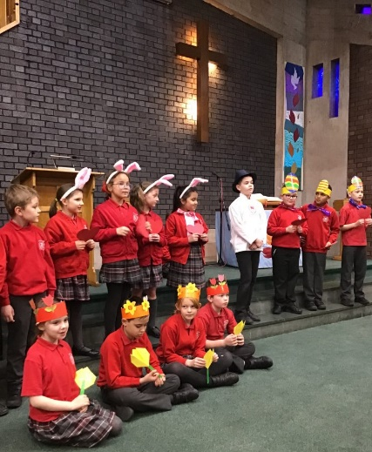
Thank you to those of you who were able to come with us to Trinity Methodist Church to join in our Easter Service there. We hope that you all enjoyed the service, led by Year 4 with the able assistance of Reverend Tim.

The children told the story of “The Chocolate Shop”; Easter eggs and bunnies jostle for position in the Chocolate Shop. The story is a 'sweet' (pun intended!) and simple tale of conflict resolved!
At Easter, the Chocolate Shop window is always full of Easter Eggs, until one year the Chocolate Maker puts Easter Bunnies in the centre of the display instead. The Eggs are furious, thinking it’s their right to have pride of place, while the Bunnies claim it’s their turn. Although the Tulips and Daffodils try to keep the peace, the Bunnies and Eggs fight with each other and the Chocolate Maker is very disappointed in them. The Eggs and Bunnies are ashamed, and with the encouragement of the Tulips and Daffodils they all apologise. By the time the Chocolate Maker returns they’ve forgiven each other, and there is joyful celebration. The shop window will look beautiful after all! The children all loved the story and especially the songs that they all sang with great gusto!
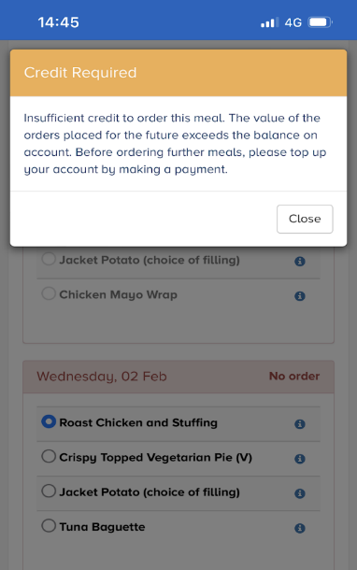
SCHOOLGRID CHANGES
Dolce, our school caterers, have changed the process of ordering school meals on SchoolGrid. From next term you will require a credit on your account or have a Direct Debit set up to be able to place orders. Please note this does not affect your account if you are entitled to Free School Meals or if your child receives Universal Infant Free School Meals (Reception, Year 1 or Year 2).
If your SchoolGrid account is not in credit or does not have a Direct Debit set up, you will no longer be able to place an order for a meal. You can top up your account by making a card payment via your SchoolGrid account or you can set up a Direct Debit via your SchoolGrid account (if your outstanding balance is less than £16). This is not a decision that has been taken lightly, but as they have had a number of bad debts they have decided that this is the best way forward.
This is an example of the message you will get if your account is not in credit.

HOMEWORK
Homework has been set for all the children for over the Easter break. As well as doing the set homework, please read / do spellings with your child daily. Hopefully this will help them to catch up on some of the lost learning that they have had with all the lockdowns that we have had to endure during the Covid pandemic.
Mrs Isherwood has set the children a small challenge; simply complete a daily diary of no more than a couple of sentences each day, stating what learning they have done each day. There will be a reward for those that bring in a completed diary of work done. Pictures would be good too if you wanted to add them.
EASTER EGGS
Every child in school has been given an Easter Egg. If your child is absent this week, there will be someone in school next week, Monday – Thursday inclusive from 9:00am until 1:00pm if you would like to collect your child’s egg in time for Easter.

SCHOOL GATES
We would again like to take this opportunity to remind parents about the opening/closing times of our school gates.

Both of the ‘walking gates’, the one on Waggs Road and the one leading from The Westlands are open from 8:45am and are then locked at 9:00am promptly. They will then re-open at the end of the school day.
The driveway gates will be locked once all of the staff are on-site at 8:30am and re-opened at 9:15am. If you arrive at school after the ‘walking gates’ are locked, please wait patiently until the driveway gates are re-opened at 9:15am; do not call the office for the gates to be opened as all staff are busy at this time and are unable to come to unlock the gates.

PARKING
Please remember to park considerately at drop-off and pick-up times. We have understanding neighbours, but they do get annoyed by parents’ inconsiderate parking, especially when their driveways are parked over.

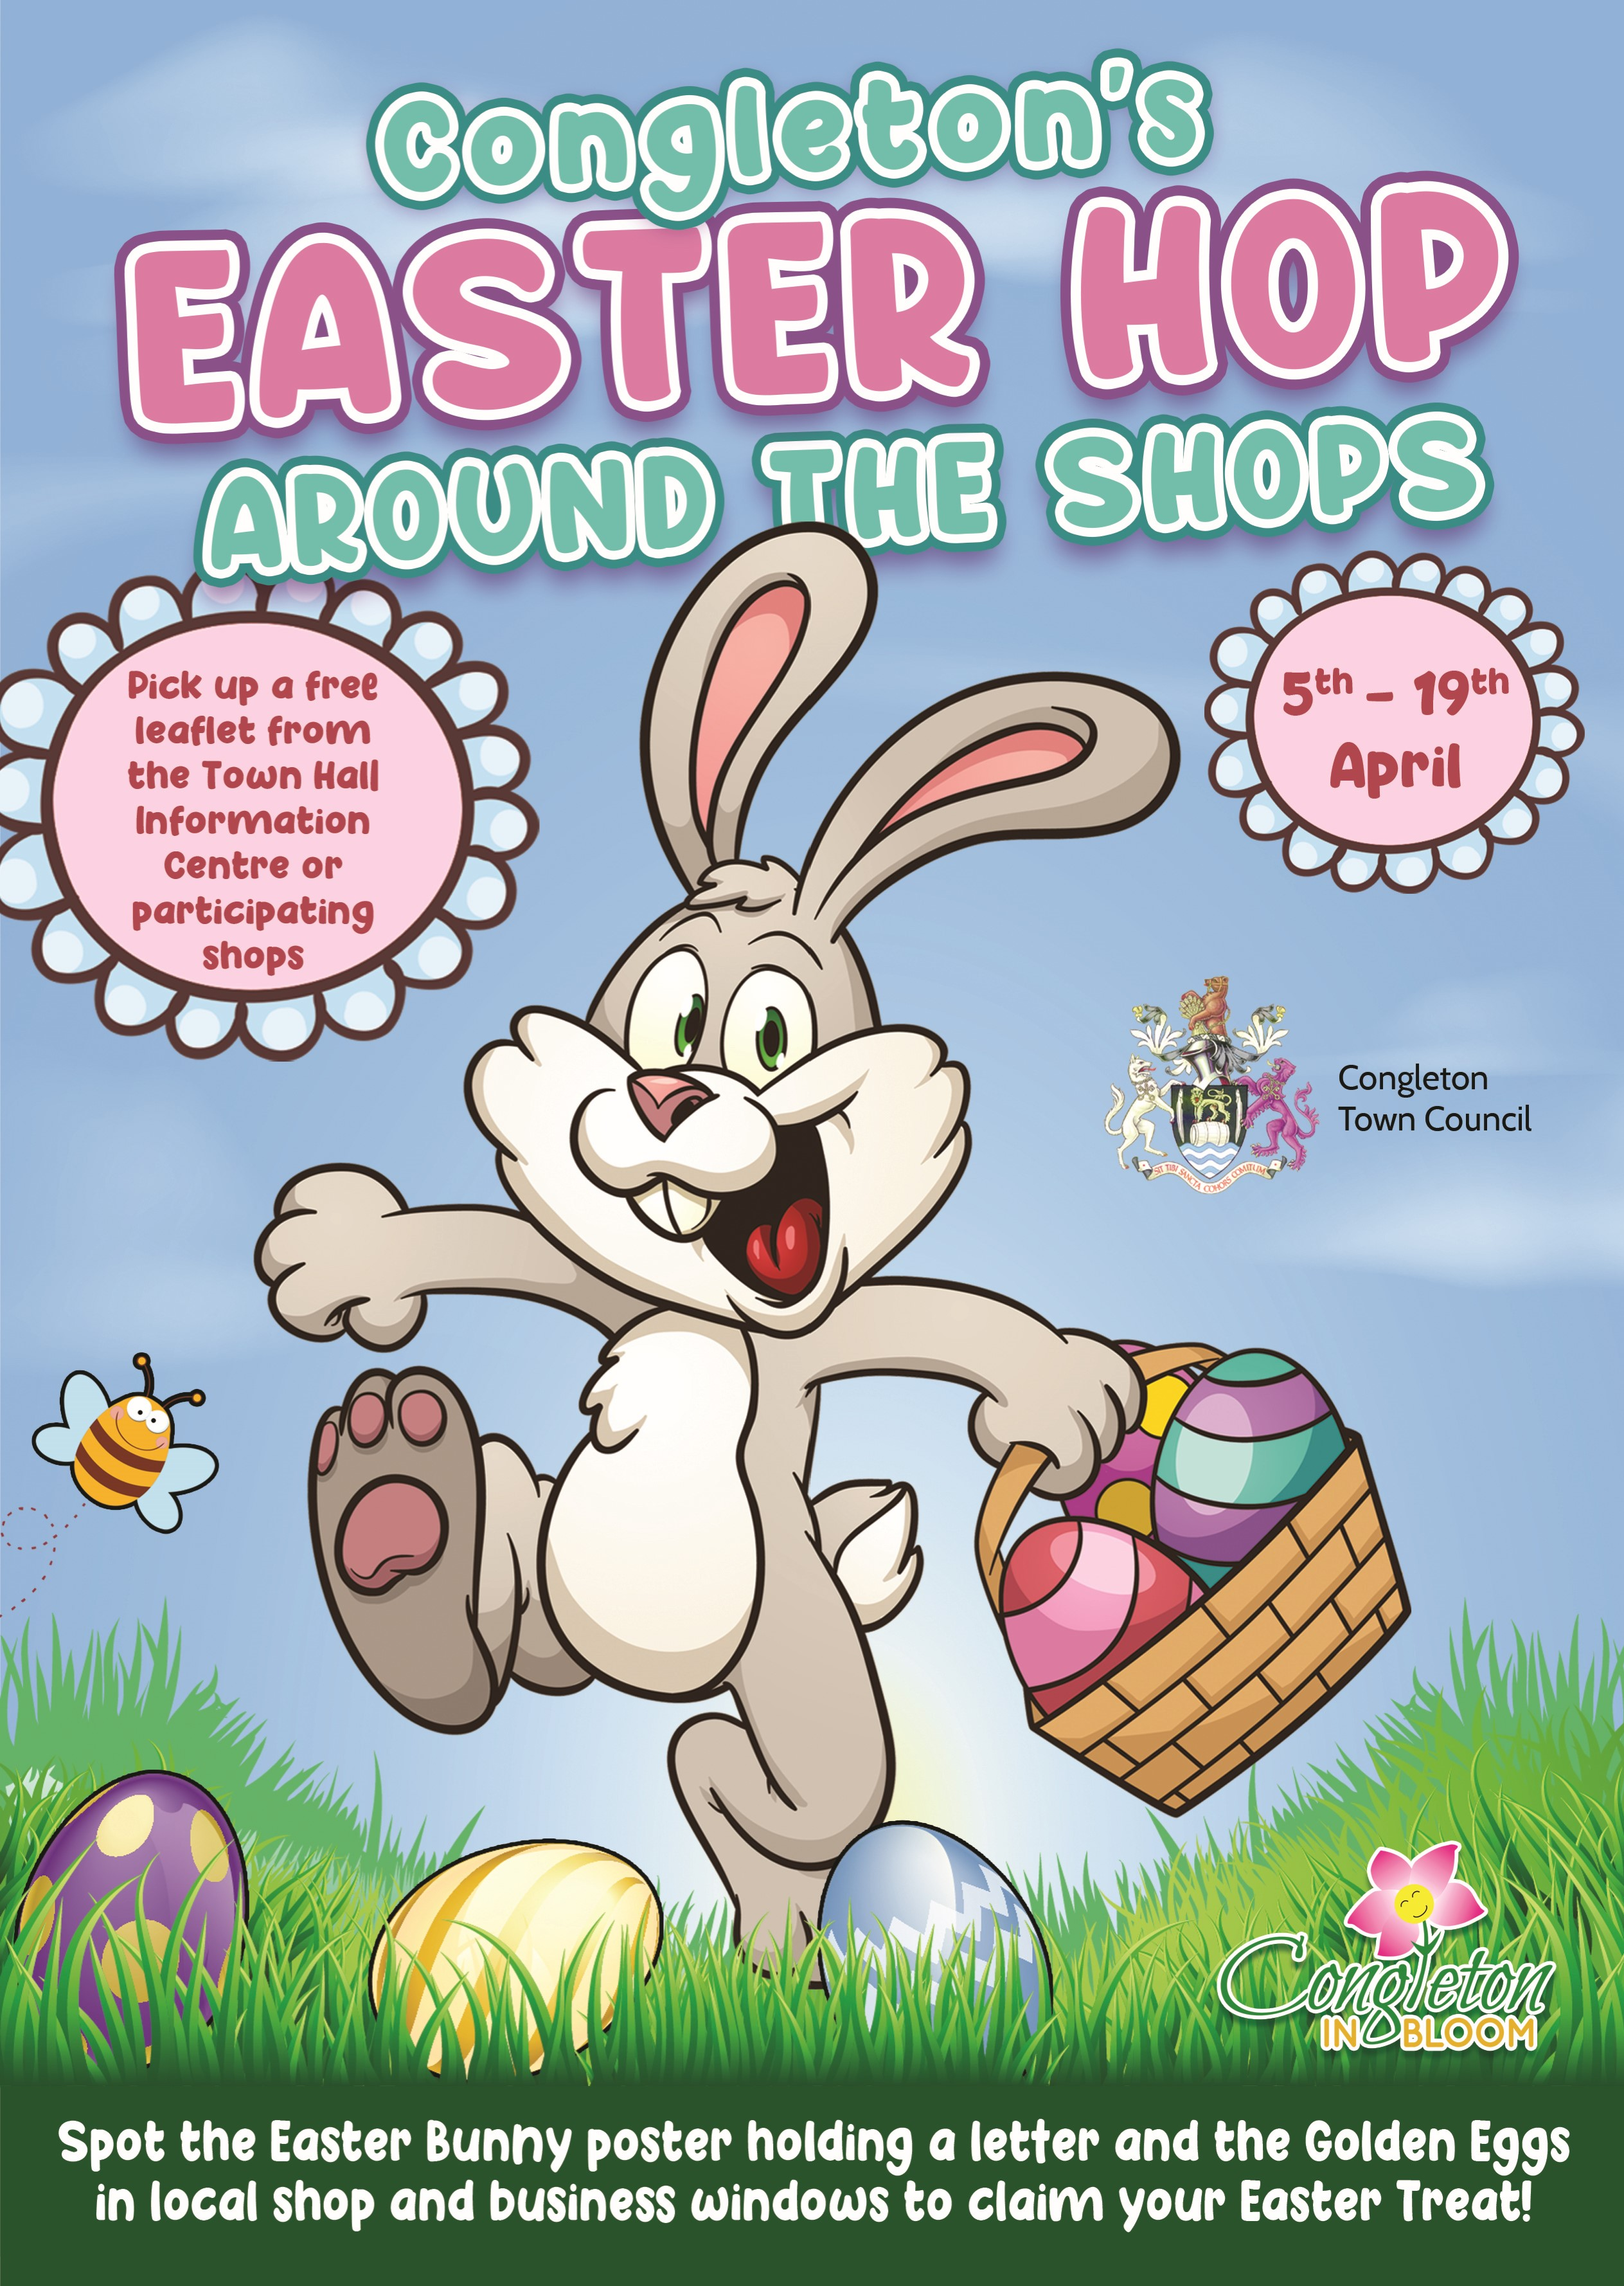

Easter Sunday

Family Service

at Trinity Methodist Church,
Wagg Street, Congleton

17th April 10.00am

Everyone is welcome to attend!

-oOo-

All that is left to say is that we wish you all a Happy Easter,
and hope you have lots of chocolate to eat!

Keep yourselves safe and well,
and we will see you when school re-opens for the Summer Term
on Tuesday 19th April.

