 **Marlfields Newsletter**

**7th March 2022**

**What a week we all had last week!**

Thank you for being so understanding in having to collect your children an hour after they had been dropped off last Monday, but as you know we wouldn’t have been able to stay open with no toilet/washing facilities.

The rest of the week was pretty eventful too with Shrove Tuesday (Pancake Day) and World Book Day. Both of these occasions were well photographed by all the classes, please see a few photos below and check out the school blog on our web-site for more.

**Pancake Day**

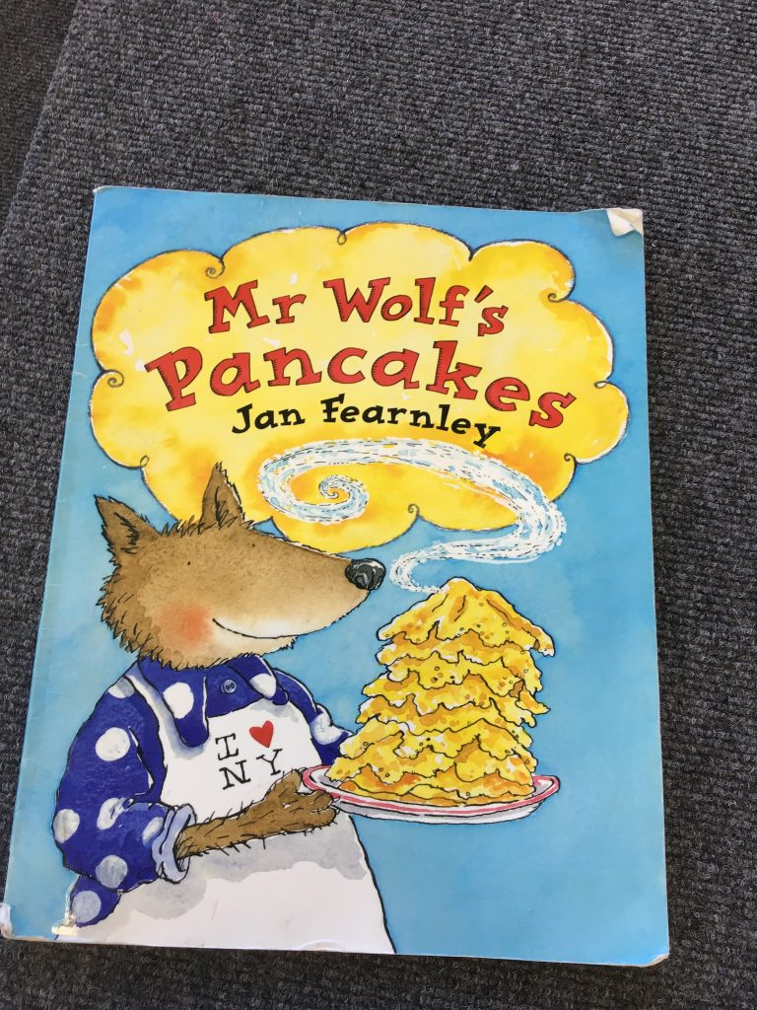On Tuesday the children in Foundation Stage celebrated Pancake Day. They began their celebrations by sharing the story “Mr Wolf’s Pancakes”. The children learnt about what ingredients were need to make the pancakes before tucking in to enjoy them!

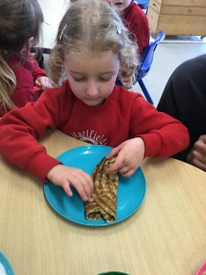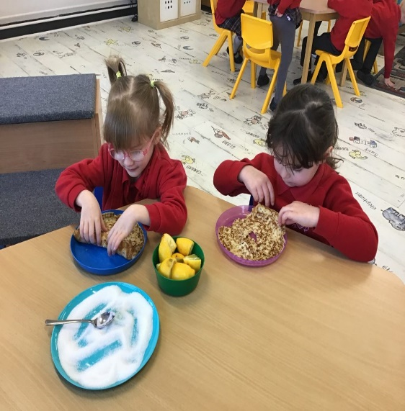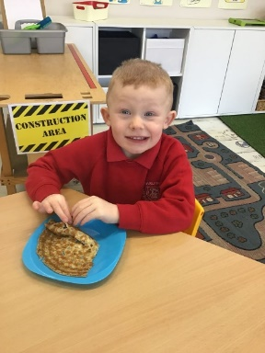

**WORLD BOOK DAY CELEBRATIONS**

On Thursday we were celebrating World Book Day. We all came into school dressed as our favourite book characters (even the grown-ups joined in too!). Again, there are many more pictures on the school blog.

**FOUNDATION STAGE**

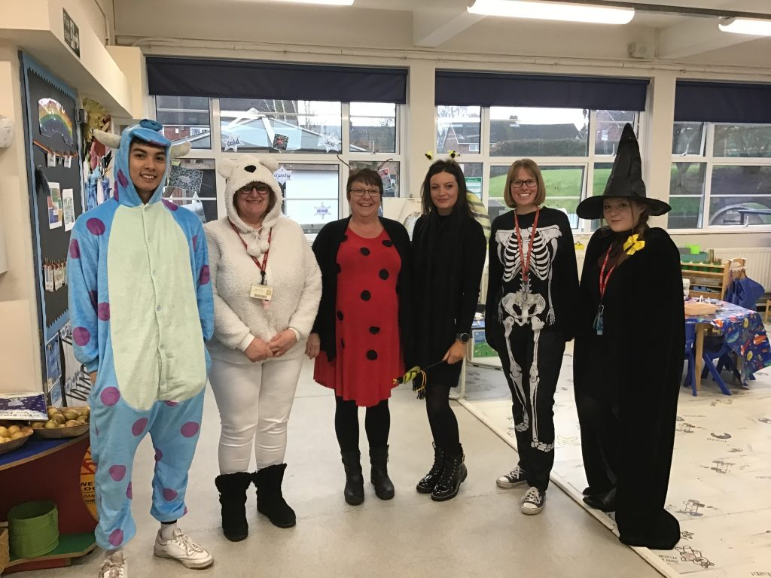 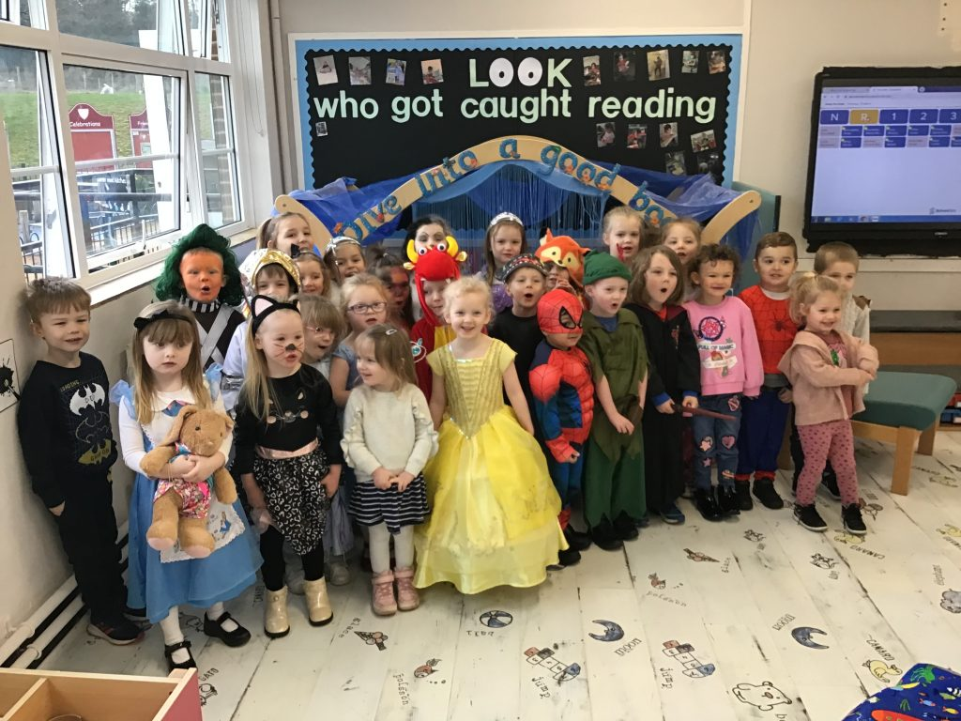

**YEAR 6 YEAR 5**

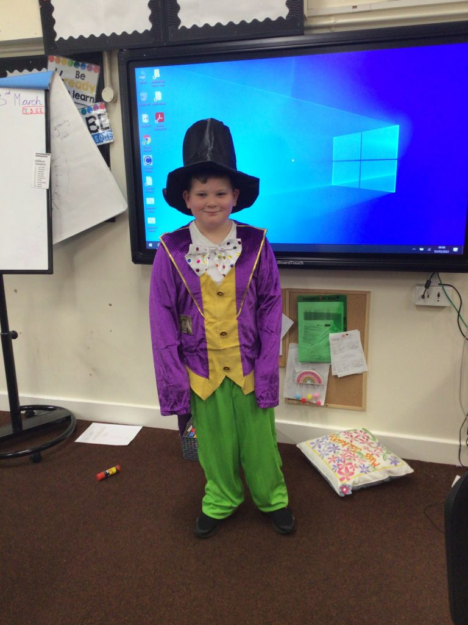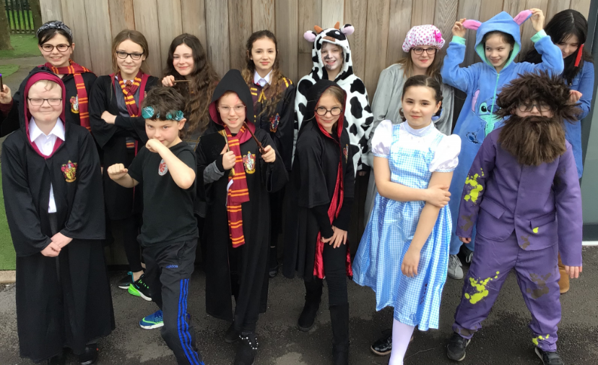 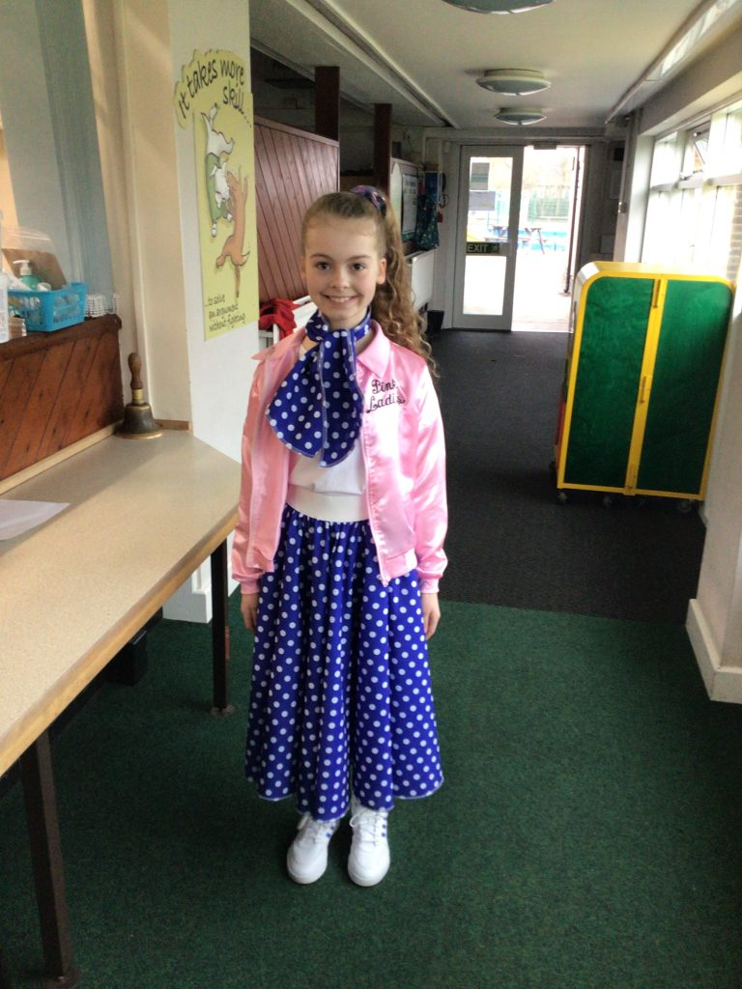

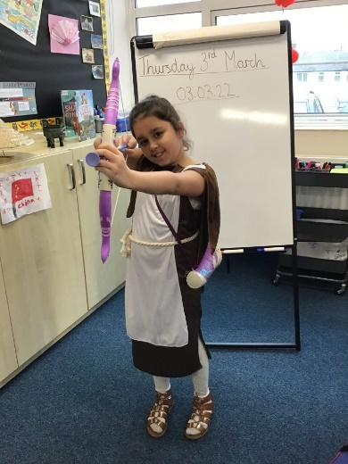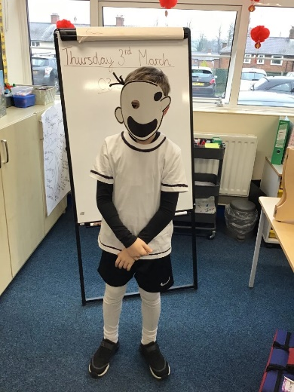**YEAR 4 YEAR 3**

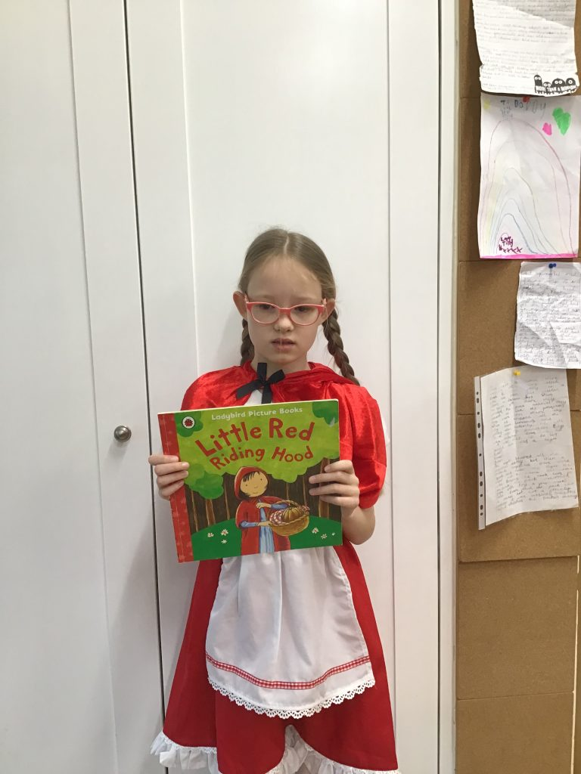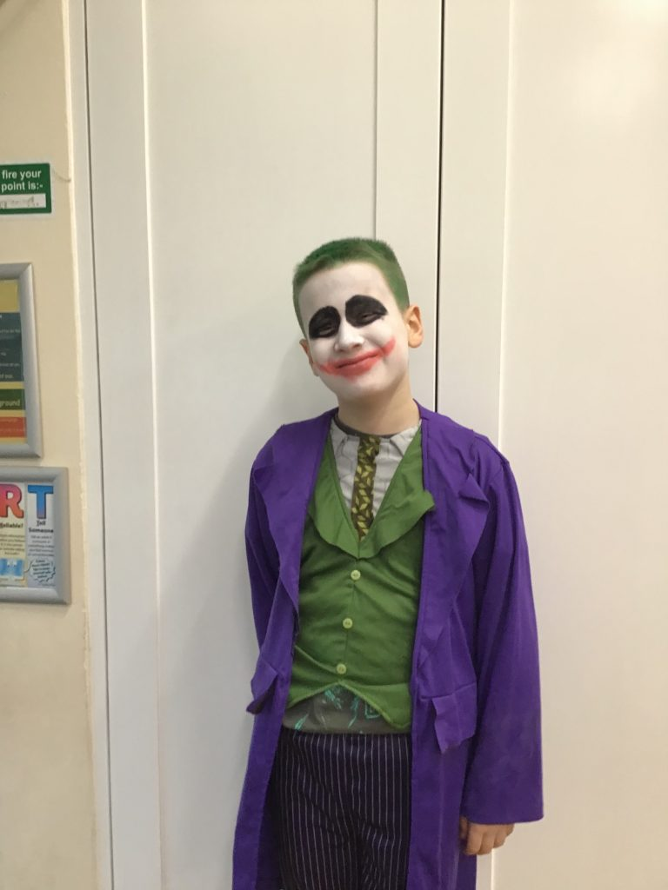

**YEAR 2 YEAR 1**

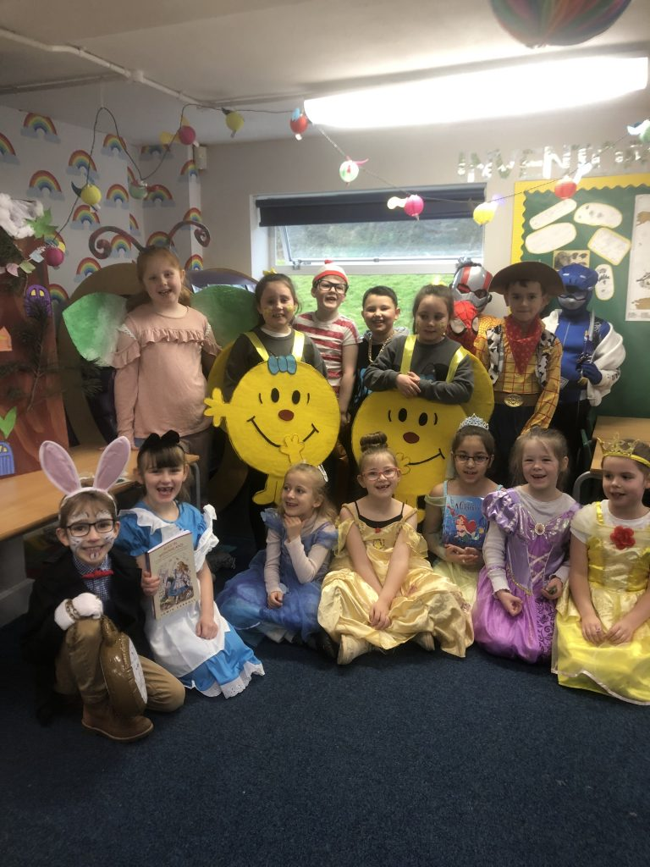 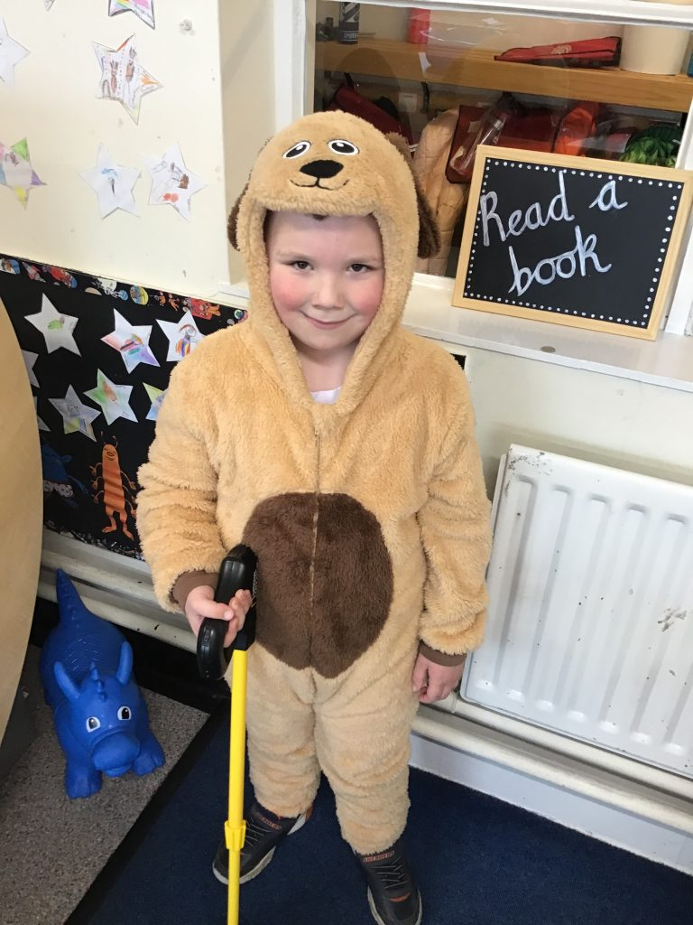 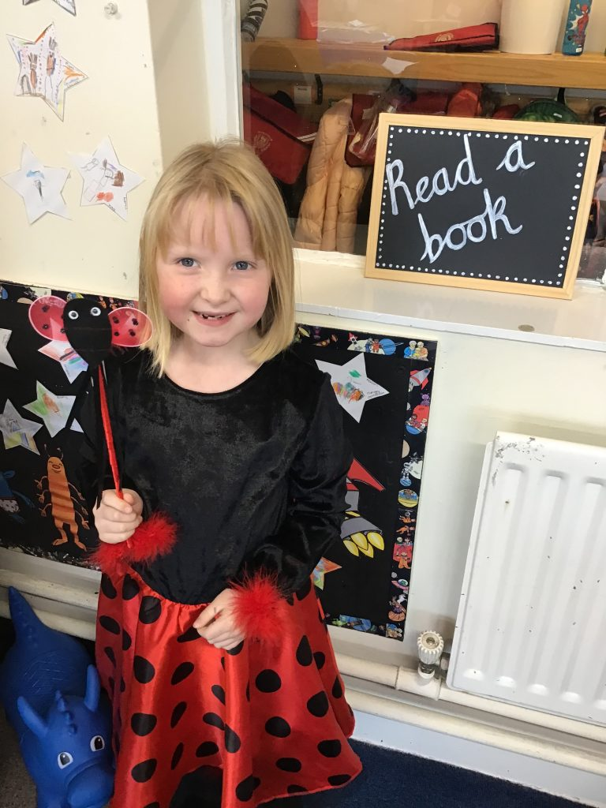

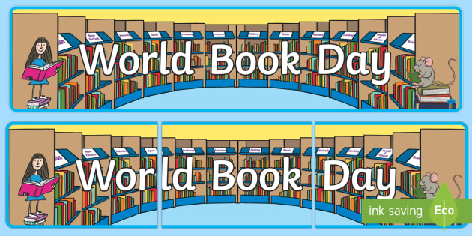

**CONGLETON ROTARY CLUB SWIMATHON**

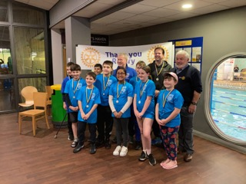On Saturday afternoon, our swimming team took part in this years’ Swimathon. Due to the covid restrictions of the past couple of years the Rotary Club have been unable to hold this annual event since 2019.

Usually the Swimathon takes place at Congleton Leisure Centre, but this year it was held at Biddulph Leisure Centre due to the on-going works.

Teams of swimmers take it in turns to swim as many lengths of the swimming pool as possible, whilst gaining sponsorship for doing so. 50% of all monies raised goes to local charities via Congleton Rotary, with the remainder going to a charity of the school’s choice. This year we have chosen to donate our portion of the sponsorship to the East Cheshire Hospice. We do not know yet how much has been raised by our team, but as soon as we know we will inform you.

We would like to take this opportunity to thank both parents and children for giving up your Saturday afternoon to support the school in raising funds for the charities involved.

**PIANO LESSONS**

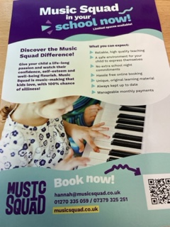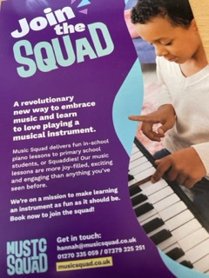We are launching exciting piano lessons for children in Years 3, 4, 5 and 6 through fun-based music tuition company, Music Squad ([www.musicsquad.co.uk](http://www.musicsquad.co.uk)). Music Squad use their own tuition books to teach and are all about having fun, being silly, and making learning an instrument as joyful as it should be! Please see the flyer that your child will be bringing home.

We will be starting individual piano lessons during the school day after half term. To register for lessons or for more information, please either contact Hannah directly on 07379325251 or [hannah@musicsquad.co.uk](mailto:hannah@musicsquad.co.uk). **Places are limited** so please get in touch early to avoid disappointment.

Funding for Pupil Premium students can be provided. Please ask the school for further information on this.

**SCHOOL DINNERS, “Buy one, get one free”**

We are pleased to say that the problems that we have encountered over the past few weeks with faulty equipment in our kitchen have now been resolved and we are now back to the full menu.

Now that we are able to invite parents back into school, we would like to invite you to have a **FREE** school lunch with your child; this will be for one parent per family of a child having a a paid lunch. These lunches will take place on **Wednesday 27th April** for parents of children in **Reception, Year 1 and Year 2** **Wednesday 4th May** for parents of children in **Years 3, 4 & 5.**

We know that these dates are a long way off, but the catering company need to have an idea of how many parents would be interested in taking advantage of this offer. If you would like a free lunch and your child has school lunches, please fill in and return the slip below.

Don’t forget to order your child’s lunches on the Dolce/SchoolGrid site.

**BUY ONE GET ONE FREE SCHOOL LUNCH**

I would like to join my child in Class for lunch on:

**Wednesday 27th April** (Reception, Yr 1 and Yr 2) **Wednesday 4th May** (Yrs 3, 4 & 5)

please delete where applicable

**SCIENCE WEEK**

This week is the start of Science Week. There will be lots of exciting things happening throughout the whole of the week. More information will follow on what we will be doing.

To help us celebrate Science Week, Dolce, our school caterers are putting on a special lunch.



|  |
| --- |
| **TUESDAY 15th MARCH** |

**P.E. KITS**

Please ensure that your child has their P.E. kit in school **all week** which they can bring home at the weekend for washing. We have lots of things happening in school where the children will need their P.E. kit to hand. Many thanks in anticipation of your co-operation with this.

**COATS**

The weather is still cold and very changeable. Please send your child to school each day with a coat to put on for outdoor play.

**EASTER CELEBRATION**

For the first time, since 2019, we will be holding an Easter Service. This will take place at Trinity Methodist Church on Waggs Road. You are all welcome to attend to celebrate our version of the Easter story with us and the children. The service will take place at the church on **30th March** at **9:30am.** Please bring your child to school as normal for registration, and you can make your way to church. We will then walk the children to the church. We hope that with this early notification you can join us.