MARLFIELDS NEWSLETTER
“Remember, Remember the 5th of November”
Welcome back to school following a rather wet and dreary half term break. Despite the weather, we hope that you all had a well-deserved break; and had a ‘spooktacular’ Hallowe’en.

The next exciting event will be Bonfire Night celebrations this weekend.

Please endeavour to follow the Fireworks Code, whether you hold your own Bonfire celebration or go to an organised event.
We would hate it if someone got hurt or injured.

Having said that, have a great time and enjoy yourselves!

--oOo--

Thank you to everyone for assisting us with the transition of allowing parents on-site, which is going smoothly. Please see the arrangements reminder below -

Morning arrangements
In the morning two gates (Westlands entrance and the walking gate by Nursery) will be open at 8:50am and closed again promptly at 9:05am. This will give parents a 15-minute window to drop off their children and leave.
PLEASE SUPPORT US AND YOUR CHILD BY BEING ON TIME, AND WITHIN THE TIMES INDICATED ABOVE.
AFTER THE GATES HAVE RE-OPENED, CHILDREN ARRIVING LATE WILL NEED TO BE TAKEN TO THE MAIN RECEPTION.
- Please note staff will be positioned within our grounds to see the children into the building, to ensure that they still wash their hands and use hand sanitiser.
- We will not be asking the children to line up on the playground in the mornings.
- Children will enter school by the door nearest to their classroom.
Teachers will no longer be out on the playground in the mornings; they will be in their classrooms ready to receive the children as they arrive.
THE MAIN VEHICLE GATE FOR THE SCHOOL WILL NOW NO LONGER BE USED AS A GATE FOR CHILDREN TO COME IN AND OUT OF. THE GATES WILL BE LOCKED AND UNMANNED FROM 8:30am UNTIL 9:20am.

Afternoon arrangements.
Please note the gates will only be open from 3:15pm to 3:40pm
- Those parents collecting FS1/FS2 and Year 1 will be collected from their playground gate at 3:15pm (Nursery children at 3:00pm)
- Years 2-6 will be collected from the main playground.
- Staff will have the children lined up for collection within a designated area and once they see you they will send your child to you from this area.
- When you have your child, please make your way off the site quickly and safely via the walking gates.
- Both Walking Gates will be closed at 3:40pm prompt.
Children not collected by 3:35pm will be brought into the school by staff and taken to the after-school club for which you will be charged.

For Maths Week England we want to make maths more exciting and to have high profile in our school.
We will be taking part in a friendly competition involving schools from around England from Monday 8th November to Thursday 11th November. It’s all done online via play.ttrockstars.com.

For every correct answer to a multiplication or division question, your child will earn their class a point. The Times Tables Rock Stars platform will calculate the class average (the number of correct answers per pupil in the class who play during the competition hours, subject to a daily 60-minute limit (see below). Winning classes in the school and in the competition as a whole will be the ones with the highest average.

All game modes (Gig, Garage, Studio, etc.) will count but only from games played between 7:30am and 7:30pm on Monday 8th, Tuesday 9th, Wednesday 10th and Thursday 11th.

To support player wellbeing, there is a daily time limit of 60 minutes per player. In other words, each player can earn competition points for up to 60 minutes between the hours of 7:30am and 7:30pm each day. Once a player goes beyond the daily 60 minutes of play, they will still earn coins but will no longer earn points towards the competition.

In the spirit of the competition, please don’t play on their behalf, but by all means encourage and support them to the extent that it doesn’t cause high stress levels or impact on family plans.
We suggest a limit of half an hour a day outside school hours – some will play more; some will play less.

The 3 highest-average-scoring primary-age classes will each receive an Amazon gift card.
1st place: £100 gift card 2nd place: £90 gift card 3rd place: £80 gift card

NATIONAL SCHOOL MEALS WEEK
Next week is National School Meals Week, and to celebrate we wondered if our artistic children would like to design a MASCOT for our school meals.
Your design should be on an A4 sheet of paper, and can be of anything to do with school meals. 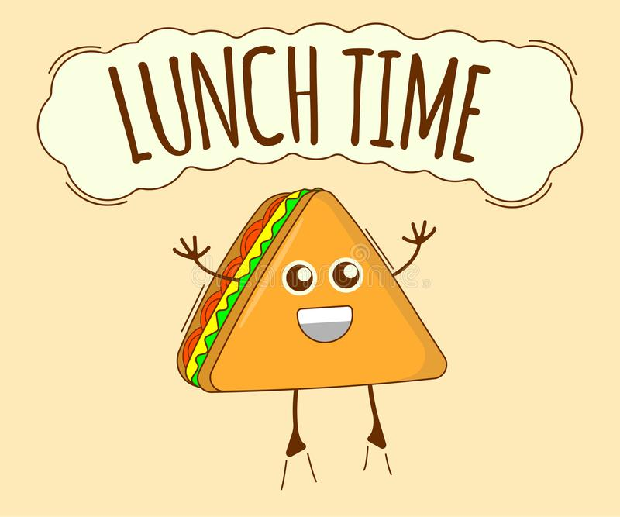
Here are a couple of ideas. The winning design will be made into a banner which will be displayed in the canteen.

our school catering company are also asking for our children to enter their Snowman competition, please see the poster below.
PARENT’S EVENINGS  This term we trialled using telephone calls for your child’s Parent’s Evening rather than face to face appointments. We would like your opinion on this system by answering the question below.  Please let us know your opinion, was 10 minutes long enough? Were you called at the correct time? Would you have preferred to have a shorter/longer appointment? Was the system perfect or flawed? In your opinion was it the best way to do the appointments? Do you have anything else to add?  We need your honest opinions, good or bad, that’s the only way that we can improve and move on, with constructive critisism. Together we can work to make things better. |  | HOLIDAY DATES  Academic Year 2021 – 2022
 |  | School Opens School Closes
 |  | Autumn 1 | 01.09.2021 | 22.10.2021
 |  | Half Term
 |  | Autumn 2 | 02.11.2021 | 17.12.2021
 |  | Christmas Holidays
 |  | Spring 1 | 04.01.2022 | 17.02.2022
 |  | Half Term
 |  | Spring 2 | 28.02.2022 | 31.03.2022
 |  | Easter Holidays
 |  | Summer 1 | 19.04.2022 | 26.05.2022
 |  | Bank Holiday | Monday 2nd May 2022
 |  | Half Term
 |  | Summer 2 | 07.06.2022 | 22.07.2022
INSET Days
01.11.21, 18.02.22, 01.04.22,
27.05.22 & 06.06.22

YEAR 6 GIRL’S FOOTBALL
The Year 6 girls played in their first league matches of the season on Thursday evening at Eaton Bank Academy.
After competing against Buglawton and Black Firs, they then went on to beat Daven before narrowly losing 2-1 to Mossley.
The determination from the girls was exceptional and in each game they went from strength to strength. A special mention must go out to our goal scorers Ellie N and Amelia as well as our quick-thinking goal keeper Paige.
Well done to all the girls who played and we look forward to hearing how you get on in the rest of the league.
A special thank you to Mr Shelton, Mrs Wood and Mr Rowe for supporting the girls on this night.
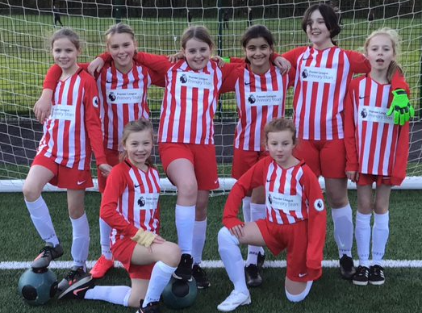
WATER BOTTLES
Why is drinking water important for a school child? It boosts learning
When we are thirsty, mental performance including memory, attention and concentration can decrease by about 10 per cent. Pupils concentrate better because they are not distracted by the effects of dehydration such as thirst, tiredness and irritability.
It good for the body - keeps joints, bones and teeth healthy, helps the blood circulate. Being well hydrated improves mood, memory and attention in children. And it's economical – tap water is much less expensive than sports drinks, sodas and juice.

As you know, here at Marlfields we actively encourage your child to have a water bottle with them in class, the emphasis being on WATER. May we remind you that you should only send water to school with your child, not fruit juices etc. If we see a child with juice in their bottles we will ask them to bring them home and we will provide them with water in a bottle as well as them having the use of the water fountains around school. Thank you for your co-operation with this.

Have a fantastic, safe Bonfire Night

