Marlfields Newsletter

26th November 2021

Anti Bullying Week
The children of our Foundation Stage started Anti-Bullying week last week by coming into school wearing odd socks. The children all made their very own odd sock to make a washing line of odd socks to represent that we are all different. The children enjoyed the story of Elmer to talk about how everyone is different.
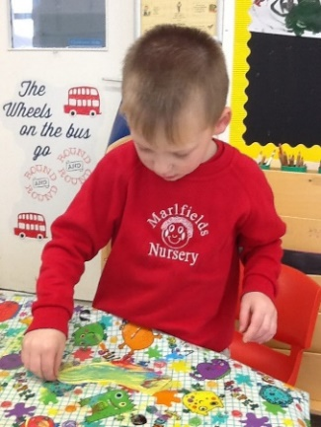
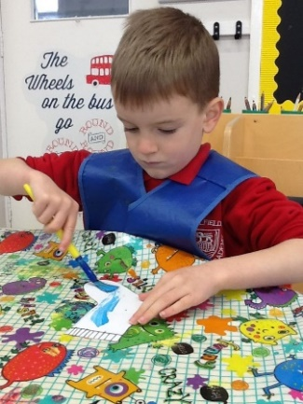
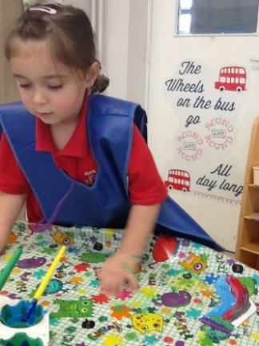
Throughout the week the children tried very hard to be kind towards each other. They used Andy’s Odd Sock Song – One Kind Word as a reminder.

On Friday the children then came into school wearing clothes which makes them feel happy. All the children (and adults) looked great!
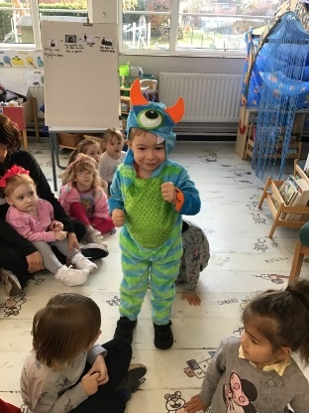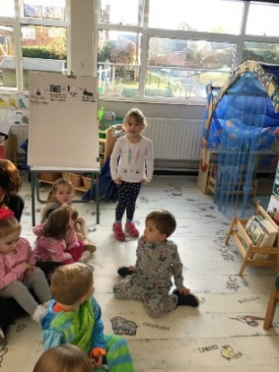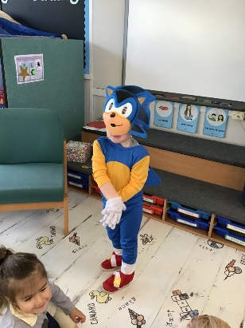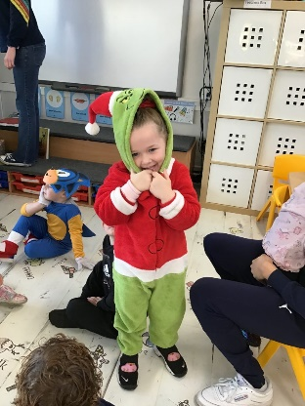
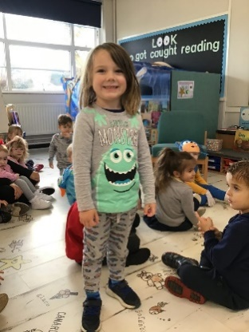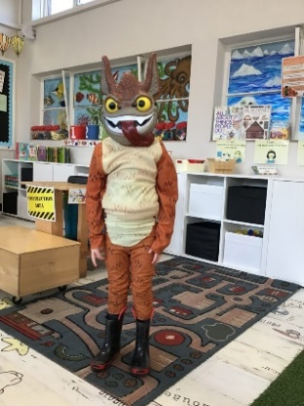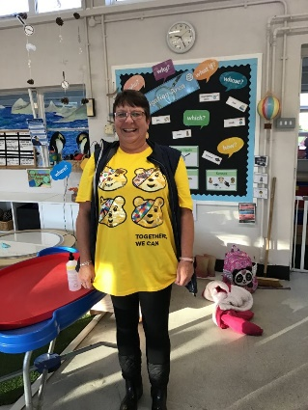

Night Time Animals
Foundation Stage have also been learning about which animals come out at night – nocturnal animals. The children have used non-fiction books to find out about Owls, Badgers and Foxes and then made the different animals.
Then in our Forest Friday session the children went to look for animal homes. They found a bird box where an owl might live and they found a fox hole and badgers hole. What fun!
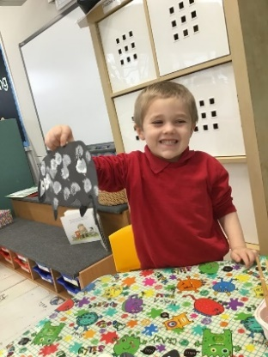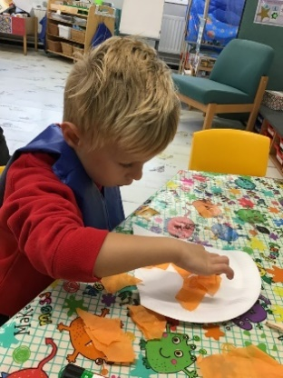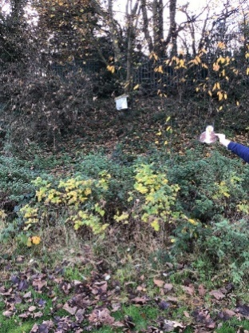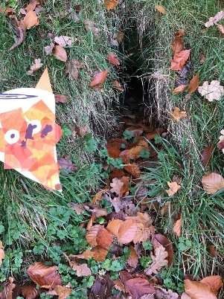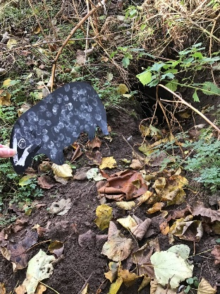

A Week of Kindness in Year 1!
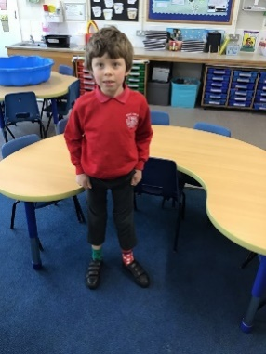
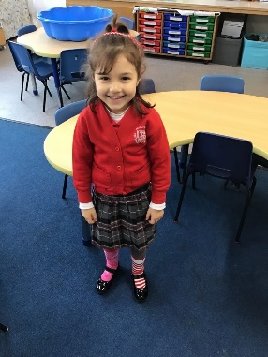
To start anti-bullying week last Monday, the children and staff came into school wearing odd socks to represent everyone being unique!
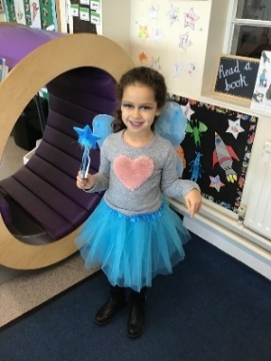
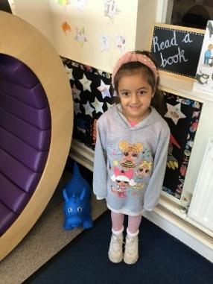

To finish the week, the children have come into school wearing
something that makes
them smile.

Fantastic Friday
To celebrate the end of anti-bullying week the children in Year 4 have come into school wearing something to make them smile. We are sure that you will agree, they certainly make you smile!
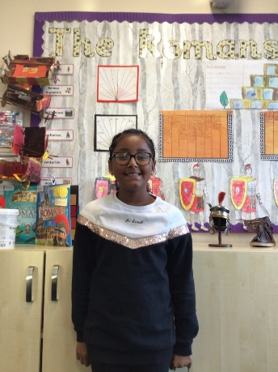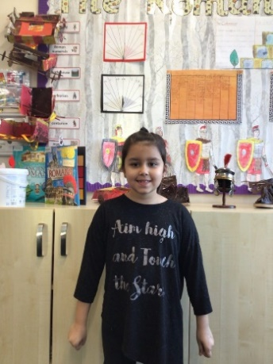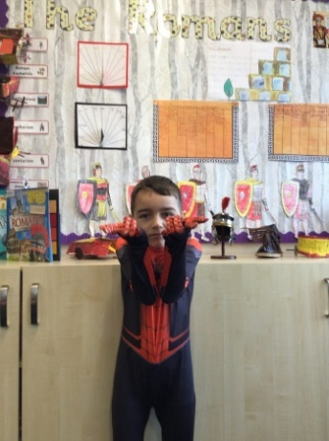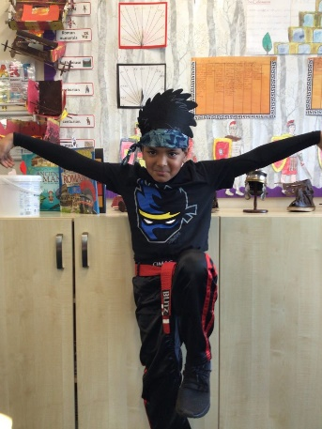

Year 6 Celebrate Anti-bullying Week
To kick off anti-bullying week in school the children came in wearing odd socks. This showed us how each of us are different and unique in our own amazing ways and how not one person should be singled out for having differing traits. Can you guess whose odd socks belong to who?
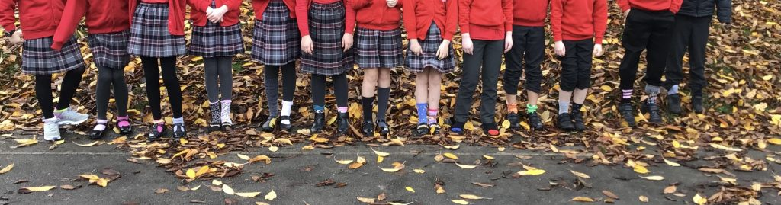
Kindness Awards
As part of Anti-Bullying week, each class was asked to nominate someone to be awarded The ‘Marlfields Kindness Award’. During Friday afternoon of last week, we held an assembly on Zoom so that the whole school could come together to celebrate the winners.
It was heart-warming to hear some of the reasons why the children had nominated their classmates. Including, amongst others, being a good listener, helping and being considerate were just a few of the reasons they thought their friends should be awarded.
Here are our wonderful winners:
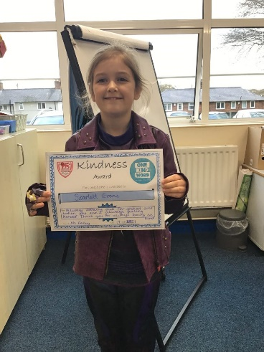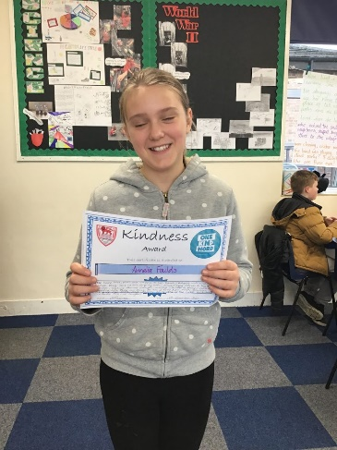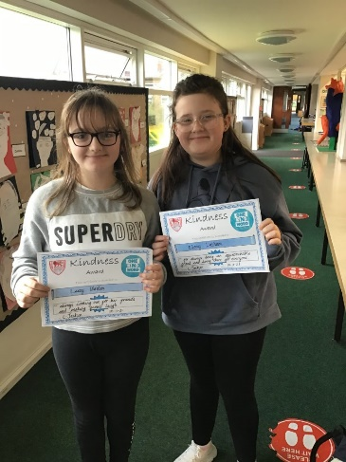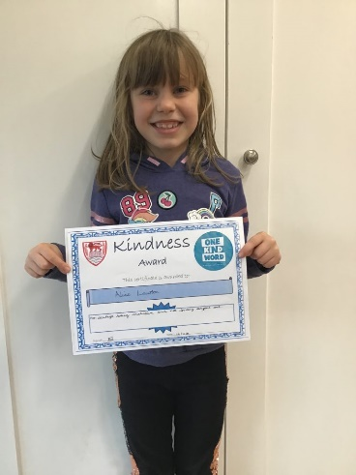

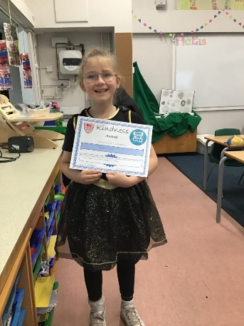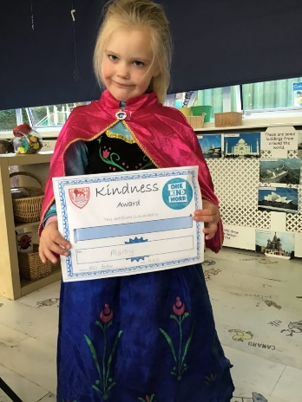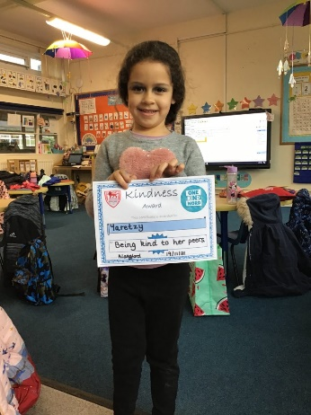
Congratulations to all of our worthy winners!

Let’s go fly a kite…
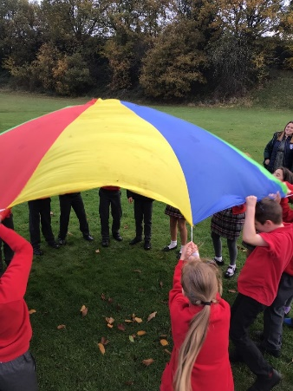
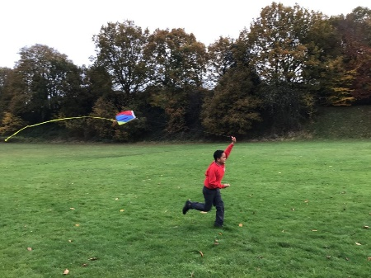
In Science Class 4 have been looking at gases. They talked about how all gases can’t be seen, and wondered how we could investigate what they can be used for. The class decided to take a kite onto the field to see if the air outside would help it to fly, they noticed that there is gaps at the top of the kite that let the air in and this then helps them to fly. They also noticed that the faster we ran the higher the kite went and the longer the kite stayed up.

They then had some fun with the parachute, they couldn’t see the air but knew that the air was underneath the parachute because when it was lifted, the shape changed into a dome.

WINTER WEATHER
Now that winter is well and truly with us, please ensure that your child has with them a warm, waterproof coat for outdoor play. The children should also wear sturdy sensible shoes to keep feet dry and to provide a decent grip on potentially icy pathways.

Should the worst happen over the next few weeks, and we have a heavy snowfall which may mean that staff cannot get into school for us to run efficiently, we may have to close school for the day. If this were to happen, we will text parents in the first instance to let you know; we will also advertise it on local radio stations: SIGNAL RADIO 96.4 FM / SILK RADIO 106.9FM / RADIO STOKE 94.6FM.

LATERAL FLOW TESTING
Please remember to test your child over the weekend with a Lateral Flow Test to try to prevent any further Covid outbreaks. If you do get a positive result you must get a PCR test, and you must let us know. If there is a positive result your child should be off for 10 days and any siblings should also be kept off school for 5 days.

FOOTBALL TOURNAMENT
Last night our children took part in an inter-school tournament. Next week there will be a full report and photographs for you all to enjoy and celebrate.

