**MARLFIELDS NEWSLETTER**

**12th November 2021**

**ANTI-BULLYING WEEK**

Kindness is more important today than it has ever been. The isolation of the last year and a half has underlined how little acts of consideration can break down barriers and brighten the lives of the people around us. This is one of the reasons, that **‘One Kind Word’** has been chosen as the theme of Anti-Bullying Week taking place from 15 to 19 of November 2021.

We will begin the week with Odd Sock day, celebrating our individuality. All the children need to do is wear Odd Socks on Monday! Below is their call for action.

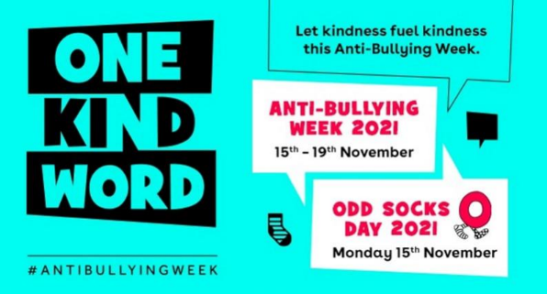**The Anti-Bullying Alliance call to action:**

*Ask if someone’s OK. Say you’re sorry. Just say hi.*

*In a world that can sometimes feel like it’s filled with negativity, one kind word can provide a moment of hope. It can be a turning point. It can change someone’s perspective. It can change their day. It can change the course of a conversation and break the cycle of bullying.*

*Best of all, one kind word leads to another. Kindness fuels kindness. So from the playground to Parliament, and from our phones to our homes, together, our actions can fire a chain reaction that powers positivity.*

***It starts with one kind word. LET It starT today.***

**To continue the theme of Being Kind –**

Marlfields will be raising money for **Children in Need** on **Friday 19th of November**.

We invite the children to come to school wearing something that makes themselves or other people smile.

This can be fancy dress, their favourite outfit or just some accessories.

**Suggested donation is £1 payable on SCOPAY**

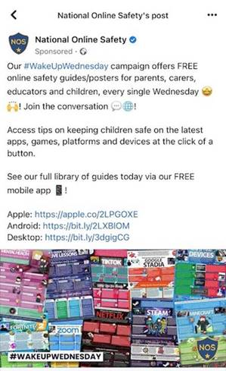**ON-LINE SAFETY**

Due to a number of recent reports and concerns around children being exposed to inappropriate material online on all sorts of different platforms including You Tube, Netflix, Roblox and TikTok I wanted to send out this e-mail for you to share with parents.

National Online Safety offers free online safety guidance for parents on the latest apps, games, platforms and devices. It can be accessed on line at <https://nationalonlinesafety.com> and followed on Facebook and Instagram.

We would encourage parents to visit the site and use the guidance to understand what their children are accessing and to apply parental settings to all apps and games as well as regularly checking devices including images, installed apps and conversations.

**CINEMA VISIT**

As a treat for taking part in the Congleton Library’s Summer Reading Challenge, for being a Class Dojo Champion and Runner-up or for representing Marlfields at inter-school sports we went to the Vue Cinema in Newcastle-under-Lyme to see the film **“Spirit Untamed”**. As always our children behaved impeccably and they all seemed to enjoy themselves. We must, of course, say a massive **THANK YOU** to the **parent helpers**. Without your help the visit might not have been able to go ahead.

Our next visits to the cinema are for Year 3 and Year 4 who will be going to see films relevant to their class topic work, **“The Croods 2”** and **“Rotten Romans”**. Hopefully they will too will have fun and learn lots towards their topic work. If your child is in either of these classes, please ensure that you have sent back to school the reply slips, if one is not returned, sadly your child will be unable to go. Please send in by **9:00am** on **Monday**.

Further information to follow on a whole school visit to the cinema as a pre-Christmas treat!

**REMEMBRANCE DAY**

Yesterday was Remembrance Day, and each class paid their own tributes to all those who gave up their lives so that we can be free by making poppies. Each class then came down to the entrance hall throughout the day to honour those no longer with us by laying their poppies down. It was very emotional to see the reverence on the children’s faces as they did so.

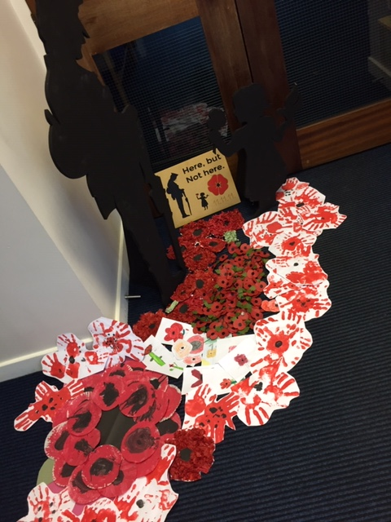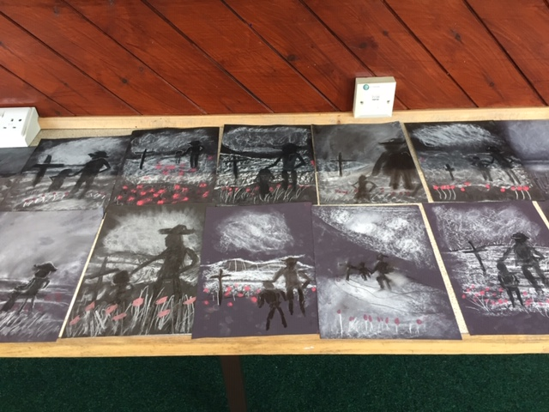 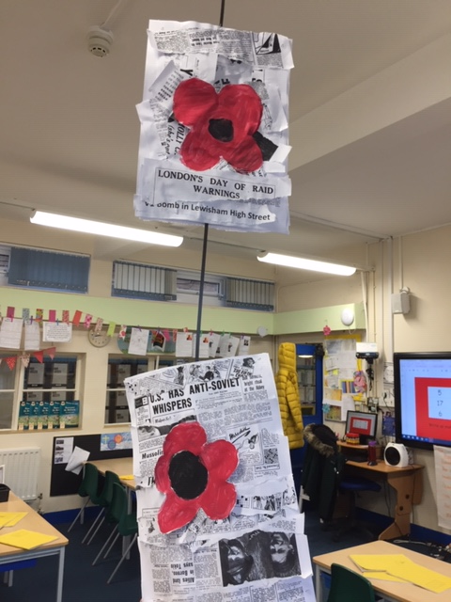

**SCHOOL PHOTOGRAPHS**

Due to the pandemic, we have been unable to invite the school photographers in. We are now in a position to do so. The photographers will be in school on **Tuesday 23rd November** from **8:15am**, photographing **families (babies and siblings)**, school will then organise the photographing of in-school siblings, and of individual pupils.

The photographer will set up in Miss Barber’s old classroom. If you are bringing younger children to have the ‘family photo’ please enter through the Infant playground and into the classroom via the ramp. One the photos have been taken you can then exit via the corridor door to the Infant playground, thus maintaining a safe distance.

**FOOTBALL REPORT**

Our amazing team played Marton in game 1, Havannah in game 2, St Mary's in the third game, Quinta in the penultimate match and Buglawton in our final game of the evening.

In the first game, we were narrowly beaten by a team that took their chances. Marlfields created better goal scoring opportunities than their opposition, with Thomas D, Isaac B and Lennon all having great shots at goal. Paige produced some fantastic saves to keep the opposition out at the other end. Vayun and Toby were excellent at the back with some great last-ditch tackles.

In the second game we made some changes with Ryan and Mia S coming into the starting 7 and having an immediate impact in the game. Ryan produced a great block, and Mia never stopped running! Leo and Lennon linked up well and Thomas again was influential going forward, and was supportive of his teammates when tracking back well to win the ball back from the opposition. This was a tough game and Havannah scored two excellent goals which were the only difference between the two teams in this match.

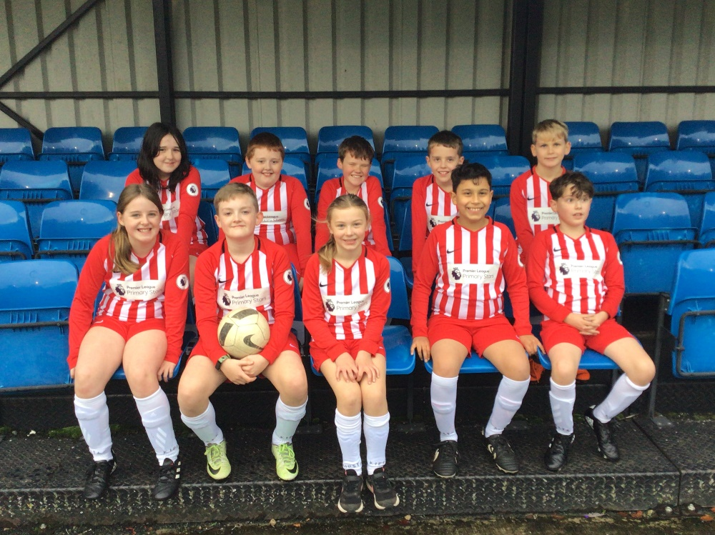Thirdly, the team played against St Mary's and this was another tough game. The team dug deep in a contest which saw Ellie N make some good blocks and tackles in midfield, and the Marlfields lads linked up well in attack, supported well again by Mia's energy and desire to win the ball back for her team. Isaac led the line well with some great runs forward and was unlucky to be blocked in his attempt to score. Paige, again made some outstanding saves to restrict the number of goals scored by the opposition.

Next up was Quinta, in another game in which the team went from strength to strength. The team built from their previous games and were unfortunate to concede a dubious goal which the referee deemed to have squirmed over the line. Ryan was in the goals for this game and stepped in really well while his sister had a well-earned rest. He made some good saves and blocks for his team. At the other end, the players carved out some good chances and were unlucky not to score again.

The team saved their best performance until last though, as they battled to earn a win against Buglawton. The team were creating numerous scoring opportunities, with Lennon, Isaac and Thomas instrumental in the build-up play; Vayun and Toby keeping it tight in defence. The pressure from Marlfields became too much, as one of the Buglawton players handled the ball in the penalty area leading to a penalty kick being awarded. Thomas stepped up coolly to slot home the only goal of the game, low into the bottom left corner. Leo came on in the game and defended resolutely with his teammates to see out the win!

Mr Shelton and Miss Jackson are both really proud of all the team because every single player tried their best throughout, battled and never gave up. Our player of the evening award went to Paige because her performances in goal were excellent, and she stopped the opposing teams from scoring on countless occasions! A big well done to you all!

**CASHLESS SCHOOL**

We would like to take this opportunity to remind all parents that Marlfields is a **CASHLESS** school.

The only exception to this would be for something like the poppy appeal.

If you haven’t yet registered your child on to **SCOPAY** please do so as soon as possible.

E-mails were sent out earlier this week to parents of children who aren’t registered.

If you have lost this, please let us know and a new activation code will be sent out to you. Thank you for your understanding and co-operation.

**EXTRA-CURRICULAR CLUBS**

By applying for a place at one or more of our free extra-curricular clubs your child has committed to attending each week.

Clubs began this week, and everyone who wanted places were sent a text before half term and again on Monday as a reminder. Despite these measures, staff have had to spend time chasing up children who had decided not to stay instead of beginning the club on time.

Please let us know in advance of any club if your child will not be attending; if they no longer wish to attend please also let us know and their place can then be offered to someone else on the waiting list.

**PARENT’S EVENINGS**

Many thanks to those who have already sent in their opinions on how the Parent’s Evenings were received, we are so pleased that you found the system of a phone call meeting easier than a face to face meeting. We would still like to hear opinions from more parents, it’s easy to do, just a quick e-mail to [admin@marlfields.cheshire.sch.uk](mailto:admin@marlfields.cheshire.sch.uk) to let us know your feelings.

**F.O.M. CHRISTMAS FUNDRAISER**

You should by now have received a sample of your child’s artwork to go onto Christmas cards, mugs, gift tags etc.

The samples have been printed, but we know that some names have been spelt incorrectly. If your child’s name is incorrect there is a facility for you to change it on the slip attached to your child’s illustration. Please remember to make your correction in **BLOCK CAPITALS.**

We hope that you will feel able to support the Friends of Marlfields in their fundraising.

**Swimathon 2022**

In previous years we have entered a team into the Rotary Club Swimathon. Obviously for the last two years we have been unable to do this, however we hope to be able to take a team next year which is scheduled for **Sunday 6th March 2022** with a morning session around an **11:00am start**.

We have lots of good swimmers in school. Would you be willing for your child to give an hour to the team? Would your child like to take part? We are asking now so that we can commit knowing that we have a team to enter.  The children won’t be on their own as there will be adults supporting as well.

Please email us at [admin@marlfields.cheshire.sch.uk](mailto:admin@marlfields.cheshire.sch.uk) if your child would like to participate.

  
The event is a sponsored event and 50% of the money raised goes to the Rotary Club, and 50% to a charity of our choice, so everyone’s a winner.