Well done everyone for making it to half term; we made it by working together as a team. Thank you for working with us to keep both children and parents safe and also staff too.

We are back in school on **TUESDAY 2nd NOVEMBER** (Monday 1st November is an INSET Day).

Whatever you’re doing next week, whether you go away on holiday or stay at home, have a lovely time and most importantly keep yourselves safe, and we will see you on Tuesday the 2nd.

As you are aware the Government and DfE have asked all schools to be back to normal by the end of the Autumn term.  We have been lifting restrictions slowly to ensure we keep everyone as safe as the guidance asks us to.

Following the opening of one gate allowing parents to come within the site we are now writing to tell you of the next restrictions we will be lifting.  **PLEASE NOTE WE WILL ONLY CONTINUE TO KEEP EVERYONE AS SAFE AS WE CAN IF WE ALL WORK TOGETHER.**

Therefore, we will be inviting you back onto the site with the following guidelines to follow -

We will be using our two gates for entry and exit – these being the Waggs Road walking entrance and the Westlands entrance. Any family can use any of the gates that are open that suits their needs.  We will not be restricting classes to certain gates anymore.

**WE ASK THAT WHEN ON THE PREMISES ADULTS WEAR MASKS AND WHILE THERE IS NO OFFICAL GUIDANCE FOR SOCIAL DISTANCING ANYMORE; WE ASK YOU TO BE MINDFUL WHEN ON SITE AS WE ARE STILL BEING ASKED TO OBSERVE THIS WITHIN THE PREMISES FOR OUR ADULTS**.

**Morning arrangements**

* In the morning two gates will be **open at 8:50am** and **closed** again **at 9:05am**.
* This gives parents a 15-minute window to drop their child/ren off and leave.
* Please note staff will still be positioned within our grounds to see the children into the building, ensuring they still use hand sanitiser.
* We will **not** be returning to our old way of asking the children to line up in the mornings.
* They will enter into the door nearest their classroom.
* FS1 and FS2 will enter their area through the first internal playground gate – staff will welcome them.
* This means Year 2/3 can continue to use the door by the Nursery playground to come in school in the morning.
* Year 4/5 and 6 will enter the doors from the main playground.
* Year 5 at the top door.
* Year 4 and Year 6 at the bottom door.

Please note teachers will not be out on the playground in the mornings as they will be in their classrooms to receive the children when they arrive.

**PLEASE NOTE THAT THE MAIN VEHICLE GATE FOR THE SCHOOL WILL NOW NO LONGER BE USED AS A GATE FOR CHILDREN TO COME IN, AND GATES WILL BE LOCKED FROM 8:30AM.**

CHILDREN ARRIVING LATE IN THE MORNINGS WILL NEED TO BE DROPPED OFF AT THE MAIN RECEPTION AFTER THE GATES HAVE RE-OPENED – PLEASE SUPPORT THIS BY BEING ON TIME WITHIN THE TIMES GIVEN ABOVE.

**Afternoon arrangements.**

**Please note our gates will not be open from 3:15pm to 3:40pm**

* Those parents collecting FS1/FS2 and Year 1 will be collect from their playground gate at 3:15pm
* Yeas 2-6 will be collected from the main playground.
* Staff will have lined the children for collection within a designated area and once they see you they will send your child to you from this area.
* Please when you have your child make your way off the site quickly and safely via the walking gates.
* Gates will be closed at 3.40pm prompt.   Children not collected by 3:35pm will be brought into the school by staff and parents will need to collect from the Reception area.

May we please ask for your support to run this as many staff and parents are still anxious about the rising cases within Cheshire East and while we are looking forward to welcoming you back on site, we will still need to work with caution.

Should you wish to speak with your child’s teacher please continue to use the systems that have been in place for the last 18 months, this being via the office or Class Dojo.

Any questions please call the office or email [admin@marlfields.cheshire.sch.uk](mailto:admin@marlfields.cheshire.sch.uk)

**WINTER WEATHER**

We are pleased to inform you that after finding out Cheshire East Highways were intending to no longer grit Waggs Road, following deep discussions with them we have now had confirmation that they will be continuing to grit the road.  Thank you to those of you who supported the campaign for this and giving your views to them directly.

**FREE SCHOOL MEALS**

If your child is in receipt of Free School Meals, you should by now have received your £20 supermarket voucher.

If you haven’t, please let us know as soon as possible.

If you are unsure whether your child should be eligible, please contact Cheshire East Council who will advise you as to your eligibility. This depends on any income based benefits you may be in receipt of and whether you are entitled or not. It’s worth a phone call to check, 0300 123 5012.

**CLIMATE FESTIVAL**

Caring about our environment is something that really matters to many of our young people.

During half term Congleton Town Council and Congleton Sustainability Group is hosting a Climate Festival and Green Fayre ([download a brochure here](https://emea01.safelinks.protection.outlook.com/?url=https%3A%2F%2Fwww.congleton-tc.gov.uk%2Fwp-content%2Fuploads%2F2021%2F10%2FCTC-Green-Fayre-Booklet-Final.pdf&data=04%7C01%7C%7Cef78f90c895843abbb8e08d994956660%7C84df9e7fe9f640afb435aaaaaaaaaaaa%7C1%7C0%7C637704191648953081%7CUnknown%7CTWFpbGZsb3d8eyJWIjoiMC4wLjAwMDAiLCJQIjoiV2luMzIiLCJBTiI6Ik1haWwiLCJXVCI6Mn0%3D%7C1000&sdata=8ELsBOvfhOM0giQ3oAvelpUsa%2B5A5cuU2cCXjr9CNm8%3D&reserved=0)) .

During the Festival there are a number of activities to join in. Some need to be booked ([you can book via this link](https://emea01.safelinks.protection.outlook.com/?url=https%3A%2F%2Fcongletontowncouncil.getomnify.com%2F%23!%2Fhome&data=04%7C01%7C%7Cef78f90c895843abbb8e08d994956660%7C84df9e7fe9f640afb435aaaaaaaaaaaa%7C1%7C0%7C637704191648963037%7CUnknown%7CTWFpbGZsb3d8eyJWIjoiMC4wLjAwMDAiLCJQIjoiV2luMzIiLCJBTiI6Ik1haWwiLCJXVCI6Mn0%3D%7C1000&sdata=bqWQnfFLhkwz%2F8PwrelVu%2FWyb5O9NYTNSgK70VKkRbM%3D&reserved=0)), others you can just turn up.

One of the bookable events is a talk, question and answer session by 16 year-old Eco campaigner Esther Bird from Macclesfield about what young people can do to get involved. Esther will be talking on **Friday 29th October** in the **Town Hall** from **6:00pm – 8:00pm**.

On **Saturday 30th October** there will be a Green Fayre on the closed High Street with lots of opportunities to purchase environmentally friendly products. Find out more about local campaigns, see electric vehicles and join in some activities.

There is also a free easy to follow course about how to live more sustainably in Congleton which you can find at learn.congleton-tc.gov.uk

**PUMPKIN MANIA**

This week we have gone pumpkin crazy, using pumpkins grown on our own allotment. Each class has designed and created their own. Here are a few examples of what we have created with them.

We have been celebrating our pumpkin harvest with a whole school pumpkin decorating fun day.

Some months ago, Dr Morgan our Allotment Club volunteer, planted pumpkin seeds with our Allotment Club.

Some Year 5 pupils took care of them as they grew and were eventually able to harvest them.

Those little seeds have provided pumpkins for cooking soup, been taken home by club members and have created a super celebration in schools.

The children have really enjoyed looking at each classes designs during lunch time; what a creative school we have!

**BEFORE ……………**

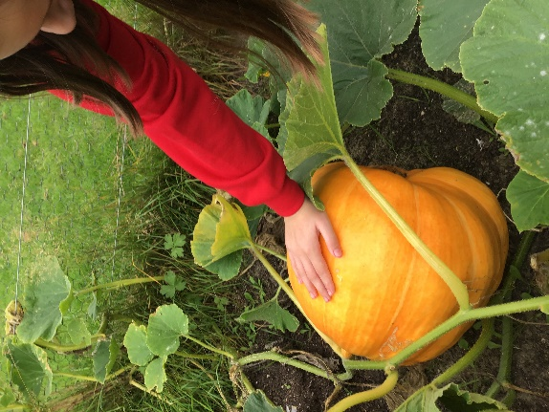 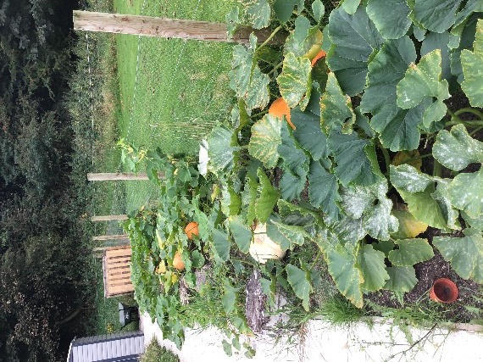

**AND AFTER ……………**

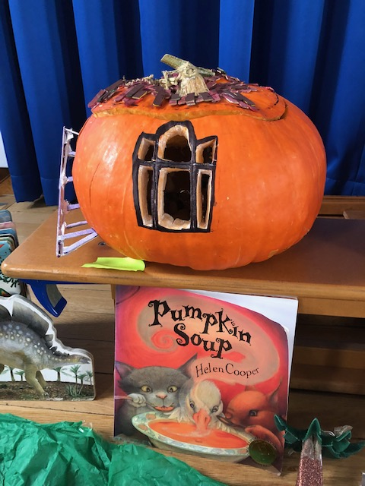 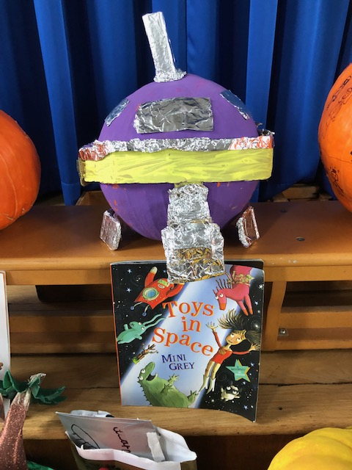 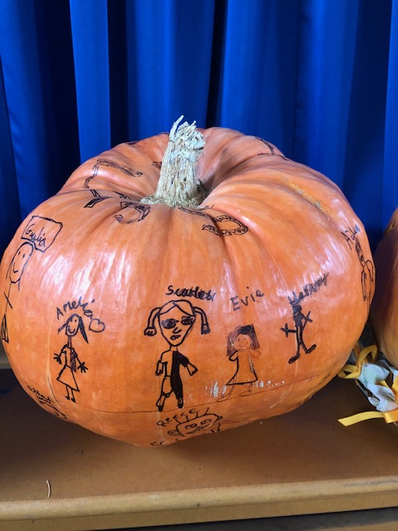 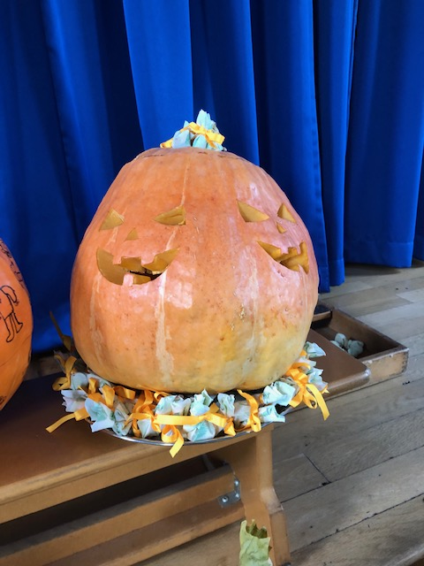

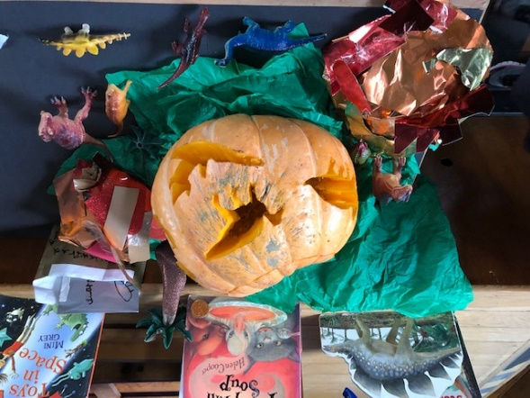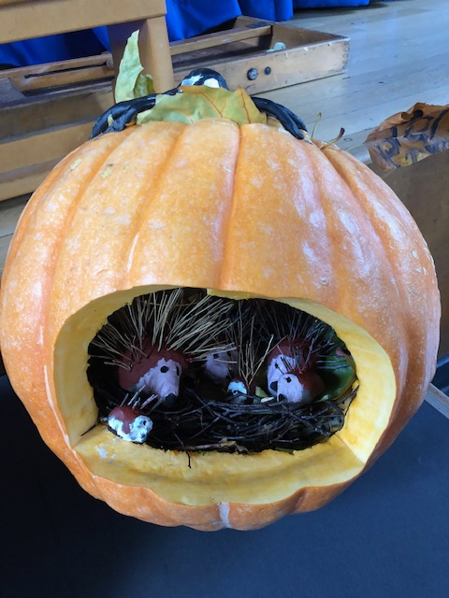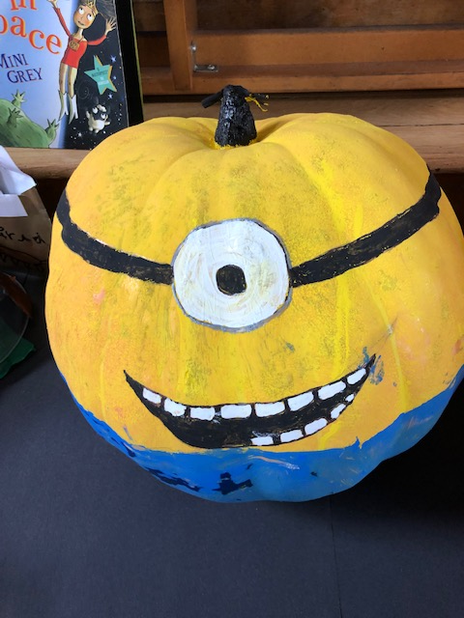

**THE FRIENDS OF MARLFIELDS (formerly the P.T.A.)**

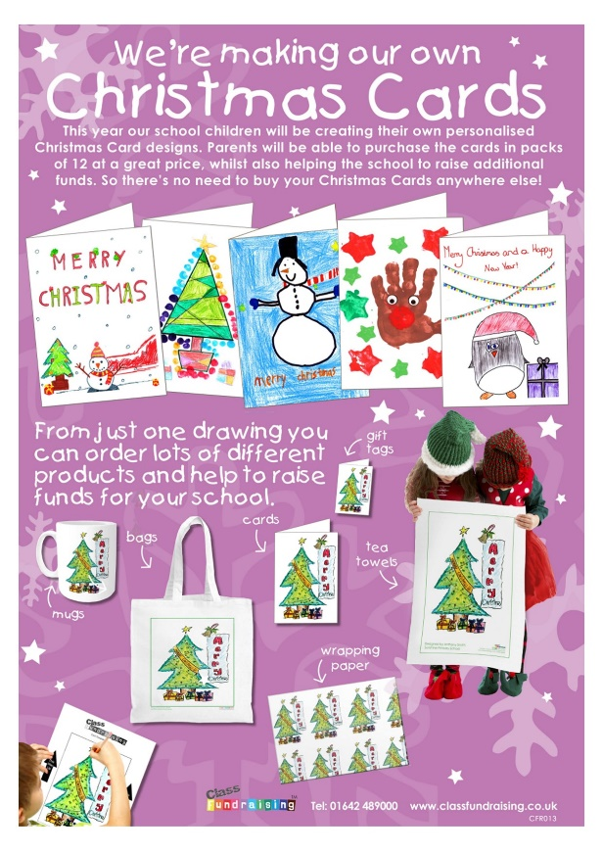

**The children have been very busy designing Christmas cards over the last couple of weeks.**

**The children's Christmas drawings, collages and paintings all look fantastic!**

**The designs have been sent off to be professionally printed and you will receive a sample card along with information about how to order your cards, mugs, bags and tea towels very soon!**





**CHRISTMAS RAFFLE**

**The Friends of Marlfields Team are collecting high quality raffle prizes in advance of their planned Christmas raffle to raise money for our school.**

**Perhaps you own or work for a business who could donate a prize**

**or a voucher?**

**We would love to receive anything from Christmas treat food donations**

**to contribute to hampers, high quality beauty products to make up beauty hampers,**

**beauty or nail vouchers, gift vouchers or any other high quality raffle prizes.**

**If you would be interested in making a donation, no matter how big or small, please**

**speak to Helen Horton or Rachel Brewer who will be collecting prizes.**

**You can also email Helen at** [**helen@hortonmade.co.uk**](mailto:helen@hortonmade.co.uk)**.**

**To reduce the spread of the coronavirus in school, please pass prizes directly to**

**Helen or Rachel for appropriate cleaning and/or quarantining (please do not take**

**prizes to the office).**

**Details of the raffle including the prizes available and how to purchase tickets**

**will follow soon.**