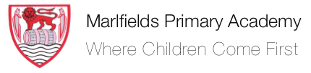
Our Foundation Stage Curriculum Goals
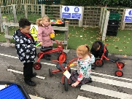  Communication & Language and  Role Play  To become a ‘Curious Chatterbox’ in everyday play and focussed sessions, show the ability to follow instructions, concentrate, think through and extend ideas. To ask relevant questions and make comments, chat back and forth with friends and adults and express ideas and feelings with confidence. | 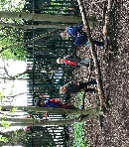  Personal, Social, Emotional Development  To become a ‘Kind and Confident Cookie' who happily greets and interacts with others, sharing thoughts and resources patiently; valuing self and others and willing to persist and not be daunted by failure. To show empathy to others, determination to complete a goal, resilience in the face of challenges and shows curiosity about the world around them. | 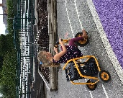  Physical Development  Gross Motor Skills  To become a confident ‘Risk Taker’ and develop body strength when climbing up, across and down various parts of the climbing frame, whizzing around the track on the bikes and digging and building various items to construct.  To use strength, balance and co-ordination to run, jump, hop, skip, climb and dance confidently and safely. | 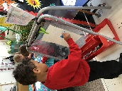  Physical Development  Fine Motor Skills  To become a ‘Funky Finger’ enthusiast who builds up hand and whole-body strength through adventurous play and enjoy mark making readily and confidently with a good grip. To hold a pencil effectively and use cutlery with confidence.
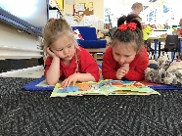  Reading  To become a ‘Book Worm’ enthusiast and readily access them for pleasure, turning pages individually, describing characters, scenes and outcomes in illustrations and recognising some symbols and letters of personal interest in their environment including digital material. To read books containing words they can decode (that are made up of single sounds {g, c} and digraphs {ee, igh}) and they can chat about what they have read. | Writing  To become a ‘Sentence Superstar’ who is able to write sentences (with words containing single sounds and digraphs) and who can write a simple story for a friend to read. | 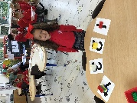  Maths  To be able to use the ‘Collected Treasure’ of embedded mathematical knowledge and language naturally in everyday play. Subitising, counting and representing marks, matching, measuring and comparing all sorts. To have a deep understanding of numbers to 10, who can recognise the pattern of the counting system, and who can recall number bonds to 5. | 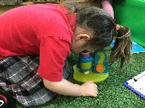  Understanding The World  To become an ‘Intrepid Explorer’ who investigates challenges with an inquiring mind and uses a breadth of vocabulary and investigative tools to observe, remember, explain and predict. Understands how to read a simple map, knows their own family tree, shows care to living creatures and understands some differences between our country and other countries.
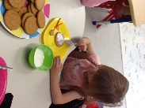  Understanding The World  To become a ‘Cracking Cook’ who can bake biscuits and make healthy fruit snacks, who can notice and describe changing states of matter. | 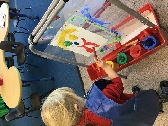  Expressive Arts & Design - Art  To become a ‘Creativity Expresser’ who develops ideas using embedded skills, techniques and knowledge of experiences and artists to represent and complete their dreams using a variety of tools and techniques. | 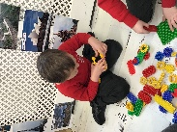  EAD - Construction  To become a ‘Crafty Constructor’ who builds a model that has multilayers of purposefully positioned pieces and spaces between. | 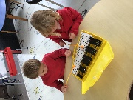  EAD - Music & Dance  To become a ‘Passionate Performer’ who can perform a story, a song, a poem or a rhyme to an audience. To distinguish between instruments, attempt to play them loudly, softly, fast and slowly whilst developing an ear for rhythm.

