|  |
| --- |
| Marlfields Primary Academy  NEWSLETTER  25th June 2021 |

**CONGLETON TOWN SPORTS**

**A message from the Congleton education Community Partnership**

Congleton Town Sports was due to take place on Wednesday 7th July 2021. After long discussions, it is with regret that the CeCP Directors have made the decision to cancel Congleton Town Sports this year. This is unfortunate in this Olympic year. Our Partnership continues to fully support competitive athletics and we hope to come back stronger than ever in 2022.

We feel with COVID delta variant spiking in Congleton, we can’t justify the risk of bring together hundreds of children from 14 schools across Town. Every school has worked hard to minimise infections over the summer term and we wouldn’t want to jeopardise increasing infections across our communities so close to the end of term.

Stay safe; let’s keep our Town safe; keep being kind toward one another.

**COVID-19**



Cases of Covid-19 are on the increase in Cheshire East and we are now an **“Enhanced Area”**.

Please adhere to the current rules of social distancing and wearing masks.

Hopefully if we all take action we can prevent the spread of the coronavirus any further.

**MARLFIELDS MEMORY BEAR**

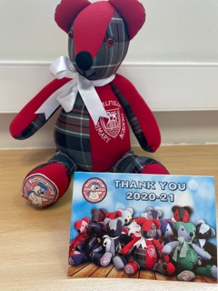Yesterday we received the Marlfields Memory Bear from Congleton’s Town Mayor, Cllr. Dennis Murphy. Inside the bear’s tummy are pieces of ribbon bearing the names of everyone in the school.

The accompanying Thank You card says:

*“To all the staff and pupils at Marlfields Primary,*

*On behalf of the Congleton Community we would like to offer a sincere thank you to all the pupils and staff connected with the school for the great way that you have pulled together and carried on learning during the COVID-19 pandemic.”*

We think that this is a wonderful way of celebrating the total resilience of the staff and our fantastic children. He is going to be a very much loved bear. He has already had lots of cuddles from many of us. He is simply adorable.

**THE CHRISTIE BEAR SPELLING CHALLENGE**

**Final Reminder:**

Please send in your completed sponsor forms and any monies raised as soon as possible so that they can be forwarded on. There is also the facility to pay on SCOPAY, Trips & Events - The Christie. Don’t forget, if you are a tax payer you can claim Gift Aid, which means the charity get more funds from the government. All donations will be gratefully received, large or small.

**SPORTS DAY**

Please see below a few pictures to show what went on at our Sports Day on Wednesday. This year each of the pods had time on the field to show their sporting prowess. As a reward for all their efforts the children were treated to an ice cream from the Ice Cream Van, which was enjoyed by all.

These are a small snapshot of the events. To view more have a look on individual class blogs on the school web-site.

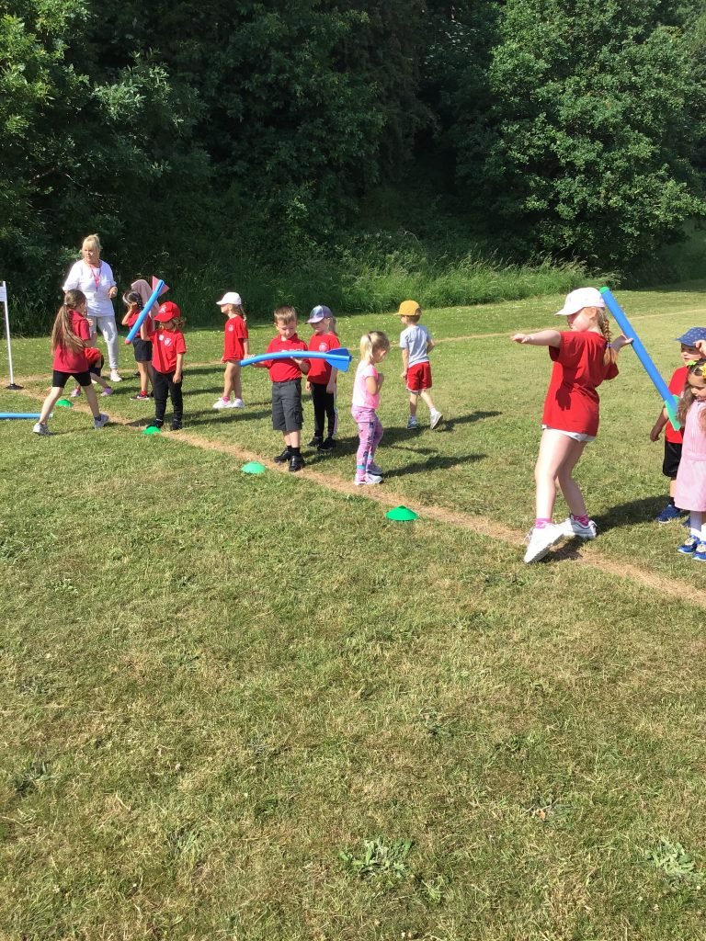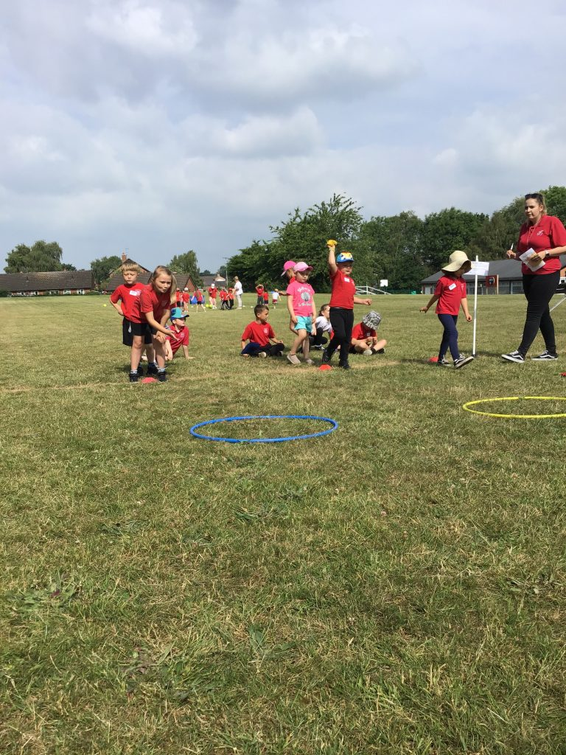

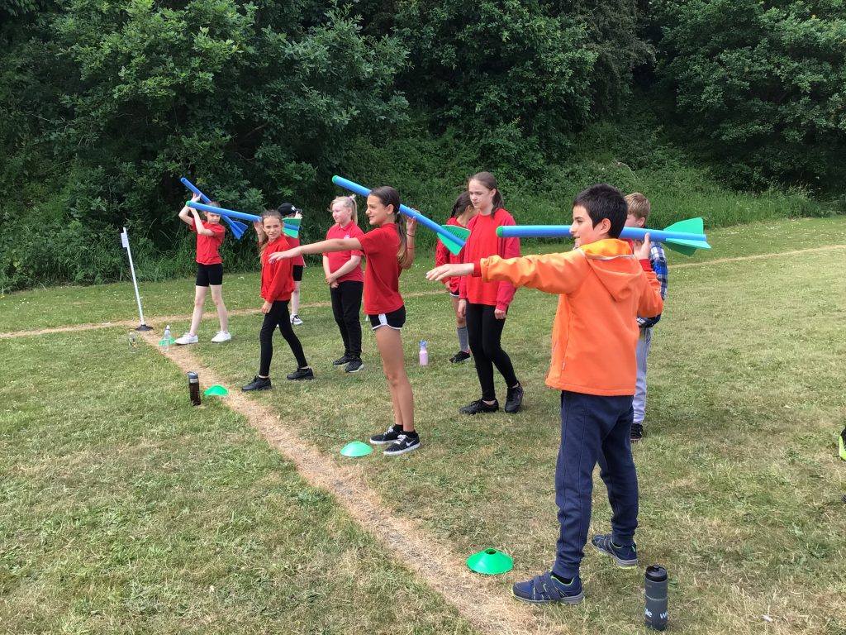

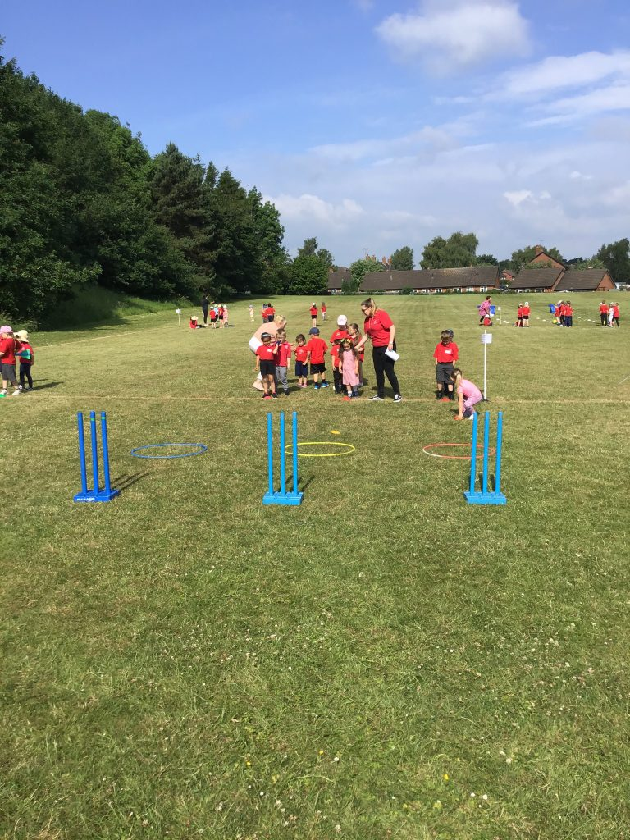

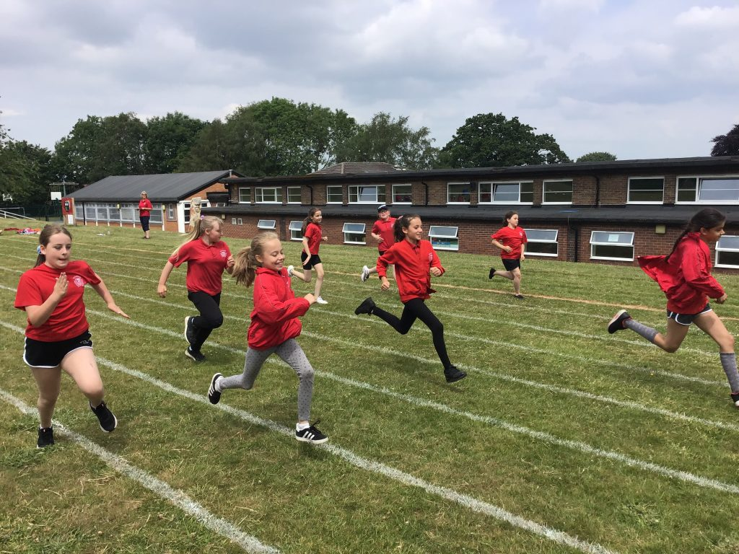



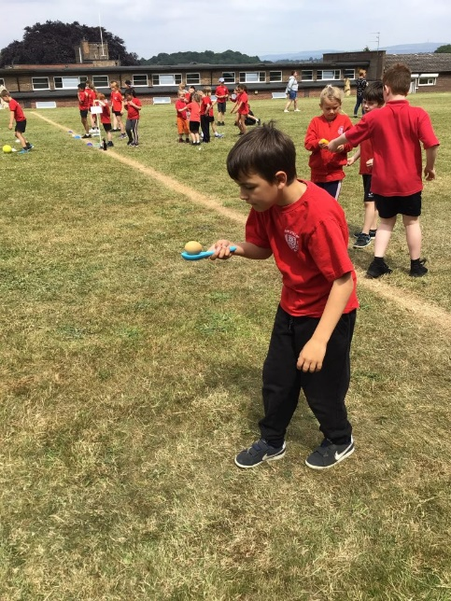

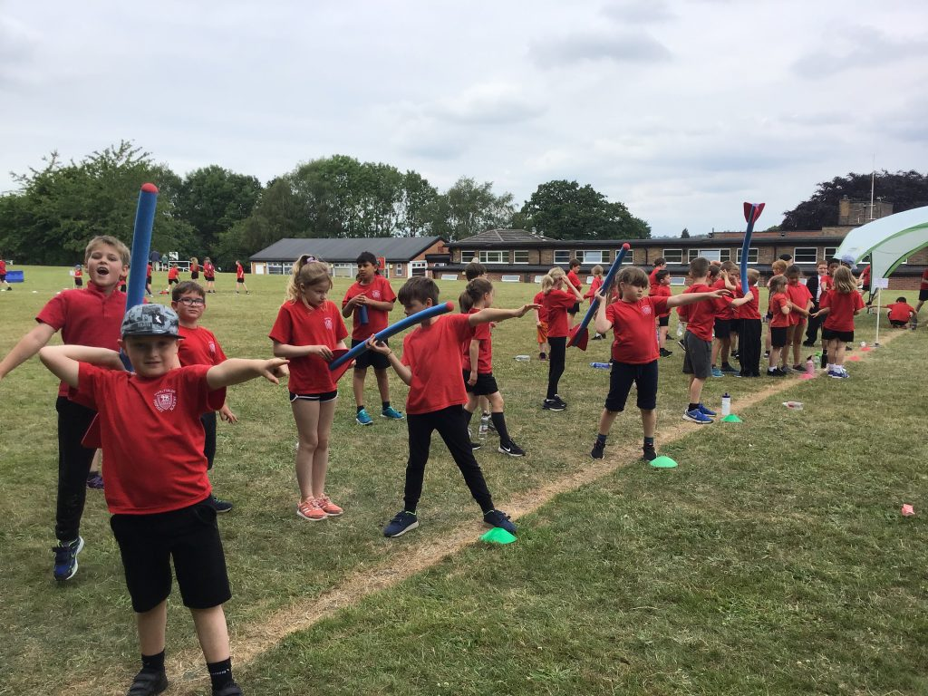

Don’t forget to check out the blog there are lots of different pictures to look at.

Have a great weekend!