Marlfields Primary Academy
NEWSLETTER
2nd July 2021

PARKING

May we please remind all parents to be considerate when parking on Waggs Road, Crescent Road and The Westlands. We often receive calls from irate neighbours because a parent has either parked across their driveway or has parked inconsiderately. If you find it difficult to park near to school, please consider parking on West Street Car Park which only costs 60p for up to 2 hours and walk up to school.
We are due a visit from the local PCSO who will challenge anyone parking illegally, and especially on the zig-zag lines on Waggs Road. Thank you in anticipation of your co-operation.
SUMMER READING CHALLENGE
begins Saturday 10th July

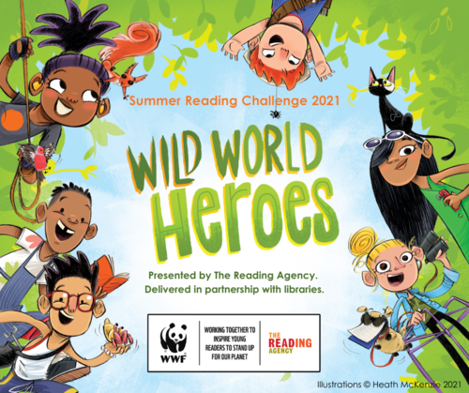
The Summer Reading Challenge at Congleton Library encourages children aged 4 to 11 to set themselves a reading challenge to help prevent the summer reading ‘dip’.
Each year the Challenge motivates over 700,000 children to keep reading to build their skills and conﬁdence.
By encouraging the children to take part you can:
- Celebrate the joy of reading whilst ensuring that they are able to read well by the age of 11
- Continue to support their learning during the holidays
- Help to prevent the trend for children’s reading skills to dip over the holidays
Each year the Summer Reading Challenge has a different theme. For 2021, the Reading Challenge is Wild World Heroes, a nature-themed Challenge that will inspire the children to engage with environmental issues.
If your child reads a minimum of 6 books over the summer holidays they will receive a certificate and medal and maybe a reward from school too on production of their medal and their certificate…….

