|  |
| --- |
| **Marlfields Primary Academy**  **NEWSLETTER**  **10th July 2021** |



**IS IT COMING HOME?**

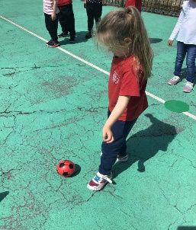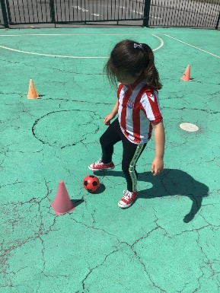Well done to the England team for getting through to the Euro 2020 Final on Sunday. We had a few rather tired children (and staff) in school yesterday! For a bit of fun, the children were allowed to come to school on Wednesday dressed in red, white and blue.

Here are a couple of Year 1 children honing their football skills.Who knows, they may be stars of the future!

If you are going to allow your child to watch the final on Sunday try to encourage them to have a nap on Sunday afternoon as kick-off isn’t until 8:00pm, then hopefully they won’t be too jaded in school on Monday. “**COME ON ENGLAND, BRING IT HOME!”**

**ANNUAL REPORTS**

Your child(ren)’s Annual Reports were emailed out to everyone yesterday (Thursday 8th July). If you did not receive yours, please check your spam/junk box and if it doesn’t appear there let us know and we will resend it to you. Fingers crossed that you have received it and are pleased with the progress made during the past, very strange pandemic year. We would appreciate any comments from you, either negative or positive. Share your concerns; if we aren’t told of a problem, we can’t try to sort it out.

**PARKING**

May we please remind all parents to be considerate when parking on Waggs Road, Crescent Road, The Crescent and The Westlands. You may have noticed over the past few days that the local PCSO and Traffic Enforcement Officers have been around the area handing out tickets to offenders.

We often receive calls from irate neighbours because a parent has either parked across their driveway or has parked inconsiderately. If you find it difficult to park near to school, please consider parking on West Street Car Park which only costs 60p for up to 2 hours and walk up to school.

We are due more visits from the local PCSO and TEO who will challenge anyone parking illegally, and especially on the zig-zag lines on Waggs Road. Thank you in anticipation of your co-operation.

**SUMMER READING CHALLENGE**

**begins Saturday 10th July**

Don’t forget to join The Summer Reading Challenge at Congleton Library. By encouraging the children to take part you can:

* Celebrate the joy of reading whilst ensuring that they are able to read well by the age of 11
* Continue to support their learning during the holidays
* Help to prevent the trend for children’s reading skills to dip over the holidays

For 2021, the Reading Challenge is **Wild World Heroes**, a nature-themed Challenge that will inspire the children to engage with environmental issues.

If your child reads a minimum of 6 books over the summer holidays they will receive a certificate and medal and there may be a reward from school too on production of their medal and their certificate…….

**CELEBRATION TIME**

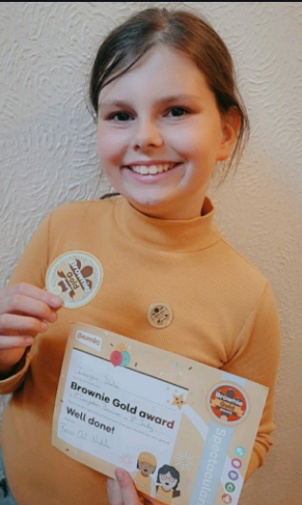We would like to congratulate Imogen who is in Year 5.

She has recently left Brownies ready to begin her journey with the Girl Guides. She completed her Brownie adventures by achieving one of the highest Brownie Awards possible.

The Brownie Gold Award is a special achievement and gives each participant the opportunity to put everything they’ve learned through the Brownie programme into practice and do something for their peers before moving up to Guides.

To earn the Brownie Gold Award participants, need to earn all six Theme Awards and then do the final challenge. The final challenge includes making the Brownie Promise, organising a unit activity or meeting and visiting a local Guide unit to learn more about becoming a Guide.

The six Theme Awards are:

*Know Myself, Express Myself, Be Well, Have Adventures, Take Action and Skills for My Future.* **Well done Imogen! We are all so proud of you.**

**Has your child done something that they would like to share with everyone**? If they have, and would like us to celebrate with them in the Newsletter, please send in a picture and a description of what they have done via e-mail, ([admin@marlfields.cheshire.sch.uk](mailto:admin@marlfields.cheshire.sch.uk)) and we will include it with pleasure**.**

**EARTH CUBS**

Earth Cubs is for children aged 3 – 7. It is a FREE app and learning resource. Sign up for free and engage, prepare and support your young child on their journey about sustainability and the environment. www.earthcubs.com

**EXTRA-CURRICULAR CLUBS**

**Cooking Club:** Due to staffing issues the Cooking Club will not take place until after the Summer Holiday.

**All other Clubs:** All of the other clubs will still be on next week, but they too will cease after next week.

In the Autumn Term we will send out a new Club List for your child to choose which club they would like to join. You will need to re-apply for places at all of the clubs in September.

**HOLIDAY CLUBS**

The Love Music Trust has been awarded a grant from the Cheshire East Holiday Activity Fund to run a 'Music, Food and Nutrition Club' this summer.

Based at Marlfields Primary Academy Congleton, and open to Cheshire East Primary Children in receipt of means-tested Free School Meals, the FREE Holiday Club will start on Monday 26th July and run for 4 weeks, and students can sign up to as many of these weeks as they would like to. Each week, the Holiday Club will run for four days, (Monday to Thursday) from 9am - 1pm.

Every day a free buffet breakfast will be available for all, before participants will engage in music sessions led by Love Music Trust tutors.

Across the four weeks, fun sessions including Samba Drumming, Singing, Beginner Brass and Folk Music will be provided, with all instruments provided free of charge (and no prior experience is necessary!)

A daily session focusing on Food Preparation (participants will be shown how to make your own lunch!) and Nutrition, will be led by the catering team at Marlfields Primary Academy, covering everything from Continental Food, Healthy Picnics, Beans, and Cooking Indoors and Out!

The club will run from 9am-1pm on the following days:

*Monday 26th July - Thursday 29th July* *Monday 2nd August - Thursday 5th August*

*Monday 9th August - Thursday 12th August* *Monday 16th - Thursday 19th August*

*If you are in receipt of means-tested FSM and would like to access this opportunity, more information and a link to sign up to the free holiday club can be found below.* [*https://www.lovemusictrust.com/holiday-club/*](https://www.lovemusictrust.com/holiday-club/)

Children will should wear clothing suitable for physical activity and the weather conditions and bring a drink - lunch will be provided. All of the Bee Active coaches are DBS checked, insured and first aid trained. We value the importance of your child’s health, our services will help to encourage your family to lead active and healthy lives.

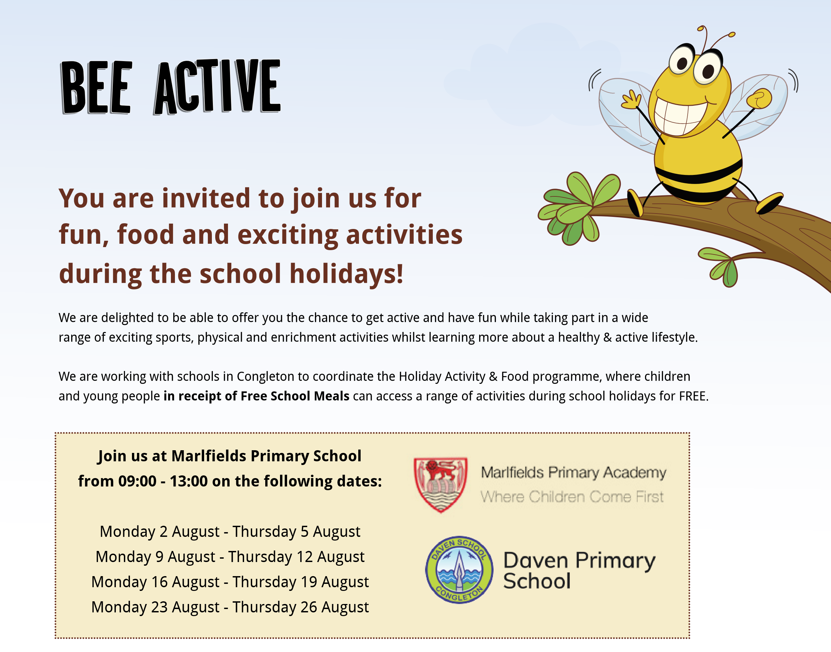**All sessions are completely free to all participants - If you would like your child to participate in any of the sessions, you can book a place by heading to www.beeactive.co.uk/haf or call us in the office on 01782 205915**



Bee Active is a trading name of Learn And Move Ltd.

Registered in England & Wales. No. 08406453 VAT No. 193950572

**Visit:**

www.beeactive.co.uk

**Tel:**

01782 205 915

**Email:**

info@beeactive.co.uk

**The Hive:**

Trent House, Dunning Street, Tunstall, ST6 5AP



**Search:**

‘Bee Active’

**Read our reviews**

See what others say about Bee Active.

Places are strictly limited - please book early to avoid disappointment.

**View all sessions &**

**secure your child’s place**

**in under 2 minutes!**

Kind Regards, **The Bee Active team.**

**All sessions are completely free to all participants - If you would like your child to participate in any of the sessions, you can book a place by heading to www.beeactive.co.uk/eaton-bank or call us in the office on 01782 205915**

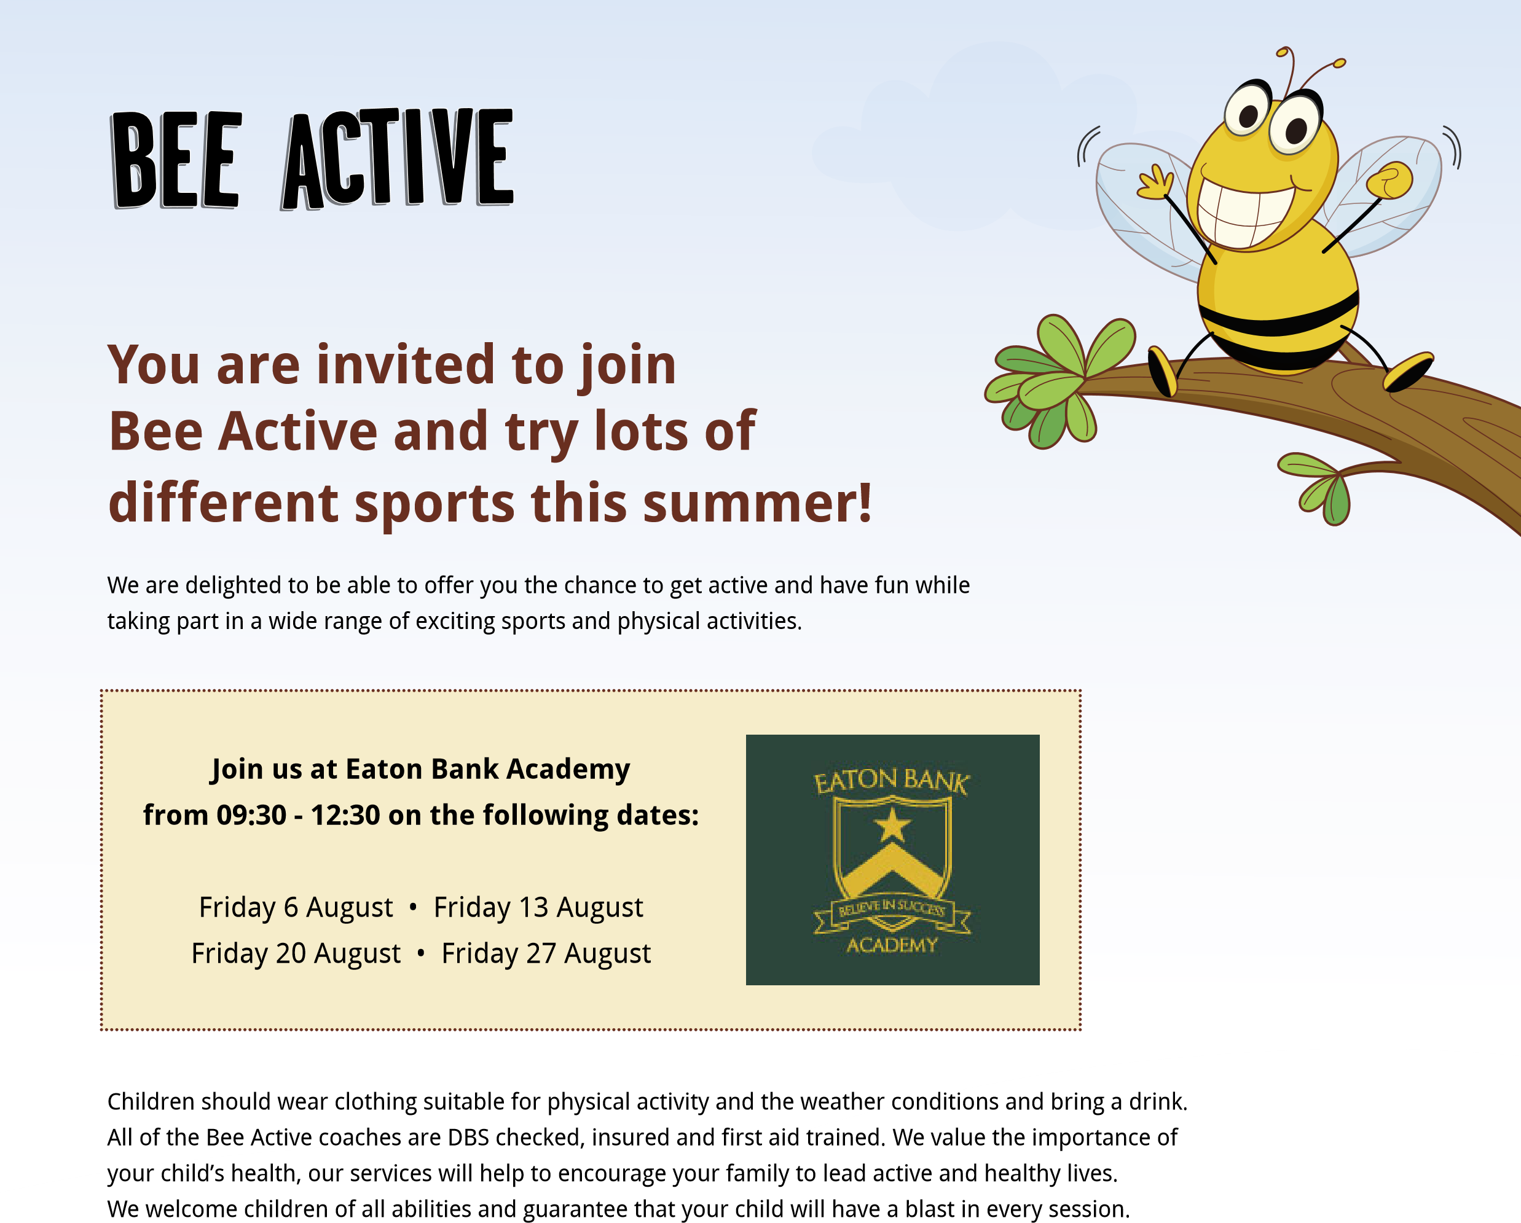Places are strictly limited - please book early to avoid disappointment.



Bee Active is a trading name of Learn And Move Ltd.

Registered in England & Wales. No. 08406453 VAT No. 193950572

**Visit:**

www.be

e

active.co.uk

**Tel:**

01782 205 915

**Email:**

info@beeactive.co.uk

**The Hive:**

Trent House, Dunning Street, Tunstall, ST6 5AP



**Search:**

‘Bee Active’

**Read our reviews**

See what others say about Bee Active.

View all sessions &

secure your child’s place

in under 2 minutes!

Kind Regards,

**The Bee Active team.**