Marlfields Primary Academy
NEWSLETTER
18th June 2021

COVID-19
Cases of Covid-19 are on the increase in Cheshire East and we are now an “Enhanced Area”.
Please adhere to the current rules of social distancing and wearing masks.
Hopefully if we all take action we can prevent the spread of the coronavirus any further.

The main symptoms of coronavirus (COVID-19) are a high temperature, a new, continuous cough and a loss or change to your sense of smell or taste.
- a high temperature – this means you feel hot to touch on your chest or back (you do not need to measure your temperature)
- a new, continuous cough – this means coughing a lot for more than an hour, or 3 or more coughing episodes in 24 hours (if you usually have a cough, it may be worse than usual)
- a loss or change to your sense of smell or taste – this means you've noticed you cannot smell or taste anything, or things smell or taste different to normal
If you have any of these symptoms, get a PCR test (test that is sent to a lab) to check if you have coronavirus and stay at home until you get your result.
About 1 in 3 people with coronavirus do not have symptoms but can still infect others. This is why everyone is advised to get tested regularly.

The most common symptoms of COVID-19 in children are fever and cough, but children may have any of these signs or symptoms of COVID-19:
- Fever or chills
- Cough
- Nasal congestion or runny nose
- New loss of taste or smell
- Sore throat
- Shortness of breath or difficulty breathing
- Diarrhoea
- Nausea or vomiting
- Stomach ache
- Tiredness
- Headache
- Muscle or body aches
- Poor appetite or poor feeding, especially in babies under 1year old
HOT, SUNNY DAYS

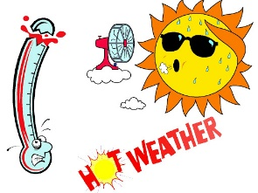
Don’t forget to apply long acting sunblock to your child each morning, and where possible (especially for Foundation Stage and Key stage 1 children) please send in a named sun hat which can be kept in school for the rest of this term.
We will obviously limit the time that children are out on the playground on the hottest of days and we will also ensure that they keep hydrated.
Equally if the weather looks like it may be a bit cooler on any particular day or even raining, please send in a light coat for your child to wear at break time.

VIKING THE HEDGEHOG
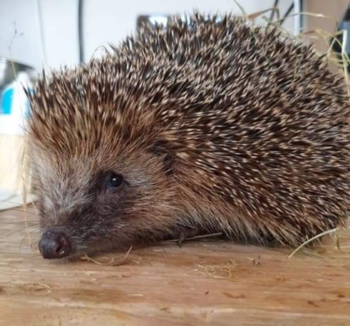

Viking when he was found, looking rather sad Viking now after lots of tender loving care

You may recall we told you a few weeks ago about Viking the hedgehog who was found out near to the pond during the day which usually means that they are not well. He was taken to the Baddiley Green Hedgehog Rescue Centre to be looked after.
They named him Viking after the football team who use our facilities and who found him.
The Centre confirmed that he was not a well hedgehog and was in distress and underweight. They kept in an incubator for a couple of weeks of TLC, then let him out but unfortunately he had to return to it a week later to recuperate further.
He is now almost 100% fit, so much so that in just a week he has gained 120g! It is hope that he will soon be allowed to return to the wild.
We are sure that you will agree that the Rescue Centre have done an excellent job nursing him back to health, and we can’t wait to welcome him back.

THE CHRISTIE BEAR SPELLING CHALLENGE
Thank you so much to those who took the time over the half term holiday to gather sponsorship for the spelling challenge in aid of The Christie Hospital. The spelling challenge took place yesterday with great success. Please send in your completed sponsor forms and any monies raised as soon as possible so that they can be forwarded on. There is also the facility to pay on SCOPAY, Trips & Events - The Christie. Don’t forget, if you are a tax payer you can claim Gift Aid, which means the charity get more funds from the government. All donations will be gratefully received, large or small.

SPORTS DAY
Our school Sports Day will be held next Wednesday for each pod at differing times. We are sure that you will appreciate that with all the Covid restriction in place we are unfortunately unable to allow parents to come and watch the races. To compensate we will put pictures and reports onto the school blog and also in next weeks’ Newsletter. All children need to come to school in their P.E. kit.

SCHOOL HOLIDAYS
Summer 2021 | 08.06.2021 | 21.07.2021
NEXT Academic Year 2021 – 2022
School Opens School Closes
Autumn 1 | 01.09.2021 | 22.10.2021
Half Term
Autumn 2 | 02.11.2021 | 17.12.2021
Christmas Holidays
Spring 1 | 04.01.2022 | 17.02.2022
Half Term
Spring 2 | 28.02.2022 | 31.03.2022
Easter Holidays
Summer 1 | 19.04.2022 | 26.05.2022
Half Term
Summer 2 | 07.06.2022 | 22.07.2022
INSET DAYS
01.11.21, 18.02.22, 01.04.22, 27.05.22 & 06.06.22
Including the end of this academic year (in red), and the next academic year from September 2021 to July 2022.

