Marlfields Primary Academy
NEWSLETTER
11th June 2021

HOT, SUNNY DAYS
Now that summer seems to have finally arrived may we take this opportunity to ask that you apply long acting sunblock to your child each morning, and where possible (especially Foundation Stage and Key stage 1 children) a named sun hat which can be kept in school for the rest of this term.
We will obviously limit the time that children are out on the playground on the hottest days and also ensure that they keep hydrated.
Is it only 3 weeks ago we were asking you to send coats in? Only in this country!

THE CHRISTIE BEAR SPELLING CHALLENGE
Thank you so much to those who took the time over the half term holiday to gather sponsorship for the spelling challenge in aid of The Christie Hospital. The spelling challenge took place yesterday with great success. Please send in your completed sponsor forms and money raised as soon as possible so that they can be forwarded on. Don’t forget, if you are a tax payer you can claim Gift Aid, which means the charity get more funds from the government.

A free online maths summer club for your Year 5/6 child
Eedi has offered all Year 5 to Year 9 families free access to Eedi Summer Club, an online maths summer program 100% free of charge that will help to boost your child's confidence in maths so it’s sky high for the new school year. Your child will first do a quick placement quiz to set their work and then get recommended topics that'll help them improve the most over 7 weeks.

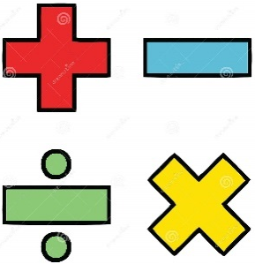
Your child will get unlimited access to review questions, videos and live chat support with real teachers over the holidays. You'll also get weekly reports on how they're doing.
The minimum recommended work is 1 lesson a week, which should be for around 30 minutes of work.
Each week, Eedi will hold competitions to boost motivation and engagement - from who’s given the most thoughtful explanation to a problem to what team has the highest amount of points 🚀...............

Plus there are real prizes up for grabs!
Signup deadline: June 14th (Get Eedi Summer Club for free until this date)
Summer Club Starts: July 5th
Summer Club Ends: August 23rd
If you want to get started using Eedi before the summer club starts, you are more than welcome to! Eedi normally offers just a 14 day free trial, but now you can use it throughout summer for free.

To get the offer, sign up on https://eedi.com/summer-club?via=teacher-invite,
create a parent account, and get the offer automatically applied.
COVID-19
Even though things are moving forward, and life is becoming a little bit more like normal we must all remember to remain Covid vigilant by still wearing masks at the school gates and maintaining social distancing and sanitising etc. Thank you for your compliance.

