Marlfields Primary Academy

NEWSLETTER

7th May 2021

**The Rainbow Tree**

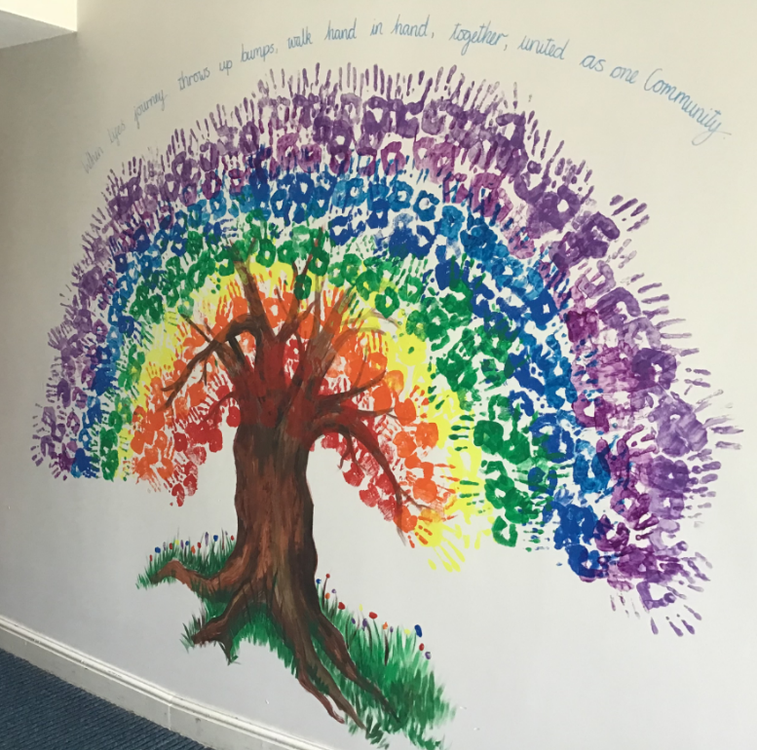

We felt that we had to share with you this fantastic display created by staff and their children which is of a Rainbow Tree to mark everything that we have been through with the covid situation.

The quote above it says it all really:

“***When your journey throws up bumps, walk hand in hand, together, united as one community”***

Thank you for the beautiful artwork and your continuing support.

**Inclement Weather**

As you are all well aware, the weather has recently been awful. Please send your child in with a coat each day for when they go out at playtime and lunchtime.

Please also be aware that, as most of our clubs are held outside, they may be subject to a last minute cancellation due to the weather, and you will be asked to collect your child at the usual home time.

**Uniform**

As we mentioned in last week’s Newsletter we have taken the decision to leave our current uniform suppliers due to the poor service received.

**DP Sportswear, Bromley Road, Congleton, CW12 1PT** are now the providers for all of your uniform needs; school no longer has any stock.

If you need any item of uniform, just call into them in person or telephone them on **01260 274400** to check stock availability. We hope that you find this change of arrangements better and more convenient for yourselves.

**Before & After School Clubs**

Since we took over the running of the Before and After School Clubs from our previous providers we are pleased to say that it has become quite successful.

We currently provide a before and after school provision for the children term time only from **8:00am- 9:00am** in the morning and **after school up to 6:00pm** if needed.

Attendance at either of the clubs is dependent on all of the relevant forms being received in school prior to the sessions that you may wish for your child.

If you would like to register your child and book any sessions, please call or email the school office for the necessary forms.



Email: [admin@marlfields.cheshire.sch.uk](mailto:admin@marlfields.cheshire.sch.uk) or

Call: 01260 633120.

**FOOD**

**School Lunches**

Please ensure that you order your child’s school lunch before **8:55am** or if you have missed this deadline contact the office who can order up to **9:45am**.

If a lunch has not been ordered for your child, we cannot guarantee that they get the hot lunch that they would prefer to have.

**Pancake Mix**

We are sending home to each family a pancake mix so you can all have a little treat of a pancake at tea time – enjoy!

**Boxes of Cereal**

Some children will be bringing home a box of cereal which we are offering out and the children have said that they would like to have some to bring home.