**MINI FUND-RAISER**

Marlfields Primary Academy

NEWSLETTER

21st May 2021

Please, please, please support **Scarlett** from **Year 3 and** her **mum** who are **walking 50K** during the month of May **for the MS Society**. This is a charity that is very close to their hearts and they want to raise awareness and vital funds to fight this cruel, cruel disease.

We are very proud of Scarlett for helping to raise money for charity. We hope as many of you as possible can find it in your hearts to support them both. It will mean so much to them and would spur them on to complete 50k.

Mrs Evans writes: ***“It would mean the world to us if you could sponsor our effort. Thank you so much in anticipation. Let’s kiss goodbye to MS”***

Details on how to sponsor them both and to find out more can be found on:

[**https://www.themay50k.com/fundraisers/debevans**](https://www.themay50k.com/fundraisers/debevans)

|  |
| --- |
|  |

**LUCKY CHARM/MASCOT NEEDED**

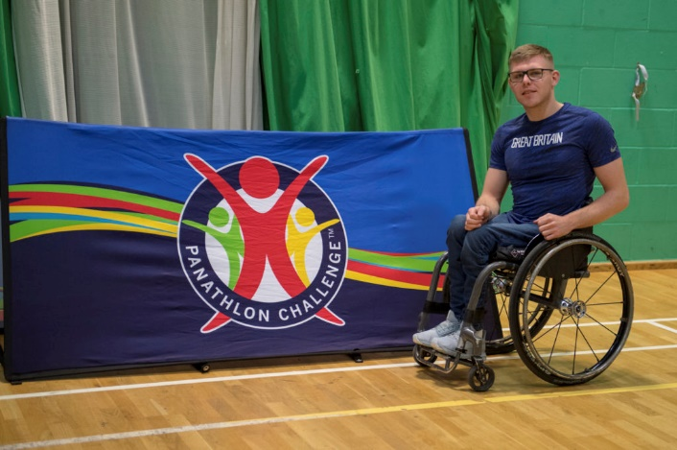**Nathan Maguire, from Chester, is a Panathlon Ambassador (enabling disabled children to take part in sporting activities) and is also a TeamGB Wheelchair athlete. He is racing later this year in Tokyo at the Paralympics.** **He needs your support and would like a lucky charm or a mascot logo to carry with him on the track. We know how artistic most of our children are, why not put pen to paper and design a lucky charm/mascot for Nathan. If he chooses your design he can show it off at the Olympic Village.** **Please see Nathan's message**at this link: [**https://youtu.be/GCv2RLaAJ8g**](https://youtu.be/GCv2RLaAJ8g)

**COATS**

Sorry to keep harping on about this, but please send your child in with a coat each day. Currently the weather is very unpredictable, and at the time of typing this Newsletter it is blustery and quite cold at 9° and some children have been unable to go outside at break time as they haven’t got a coat with them. We are sure that you would agree with us that all children need to get outside in the fresh air after spending the morning studying.



3 types of weather in less than half an hour!

**COVID-19**

Even though things are moving forward, and life is becoming a little bit more like normal we must all remember to remain Covid vigilant by still wearing masks at the school gates and maintaining social distancing and sanitising etc.

**APOLOGIES**

We wish to apologise to you all that some days we have been late opening the gates. It’s no excuse, but we have had a number of staffing issues through illness, accidents and babies! Hopefully all these issues are now resolved and we can carry on as normal. Thank you for your patience.

We must also apologise for

a) late cancellation of clubs due to staffing issues, and

b) cancelling clubs completely due to lack of interest, which must disappoint the few children

who wanted to take part.

Hopefully we can offer these clubs again next term and have a better take up of places.

**STAFF NEWS**

We have some staff news which we would like to share with you all; some good news and some sad news.

First of all, our sad news:

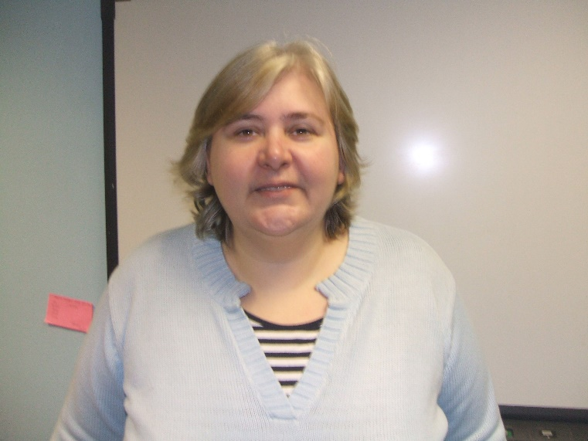Miss Carr, who has been teaching here at Marlfields since the beginning of September 2000 has decided to take early retirement at the end of this academic year. During her time here Miss Carr has taught in almost every year group, and is currently teaching Year 2. Not only has she taught in class she has also, since 2014, supported Mrs Isherwood firstly as Deputy Head and following our conversion to academy status as Vice Principal.

We will be organising a collection to buy her a super leaving present to thank her for all her hard work with us. If you would like to contribute to the collection, we will put a section under Trips and Event on SCOPAY to enable you to do so.

Now for our good news:

Mrs Daley is returning to Year 4 on 21st June following the birth of her beautiful baby boy.

We are sure she will miss both of her children when she comes back, but we are confident that with a class full of children she won’t have much time to!

Welcome back Mrs Daley, you have been missed.

**HEDGEHOG**

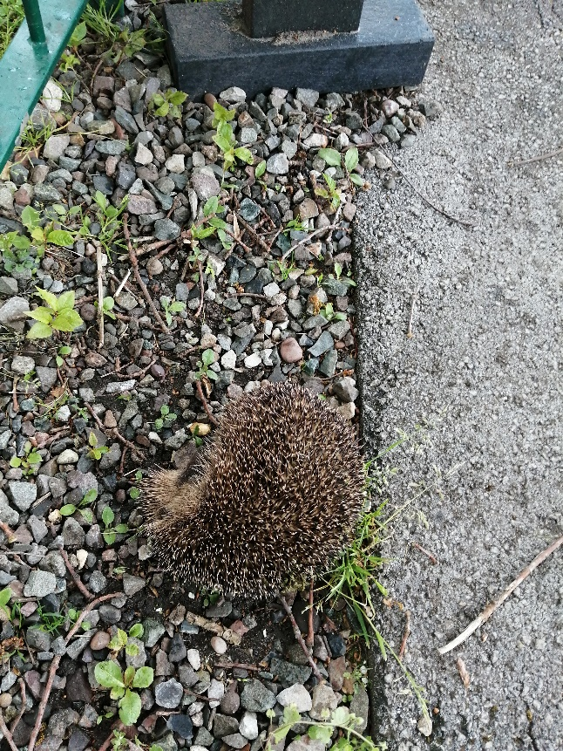While at football this week the children discovered a hedgehog out in the open near the pond. One of the Mum's present phoned the hedgehog rescue people who agreed that if it was out in the open in the daylight it would be in distress.

She has taken it to Baddiley Green Hedgehog Rescue Centre who have named it Viking after the name of the football team. They said that if it survives they will contact the school about bringing it back to rehome it. There is a small chance there could be some babies around but they think it is more likely that the hedgehog was born in the autumn and only had enough reserves to get through hibernation and has become disoriented and confused. We will update you as soon as we hear anything.

**HALF TERM**

Children are in school next week and the last day in school before the half term holiday will be Friday, 28th May. School will close at the usual time.