R
Marlfields Primary Academy
NEWSLETTER
14th May 2021

READING BOOKS

In our quest to ‘get back to normal’, from next week we will be sending your child home each day with their reading book to read with you at home, to then bring it back the next day to read in school where possible.

FEELING STRONG AND ENERGETIC?

We are hoping that we may get some help to move some soil and pebbles during the day from near to the Reception Class playground to our allotment on the field. We can’t pay, but we can make plenty of brews!
If you are able to help us out, please let us know either by phone (01260 633 120) or by email (admin@marlfields.cheshire.sch.uk). Many thanks in anticipation of your help.

CHRISTIE BEAR SPELLING CHALLENGE
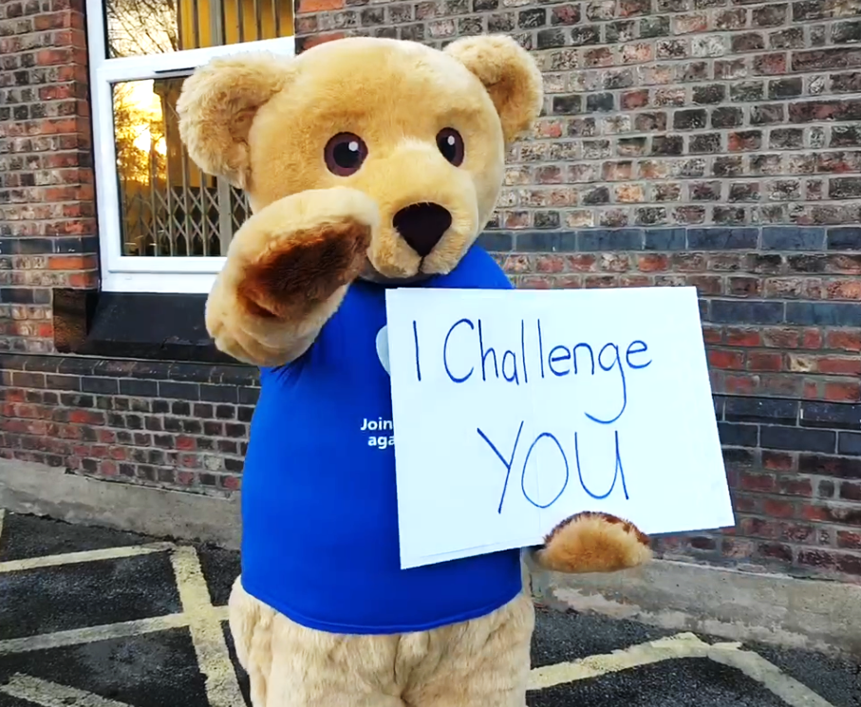
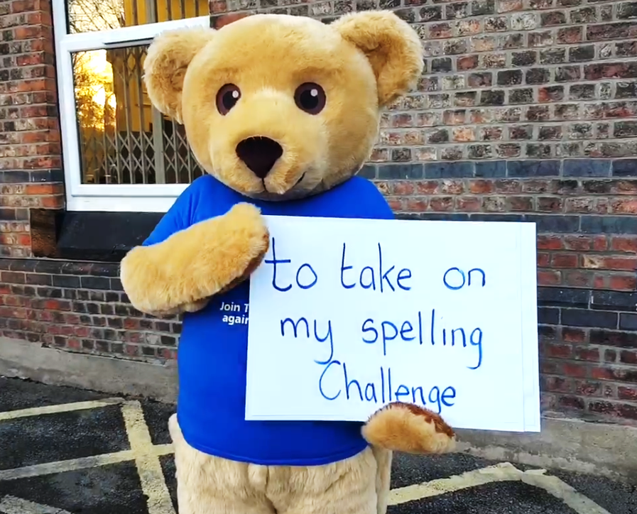
Hopefully you are all practicing your spellings for the forthcoming Christie Bear Spelling Challenge. We are aiming to hold the Spelling Challenge when we return after the half term holiday on Thursday 10th June, so there is still plenty of time to practice, especially over half term!
The Christie will shortly be sending out the fundraising pack, complete with sponsor forms so you can get as many sponsors as possible.

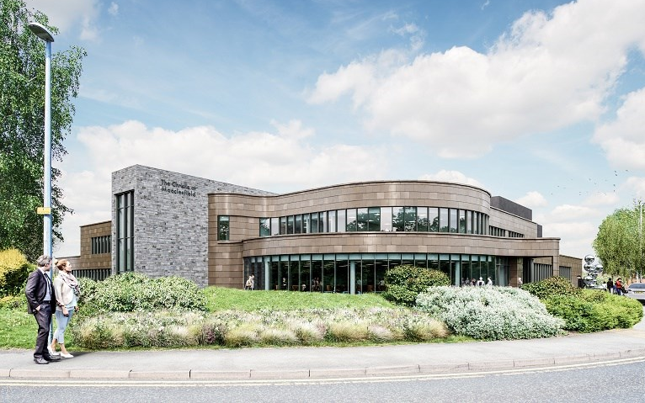
As you may be aware The Christie are in the process of building a new unit at Macclesfield. The Christie at Macclesfield will accommodate more than 40,000 patient visits a year. This will be for existing Christie patients from Cheshire, North Staffordshire and the High Peak area of Derbyshire therefore cutting out the need to travel to Manchester when needing treatment etc.

The charity has been working tirelessly during the current pandemic to raise £23m towards the £26m cost of the new centre; wouldn’t it give us all a nice feeling to know that we have helped towards this in some way?
Despite the ongoing uncertainty with the COVID-19 pandemic, works continue to progress well. The aim is to have the new centre open by the end of the year. The picture above is an artist’s impression of what the unit will look like on completion.
__________________________________________________________________________________________

If you have any problems or issues that you wish to discuss with us, please do not hesitate to get in touch.

