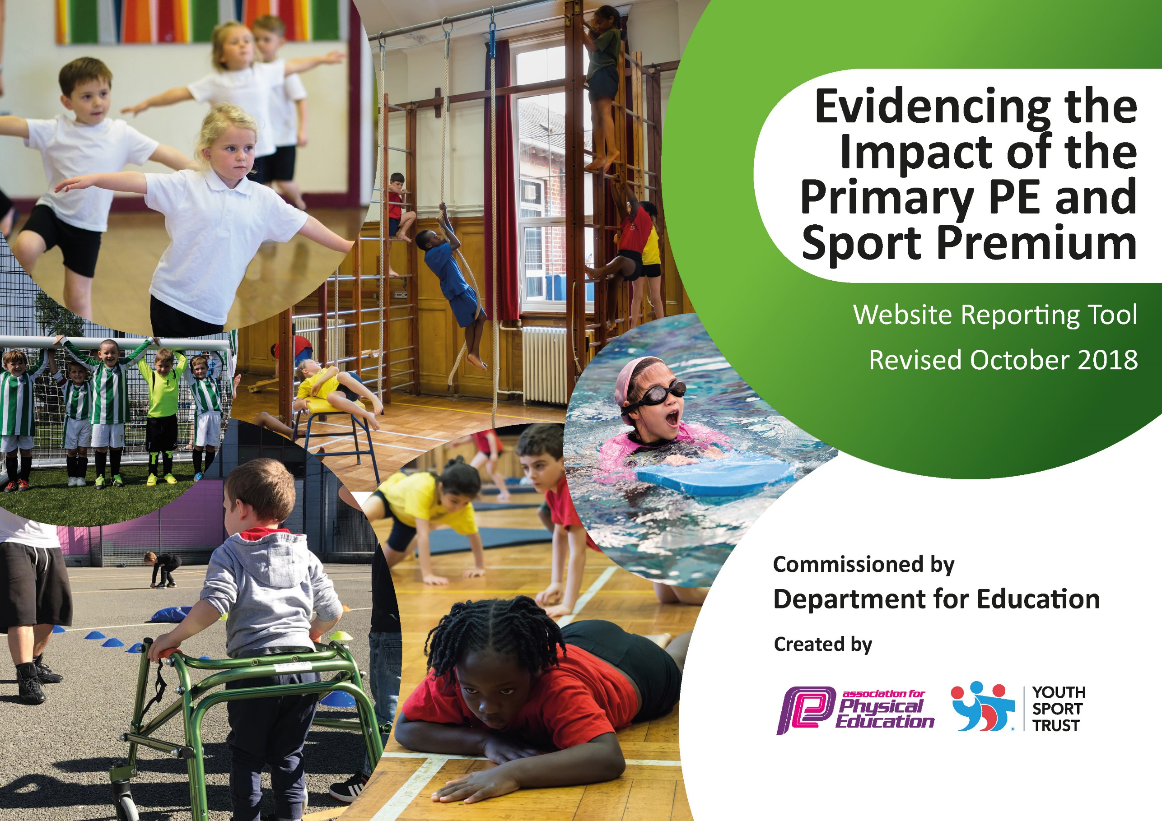

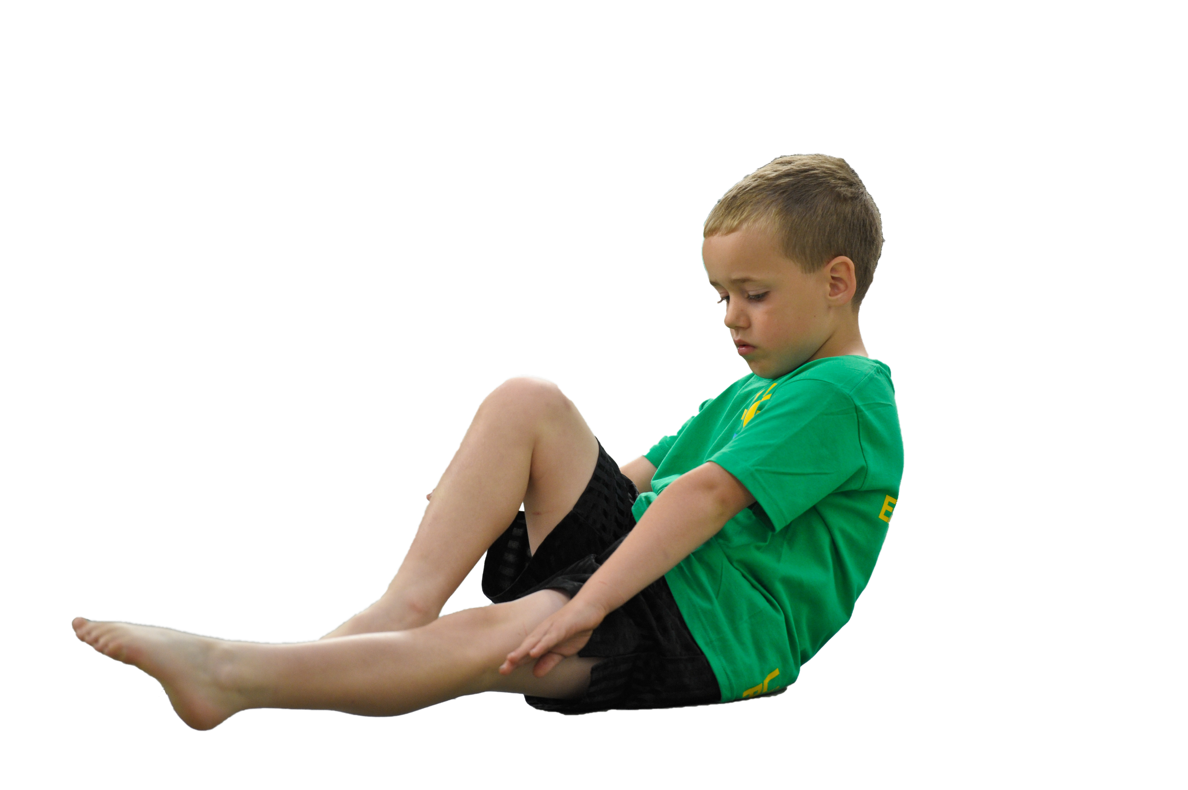
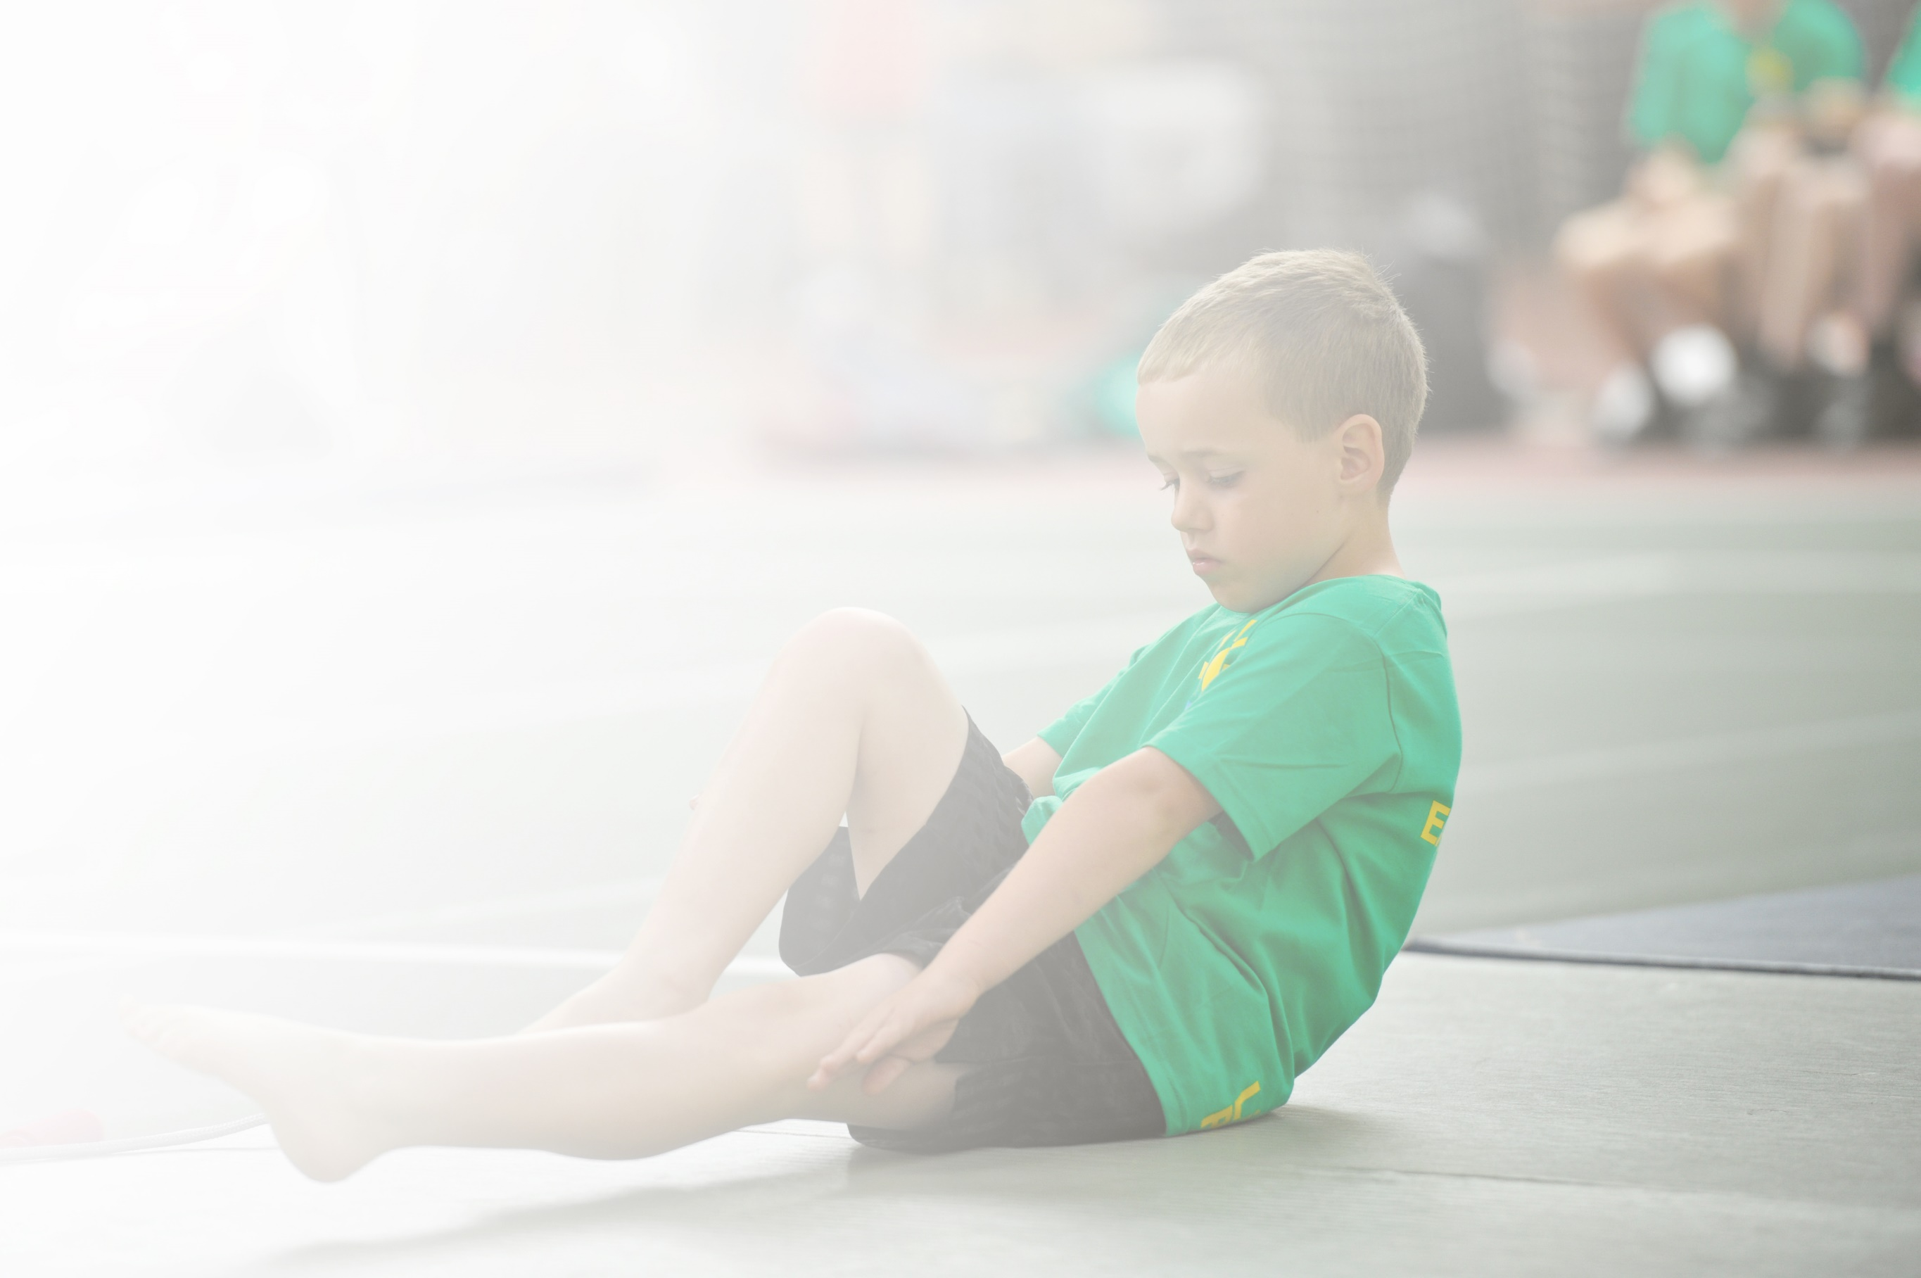
Schools must use the funding to make additional and sustainable improvements to the quality of Physical Education, Sport and Physical Activity (PESPA) they offer. This means that you should use the Primary PE and Sport Premium to:

- Develop or add to the PESPA activities that your school already offer
- Build capacity and capability within the school to ensure that improvements made now will benefit pupils joining the school in future years

Support for review and reflection - considering the 5 key indicators from DfE, what development needs are a priority for your setting and your students now and why? Use the space below to reflect on previous spend, identify current need and priorities for the future.

Key achievements to date: Marlfields Primary Acadmey  July 2020 Update | Areas for further improvement and baseline evidence of need:
- Introduction of new planning and assessment tool. Giving staff confidence to deliver a range of different activities.  - Sport specific days delivered to introduce children to a large variety of sports.  - Opportunities to take part in a number of competitive sports events at local level through CeCP.  - Range of activities available to children after-school through clubs and competitions – cycling/yoga/paddleboarding/walking/geo-caching/orienteering to name a few.  - Subject specialists delivering PE sessions as well as lunchtime sessions.  - Development of the Play Leader Programme. | To support raising standards and achievements of PE throughout the school meeting the criteria of the Sports Premium Grant.  This will include:-  To improve the effectiveness of teaching by employing specific sports coaches within school to enhance specific skills need by the children for particular sports.  To raise pupils attainment by improving the proportion of learning that builds consistently through the year and year to year for PE.  To improve the proportion of children who are choosing to take part in the sports activities to improve success of the school teams within local competitions.  To maintain and monitor the effectiveness of CPD and delivery of PE teaching.  To continue to offer afterschool activities to support motivation of the children with regard to competitions of sport.  To try to attain more time from the local pool to enhance the number of children who are able to go swimming weekly.  To ensure provision for all pupils to develop their potential.  To develop provision for older pupils to undertake high quality volunteering and leadership roles linked to PE.  To develop outdoor provision linked to achieving the LoTC (Learning outside the classroom) mark.

Meeting national curriculum requirements for swimming and water safety | Please complete all of the below:
What percentage of your current Year 6 cohort swim competently, confidently and proficiently over a distance of at least 25 metres? | 85% (2019-20)
What percentage of your current Year 6 cohort use a range of strokes effectively [for example, front crawl, backstroke and breaststroke]? | 85% (2019-20)
What percentage of your current Year 6 cohort perform safe self-rescue in different water-based situations? | 65% (2019-20)
Schools can choose to use the Primary PE and Sport Premium to provide additional provision for swimming but this must be for activity over and above the national curriculum requirements. Have you used it in this way? | No

Action Plan and Budget Tracking
Capture your intended annual spend against the 5 key indicators. Clarify the success criteria and evidence of impact that you intend to measure to evaluate for students today and for the future.

Academic Year: 2019/20 | Total fund allocated: £18,100 | Date Updated: July 2020
Key indicator 1: The engagement of all pupils in regular physical activity – Chief Medical Officer guidelines recommend that primary school children undertake at least 30 minutes of physical activity a day in school |  |  |  | Percentage of total allocation:
 |  |  |  | £6000 - %
School focus with clarity on intended impact on pupils: | Actions to achieve: | Funding allocated: | Evidence and impact: | Sustainability and suggested next steps:
Continuation / extension of established successful programme of physical education. With the addition of more physical activity within lessons and during school.  Children focused on daily mile and a new activity trail was installed | Continue to fund current provision with PE & Sports Hub offering lunchtime and afterschool sessions.  Support healthy lifestyle by using celebration assemblies, links to healthy eating, change for life and cross curricular work etc (Forest School) to raise the profile of sport.  Delivery of parent and child fitness sessions every term | £6000
Key indicator 2: The profile of PESSPA being raised across the school as a tool for whole school improvement |  |  |  | Percentage of total allocation:
 |  |  |  | £4000 - %
School focus with clarity on intended impact on pupils: | Actions to achieve: | Funding allocated: | Evidence and impact: | Sustainability and suggested next steps:
Using PE as a vehicle to be at the heart of British Values and community cohesion supporting the whole school ethos. Whole school approach to PE & Swimming, and engagement in Physical Activity. | Playground Leaders to be trained to support intra school sports comps / lunchtime activities.  Playground leaders to develop in school competitions and assist with the delivery of sports day.  Invest in ‘SwimEngland’ to assess pupil outcomes in swimming and to ensure progression across KS2.  Invest in an additional assistant swimming teacher to ensure provision in met and swimming is taught to an outstanding standard.  All certificates for sporting achievements to be handed out during celebration assemblies and all children who took part to be recognized.  Sporting events to be reported on the school newsletter weekly  Sportsman/woman of the year to be nominated and awarded to a child in each class at the end of the school year.  Encourage correct PE kit to be worn to increase school unity. Support children where necessary.  Invest in new competitive sports kits to promote team spirit and unity. | £300 (Play leader equipment)  £500 (PE Kit)  £100 (Trophies)  £100 (SwimEngland)  £3000 (Extra assistant swimming teacher)

Key indicator 3: Increased confidence, knowledge and skills of all staff in teaching PE and sport |  |  |  | Percentage of total allocation:
 |  |  |  | £2300 - %
School focus with clarity on intended  impact on pupils: | Actions to achieve: | Funding  allocated: | Evidence and impact: | Sustainability and suggested  next steps:
Continue to support staff confidence, competence and subject knowledge through CPD and improved access to resources. | Re-new license for PE Passport planning and assessment tool.  Continue to audit and replenish PE equipment, using the sports leaders and staff to identify need for new equipment.  Deliver PE Meeting with whole school staff using PE & Sports Hub. | £500 (PE Scheme of work  £1000(Equipment)  CeCP Sports Partnership  (£800)
Key indicator 4: Broader experience of a range of sports and activities offered to all pupils |  |  |  | Percentage of total allocation:
 |  |  |  | £5800 - %
School focus with clarity on intended  impact on pupils: | Actions to achieve: | Funding  allocated: | Evidence and impact: | Sustainability and suggested  next steps:
Continue the successful programme of extra-curricular activities and develop for specific groups (SEND/GD). | Boxing in house competitions using actiboards  Book unsusal sports events days eg foot golf, UV sport  Specialist disability/SEN sports day.  Climbing taster sessions  Kayaking/Sailing experience | £3000 (Actiboards)  £1000 (Unique Sports Days)  £300 (SEN sports)  £500 (climbing taster day)  £1000(Paddleboarding/canoe/Sailing Astbury water park – 2 classes)
Key indicator 5: Increased participation in competitive sport |  |  |  | Percentage of total allocation:
 |  |  |  | 0 - 0%
School focus with clarity on intended  impact on pupils: | Actions to achieve: | Funding  allocated: | Evidence and impact: | Sustainability and suggested  next steps:
Continue to engage / expand fully with School Games competitions and develop intra school competitions. Promote local clubs allowing pathways for all children. | Coaches / teachers to continue to support delivery of intra-school sports competitions and training playground leaders to support.  Host some fixtures including local schools.  School will continue to use the school budget to pay for additional hours to attend competitions.  Continue to attend as many local sporting events as possible and reporting on outcomes from competitions.

