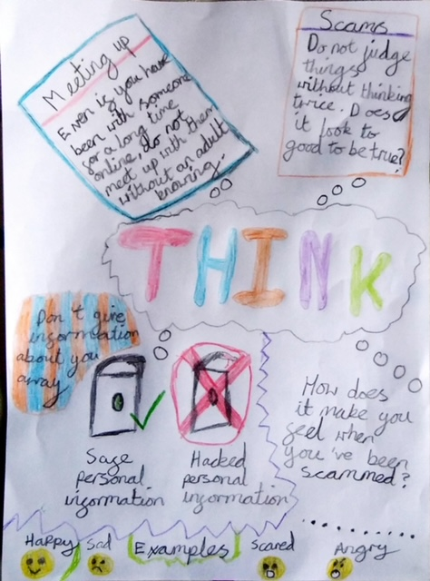 YEAR 6 KAI BRADLEY

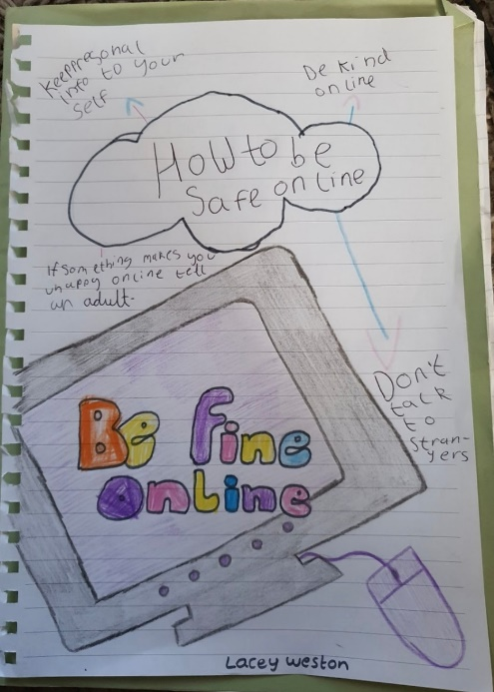YEAR 4 LACEY WESTON

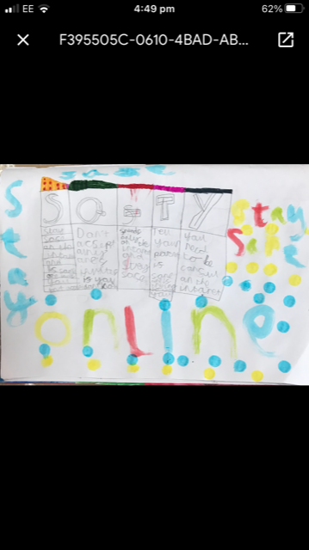YEAR 3 SAIFUL ISLAM

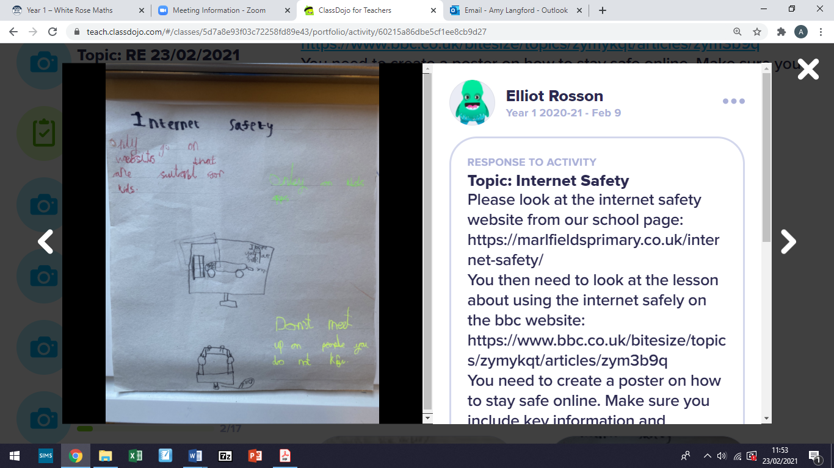YEAR 1 ELLIOT ROSSON

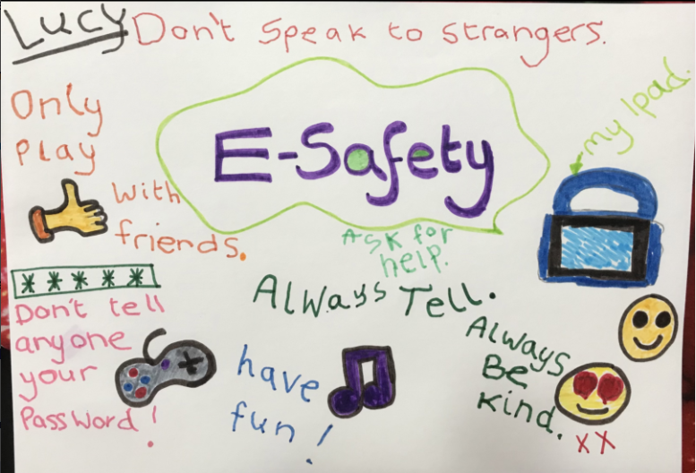Reception Lucy Horton