MARLFIELDS LOCKDOWN NEWSLETTER No. 1
8TH January 2021

Firstly, we would like to wish everyone a Happy and a particularly Healthy New Year!
We hope that you all managed to have some sort of a semblance of a ‘normal’ Christmas.

Once again we find ourselves in Lockdown for the next few weeks; schooling for the children who are not eligible to be in school is now on-line. If you do not have an available laptop did you know that you can access Google Classroom through your games consoles? We have printed the instructions on how to do this below.

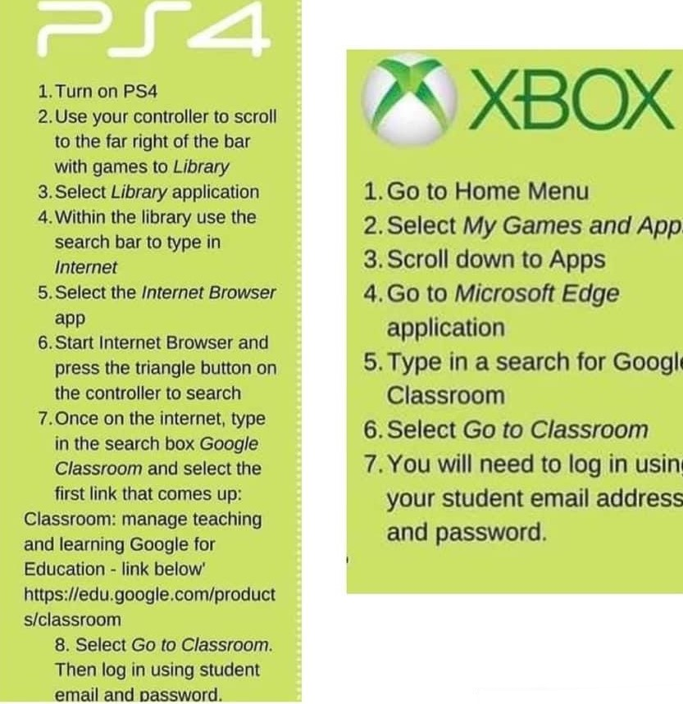

If you have any problems with Remote Learning there are people in school everyday from 9:00am until 4:00pm if you need to discuss anything.

Please remember that we are here to help in whatever way we can, not just with the learning; we can only help if you let us know that you need help. We may not be able to solve all problems, but we will do our best wherever we can.

Message from Mrs Isherwood, Governors and Staff.

Well this has been another week of fast-moving action for us all and we thank you for your support while we have been getting things in place with very little notice from the Government. Our on-line teaching and learning published guidance is now on our website and if you wish to see our Remote learning policy please visit our website where you will find it on the Coronavirus page. This give clear guidance of what we will deliver to give positive learning opportunities and outcomes and we will be working with you to ensure that we meet requirements and support where we can as indicated in the letter sent out on Tuesday.

Staff are still in school working to support children who are attending so will answer queries as soon as they can. As the media has been saying if we all work together we will get through this quicker and remember we are here to support where we can so give us a call. At times in line with guidance from the Government we may be making a call to you to keep in touch so please take the call for us and say hello.

Best wishes to all and keep safe.

Please also find attached a voucher from Domino’s Pizza who have said it is okay to share with parents to get a discount.

