**MARLFIELDS LOCKDOWN NEWSLETTER No. 2**

**18TH January 2021**

**REMOTE LEARNING OFFER**

As you will be aware this lockdown is not like the first and we are providing in line with Government and DfE requirements the online learning activities.  This is new to us all and thank you to all of you for working with us to get this up and running.  Also thank you to those of you who have given us feedback on how you are finding it.

To remind you the expectations of both school and yourselves as parents by the DfE is shown below:

* Teachers will plan daily a mixture of recorded lessons to watch and activities away from the computer screen.
* Children are expected to complete the task and return the work on the named platform.
* Teachers will check daily and give feedback between the hours of 9am – 4pm.
* There will also be a live Zoom session each week for all classes every day – timetable below.

Please note that our full Remote Learning Policy can be found on our website should you wish to read the whole policy. Listening to feedback from parents all classes will not do the same subjects each day which will support families who have more than one child to support. Attached to this Newsletter is a ‘Parent Guide’ to our offer which we hope you will find helpful.

|  |  |  |  |  |  |
| --- | --- | --- | --- | --- | --- |
|  | **Hours of time to be set from school** | **Time teachers will respond to work** | **Platform used for the work to be set** | **Catch up live Zoom for pupils & teachers  EVERY DAY** | **Daily curriculum lessons sent Monday to Friday for all classes** |
| **Reception** | 3 hours | **9am till 4pm** | Class Dojo | **2.20pm** | **Monday**  English/Maths/Science  **Tuesday**  English/Maths/Topic  **Wednesday**  English/Maths/Music or PHSCE/RE  **Thursday**  English/Maths/PE  **Friday**  English/Maths/Design Technology and Art |
| **Year 1** | 3 hours | **9am till 4pm** | Class Dojo | **11:30am** |
| **Year 2** | 3 hours | **9am till 4pm** | Class Dojo, moving to Google Classroom | **Mon,Wed,Fri**  **9.45am**  **Tues/Thurs**  **1.30pm** |
| **Year 3** | 4 hours | **9am till 4pm** | Google Classroom | **Tues/Thurs**  **9.45am**  **Mon,Wed,Fri**  **1.30pm** |
| **Year 4** | 4 hours | **9am till 4pm** | Google Classroom | **11.00am** |
| **Year 5** | 4 hours | **9am till 4pm** | Google Classroom | **10.20am** |
| **Year 6** | 4 hours | **9am till 4pm** | Google Classroom | **2:45pm** |

If you have any problems with Remote Learning there is someone in school from **9:00am** until **4:00pm** who will be able to help you. If you need to discuss anything, or would like your child’s teacher to contact you about any issues you may be having please e-mail us at [admin@marlfields.cheshire.sch.uk](mailto:admin@marlfields.cheshire.sch.uk) and your query will be passed on.

**Please remember that we are here to help in whatever way we can, not just with the learning; we can only help if you let us know that you need help. We may not be able to solve all problems, but we will do our best wherever we can.**

**BEFORE, AFTER SCHOOL & HOLIDAY PROVISION**

After being with us for 19 years and due to the current climate of people working from home, and there not being much need for additional childcare, Cherubs and Imps have decided to not renew their lease with us. **Please be assured the rumour of our site being unsafe is not correct**. With their decision we appreciate that this may be a problem for those parents who rely on this service, however we are looking at ways in which we can overcome any potential problems. **To this end we ask that you let us know by the end of the week if you would use this service, and how often you would need** **a place for before and after school care. The Governors of the school will need this information to be able to discuss the viability of setting up our own provision.**

**Please e-mail us with your response as soon as possible on** [admin@marlfields.cheshire.sch.uk](mailto:admin@marlfields.cheshire.sch.uk)

**SEND SURVEY**

This week, Cheshire East launched their annual parent carer survey aimed at parents and carers of those children and young people who have had an education health and care (EHC) needs assessment or an autism assessment with the NHS.  
They want to know if improvements made to services during the last year have been seen and felt by parents and carers and ultimately improve the lives of children and young people with SEND across Cheshire East.  
 The survey opened this week and runs for four weeks with a closing date of **Monday 8th February 2021**. The [**link to the survey can be found here**](https://s6.newzapp.co.uk/t/gtl/MTQ4NzY1MDEsMTQ2OTEzMzA1NywxNA==) as well as a short interview with Jacky Forster, director of education at Cheshire East Council, and chair of the SEND Partnership and Kate Walters, co-chair of the Cheshire East Parent Carer Forum. Please if you are a parent with children with an Educational Health Care Plan or School Focus Plan and wish to contribute please use the link above or visit Cheshire East website direct.

|  |  |  |  |  |  |  |  |  |  |  |  |  |  |  |  |  |  |  |  |  |  |  |  |  |  |  |  |  |  |  |  |  |  |  |  |  |  |  |  |  |  |  |  |  |  |  |  |  |
| --- | --- | --- | --- | --- | --- | --- | --- | --- | --- | --- | --- | --- | --- | --- | --- | --- | --- | --- | --- | --- | --- | --- | --- | --- | --- | --- | --- | --- | --- | --- | --- | --- | --- | --- | --- | --- | --- | --- | --- | --- | --- | --- | --- | --- | --- | --- | --- | --- |
| |  |  |  |  |  |  |  |  |  |  |  |  | | --- | --- | --- | --- | --- | --- | --- | --- | --- | --- | --- | --- | | |  |  |  |  |  |  |  |  |  |  |  | | --- | --- | --- | --- | --- | --- | --- | --- | --- | --- | --- | | |  |  |  |  |  |  |  |  |  |  | | --- | --- | --- | --- | --- | --- | --- | --- | --- | --- | | |  | | --- | | The Big Schools Winterwatch Live Lesson |  |  | | --- | | [https://i.emlfiles4.com/cmpimg/1/8/8/4/8/1/files/imagecache/2070059/w660_1481049_naturellbluetit.jpg](https://r1.ddlnk.net/3YNL-18D9N-2M9H7C-SAJOI-1/c.aspx)https://i.emlfiles4.com/cmpimg/t/s.gif |  |  | | --- | | Join BBC on **January 28th** for a very special **nature-themed Live**  **Lesson for KS2**, brought to you in partnership with the [RSPB](https://r1.ddlnk.net/3YNL-18D9N-2M9H7C-SAJOG-1/c.aspx) and  [BBC Two's Winterwatch](https://r1.ddlnk.net/3YNL-18D9N-2M9H7C-SAJOH-1/c.aspx). |  |  | | --- | | https://i.emlfiles4.com/cmpimg/t/s.gif |  |  |  | | --- | --- | | |  | | --- | | **KS2 pupils** can find out more about the birds in their environment in [**The Big Schools Winterwatch Live Lesson**.](https://r1.ddlnk.net/3YNL-18D9N-2M9H7C-S9U0A-1/c.aspx)Covering **key curriculum objectives** across English, maths and science, the lesson will explore the key features of a 'how-to' guide; working scientifically using classification keys; and how to present data using bar graphs. | |  |  | | --- | | Pupils will also get a chance to pose questions to our **Winterwatch experts** in a **live Q&A**.  You can [email](mailto:live.lessons@bbc.co.uk?subject=Wildlife%20question%20for%20the%20Q%26A) your bird and wildlife questions to the BBC **in advance** and they could be featured in the lesson. |  |  | | --- | |  |  |  | | --- | | Their Live Lesson will arm children with the necessary skills to go out and **explore their local wildlife** with the **Big Schools Birdwatch** (for children taking part from school) and the **Big Garden Birdwatch** (for those children at home)There are also some downloadable resources available to accompany the lesson.  Have a look at our [**teacher and parent/carer guide**](https://r1.ddlnk.net/3YNL-18D9N-2M9H7C-SAJ7U-1/c.aspx)**.** |   **COVID HARDSHIP FUND**  We are now able to again access the Covid Hardship Fund. This fund allows us to apply for certain things should you need them during these hard times.  Things available are: ***single beds, bedding, clothing voucher or for white goods such as a fridge, washer or cooker***. Unfortunately we are unable to get tumble driers or dishwashers as these are not deemed as essential.  **CAN YOU HELP?**  We have a shed that needs putting up – is there anyone of you who could come and support us to do this?  It would be COVID secure.  Please call us on 01260 633120 if you can help us.  Thank you.  **Child Mental Health & Wellbeing- 10 Top Tips for Parents**  Maintaining good mental health is just as important as having a healthy body, especially during the current climate.  It affects the way children think, feel and act.  As a parent, you play an important role in promoting your child's mental health and recognising when there may be early signs of difficulties.  **How can you promote good mental health?**  You can do this by:   * *being aware of the things you say and how you speak to your child;* * *clear and positive actions;* * *through the environment you create at home;*   So, here are our 10 top tips on practical ways you can positively promote your child’s mental health:  **1. Connect with your child every day**.  Try to have make time every day for an activity where you can connect with your child without distractions that enables comfortable conversation.  We all lead busy lives, but doing an activity like this together will offer your child the opportunity for them to feel secure and express how they are doing / feeling;  **2. Have quiet time together.**  This is a great way to connect with your child and takes no planning! Uninterrupted quiet time provides an ideal environment for your child to focus and build their attention span.  When things are overwhelming, quiet time can help your child reset their thoughts and avoid behaviour escalation to meltdowns;  **3. Praise your child when they do well.**  Recognise their efforts as well as achievements- praise the small steps. For example, say your child has difficulty sitting quietly and calmly at the dinner table.  Although desired, it would be unrealistic to initially expect them to do this for half an hour. So small steps might be praising that they achieved 5 -10 minutes.  At the next meal this could be built on by reminding them of their previous achievement and setting a new goal of 15 minutes;  **4. Foster your child’s self-esteem.**  Self-esteem is how they feel about themselves, both inside and out.  Children with good self-esteem generally have a positive outlook, accept themselves and feel confident. Fostering self-esteem includes showing love and acceptance, asking questions about their activities / interests and helping them to set realistic goals;  **5. Actively listen to your child.**  That’s ***really*** listening to what they are saying and how they are feeling.  Often the way children feel may seem unrealistic or disproportionate to adults but remember, children do not have the wisdom of experience and they may need help and direction to make sense of situations and feelings.  Try to answer your child's questions and reassure them in an age-appropriate manner.  Whilst you may not be able to answer all their questions, talking things through can help them feel calmer;  **6. Wherever possible stick to commitments and routines.**  Following through on commitments and routines builds trust and continuity, important relationship factors.  Try to keep to as many regular routines as possible to help your child feel safe and secure.  This includes having regular times for going to bed, waking up, eating meals and doing activities / hobbies;  **7. Keep your promises.**  Should the need to break a commitment or routine occur make sure there is a valid reason and take the time to explain why to your child.  Remember success comes from keeping your promises to your child;  **8. Find opportunities to play together.**  Play is a fantastic way for children to learn new things and develop problem solving skills.  It also offers great opportunities for them to learn how to express their feelings;  **9. Be a positive role model.**  Look after your own mental health and wellbeing. Children are intuitive and will readily pick up on feelings such as stress, anxiety, hopelessness and fear.  **10. Help your child to develop a language of feelings.**  Teaching children about feelings can be hard as it’s an abstract concept but if they can understand and express their emotions, they will be less likely to ‘act out’.  For example, you can discuss how characters in a book are feeling and the reasons why they may be feeling that way.  *We hope you find these tips helpful. It is important to recognise and accept that sometimes your child may not feel comfortable talking to you. As a parent this is a tough one, but the reality is that there will be occasions where this is the case. Rather than feel resentful or unhappy, you can take positive action and help them find someone they feel comfortable talking to e.g., a grandparent, an older sibling or another positive adult role model. Above all else, if you have any concerns, no matter how minor, or are at all worried about your child’s behaviour, mental health or well-being please contact your GP. In the first instance they may offer a face-to-face appointment or may ask you to speak to them via phone or video call. GPs are experienced professionals trained to help and you shouldn’t worry about wasting their time.*  **AND FINALLY!**  **We are missing you all, school is not the same when we are missing some of our friends but hope that we will see you all soon.**  **Until then please remember to take a look at the ‘Parent Guide’ attached and join your class on the daily Zoom sessions starting on Monday 25th January.**  **KEEP SAFE and BE KIND to each other.** | | |   **Parent Guide to Remote Learning at Marlfields Primary Academy**  **January 2021 Update.**  The current Covid-19 Pandemic has meant that children will sometimes not be able to attend school as they will need to self-isolate, or because they have the virus themselves and are ill. This document explains how we will make sure your child can continue to learn when they are forced to work at home.  If your child is at home ill with Covid 19, or any other illness, they won’t be expected to complete any home learning.  There are three different types of home learning available:   |  |  |  |  | | --- | --- | --- | --- | |  | **Type of Remote Learning** | | | |  | Individual Isolation | Whole Class Bubble Closure | Whole School Lockdown Closure | | Who is this for? | This is for individual children who can’t attend school because a member of their household has tested positive for Covid (they are a contact). | This is for children whose whole class bubble is having to isolate because they are all contacts of a child or staff member in the class who has tested positive. | This is every child who is unable to attend school because of a nation-wide extended lockdown closure. | | How will the learning be structured? | As the teacher will still be teaching the rest of the class in school, children will have access to generic daily Reading, Writing and Maths teaching & tasks via:  Web tutorials from the National Oak Academy or BBC Bitesize  Paper activities (downloaded from the school website/Google Classroom or Class Dojo) | As the whole class will be working from home, the teacher will teach a special unit of work designed for a two week bubble closure. It will include daily Reading, Writing and Maths teaching:  Regular recorded or live teaching.  Video tutorials made by the teacher or other recommended professionals  Individual paper activities –maths textbook or printed worksheets (sent, where possible, home in advance with the bubble closure pack)  Regular (via Zoom) feedback sessions in small group to support learning and address mis-conceptions | As the whole year group will be absent from school for an extended period of time, year group teachers will work in teams to support home learning. In line with Government recommendations it will include at least 3 hours for KS1 and 4 hours a day of learning for KS2, including: Reading/phonics or spelling, Writing and Maths lesson & Enquiry activities linked to other curriculum areas (see detailed plan over for details):  Regular recorded or live teaching  Video tutorials made by the teacher or other recommended professionals  Activities embedded within videos/ slides to reduce need for printing & use of textbook.  Regular Live (Zoom) feedback sessions in small groups.  Daily lessons linked to other curriculum subject. | | How will my child access the work? | Your child’s class teacher will have uploaded an overview of the terms work on the school website. This is always available if your child is suddenly asked to self-isolate. Class Teacher may also ask you to complete with your child other activities. | The year group teacher responsible for home learning that week will post on Google Classroom or Class Dojo a daily or weekly timetable. It will include a summary of the work to be completed each day.  All worksheets and links will be also be posted on Google Classroom and where needed Class Dojo. To support access work may sometimes be emailed to you by the office on request to them should you need. | The year group teacher responsible for home learning that week will post on Google Classroom or Class Dojo a daily or weekly timetable. It will include a summary of the work to be completed each day.  Recorded lessons will be made available and all paper activities and links will also be uploaded to Google Classroom/ Class Dojo.  Where possible activities will be paperless to reduce the need to print work. | | What will the work include? | Support to access age related daily Maths tutorials and activities using tools like BBC Bitesize and The Oak Academy.  Support to access Writing prompts(Grammar / spelling) tutorials and activities using recognised support programmes and sites.  Support to access daily Phonics/Spelling/Reading activities and resources on line. | Regular live calls with whole class linked to well-being and learning activities / SDI and addressing mis-conceptions.  Independent reading (20mins) using sites like Collins Open Page as well as reading for pleasure.  English activities and learning support materials.  Maths learning activities and support materials linked to White Rose materials and Power Maths.  Access to activities on line via My Maths and TTRockstars. | Regular live Zoom calls with whole class/ groups to support learning and well-being  Full weekly reading activities- mapped to ensure curriculum coverage for cohort using Collins Open Page books and Pathways to Reading  Full weekly English activities including aspects SPaG as well as writing  Full weekly Maths activities using White Rose and other resources such as Mymaths, and Power Maths.  Daily Independent reading for pleasure.  Daily set Maths practice on TTRockstars. (KS2 only)  Learning activities set on rolling programme to support broad and balanced curriculum delivery in time allocated – i.e. Science / History / Geography / Music / PHSCE / Art/DT.  Weekly PE session and recommended activities to keep active. | | How will the teacher keep in touch with my child? | As this will be a short absence of 10 days, the teacher will Class Dojo the parent to check that they understand the home learning and be available via email/ messaging to respond to any queries at the end of the day.  They may phone parents of children with Special Educational Needs or other vulnerabilities.  Children with an EHCP will be supported in home learning through more regular contact with the support staff. | The teacher will meet with the class once a day via a live meeting.  Children with an EHCP will be supported via additional contact with Teacher/Teaching Assistant staff to continue their bespoke curriculum or should they not be attending school. | The teacher will meet with the class once a day via a live meeting.  Children with an EHCP will be supported via additional contact with Teacher/Teaching Assistant staff to continue their bespoke curriculum or should they not be attending school. | | Will there be direct teaching or feedback? | **No** – the lesson tutorials will be from websites. Work will be marked by the teacher once the child returns. | **Yes** – the teacher will provide this – responding within 24hrs of the work being returned on line.  Teacher/Teaching Assistants will provide individual feedback on reading, phonics and specific SEND support. | **Yes** – the teacher will provide this – responding within 24hrs of the work being returned on line.  Teacher/Teaching Assistants will provide individual feedback on reading, phonics and specific SEND support. | | What resources will my child need? | Access to the internet via a laptop or i-pad.  Worksheets (downloaded from school website/ Google Classroom or Class Dojo). | Access to the internet via a laptop or i-pad.  *School can loan these to families if children have limited access to these at home.*  Where possible learning resources will be sent home in a pack in preparation for bubble closure. | Access to the internet via a laptop or i-pad.  *School can loan these to families if children have limited access to these at home.*  Reading scheme books are available via the Collins link notified.  Pathways to Reading books will be sent home as necessary. | |

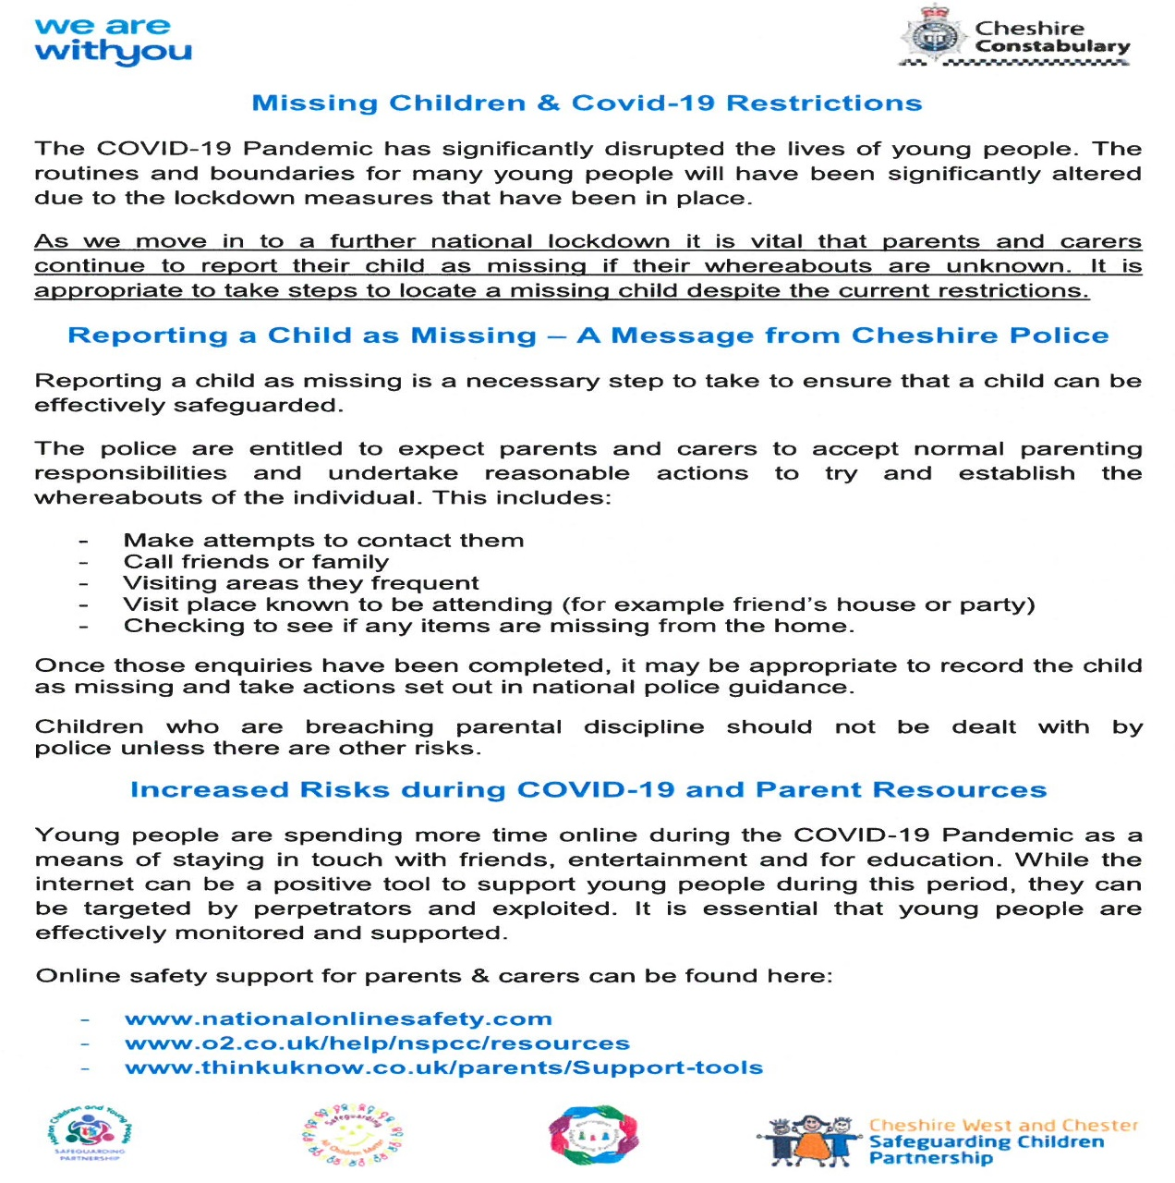

M:\While you're at Home 16\Slide1.TIF M:\While you're at Home 16\Slide2.TIF

M:\While you're at Home 16\Slide3.TIF M:\While you're at Home 16\Slide4.TIF

M:\While you're at Home 16\Slide5.TIF **M:\While you're at Home 16\Slide6.TIF**

M:\While you're at Home 16\Slide7.TIF