**Remembrance Day**

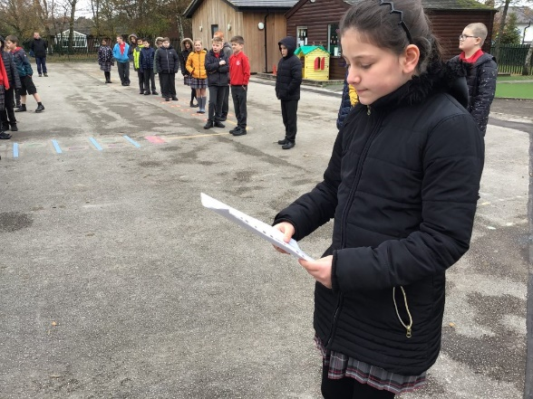Every year on the 11th day of the 11th month at the 11th hour our nation stands together for two minutes to remember those who have fought in the many wars throughout history and particularly those who have lost their lives.

On Wednesday, Remembrance Day, we all socially distanced on the playground and listened to a poem which was written and presented to everyone by Angelica Guirey from Year 5.

Whilst we could not buy poppies this year some classes made their own.

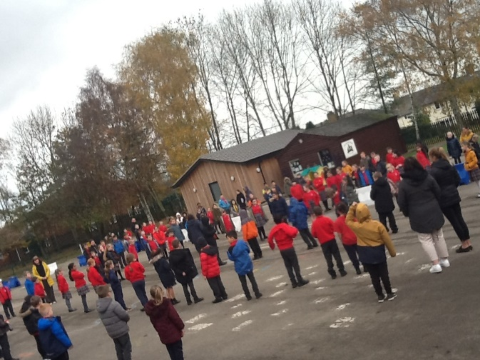Year 2 composed a class poem which we are also sharing with you on this newsletter.  It reminded us all of the remembrance saying ***'When you go home, tell them of us and how for your tomorrow, we gave our today.'***

Both poems are printed below for

you to read.

Thank you everyone for joining in with our act of remembrance.

**CELEBRATIONS**

These children all took part in the Congleton Library Reading Challenge over the Summer Holidays, and they are proudly showing off their prizes from school for taking part. Well done all of you.

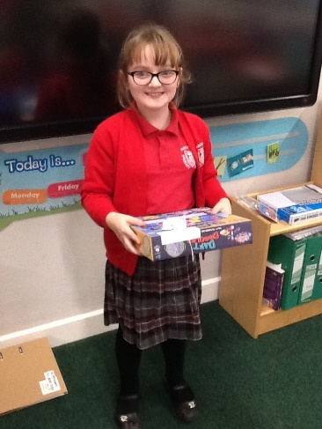 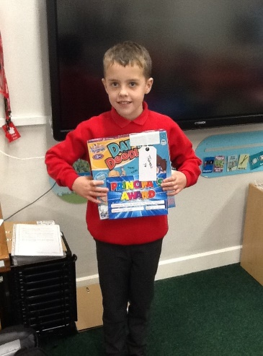 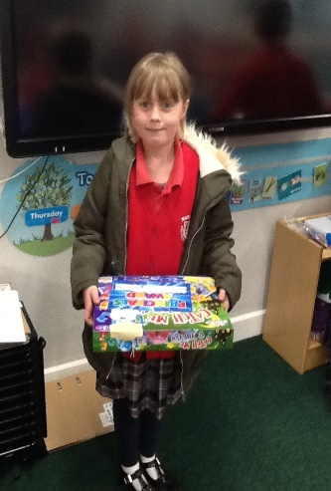 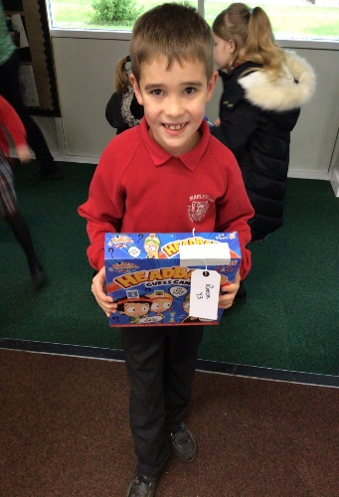

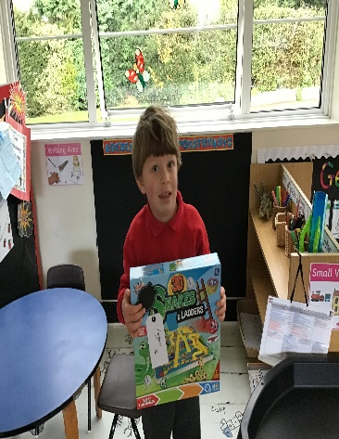 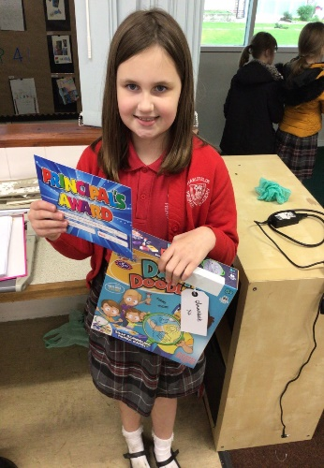 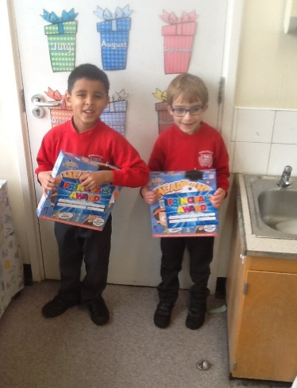 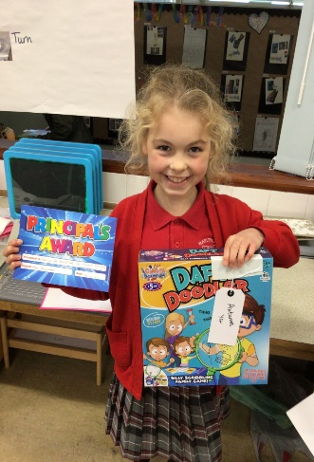

|  |  |
| --- | --- |
| This picture is of Jessica  Booth in Year 5 she raised  quite a lot of money when she took part in the race for life. | cid:fd118e96-68d4-402b-aa7e-33ea7ea67600The next one is Amelia Foulds also in Year 5 who won the end of year award for STEM last year but had not received her award until recently. |

**BIRTHDAYS**

We have had a number of requests from parents asking if they can bring in cakes etc. so that their child can celebrate their birthday with their classmates as they can no longer have a party. Unfortunately at the moment we cannot allow this. However, we have come up with an idea which will mean, if you so wish, that your child will be able to share their birthday with their friends.



We propose, that for a nominal fee, we ask Mrs Barnes to make cakes in school for your child’s class to join in with the birthday celebrations. If you feel that you would be interested in this, please email us for further details on [admin@marlfields.cheshire.sch.uk](mailto:admin@marlfields.cheshire.sch.uk) .

**AUTUMN SCHOOL REPORTS**

Due to the ongoing pandemic and the current national lockdown we are unable to hold our usual Autumn Term Parent’s Evenings. We asked if parents would like a telephone meeting to discuss their child’s progress so far; unfortunately not many parents responded to this idea. We then decided that the best way to reach all parents would be to send home a written progress report for your child. They will bring this home today.

There is a section for you to ask any questions or to make any comments and then return it to school.

If the current situation continues we have recently been made aware of a software programme which we are purchasing to hold Parent’s Evening via technology next term. In the meantime if you have any questions please call us on 01260 633120 or email us on [admin@marlfields.cheshire.sch.uk](mailto:admin@marlfields.cheshire.sch.uk) .

**FLUENZ SPRAY**

Last week the School Nurses were in school to administer the Fluenz nasal spray to all children. Some children did not receive theirs; this could have been for a number of reasons - they were absent on day, were unwell or had returned their consent form late.

Please **do not** go to your GP for this, as they are unable to offer the vaccine to healthy school age children, it is the School Nursing Service who are commissioned to deliver this.

**Instead please contact the School Nurse Immunisation Admin Team on the following number to arrange an appointment at a catch up session:  0300 123 4607.**

**CHERUBS & IMPS**

Are you aware that Cherubs & Imps before and after school clubs are still operating here at Marlfields?

They offer Breakfast Club, which runs from 7:45am until 9:00am at the cost of £4.00 per session, and after school until 6:00pm for £8.50 per session. They also offer a Holiday Club during school holidays.

For further information or to book a place/session contact **07799791336** or **07708722845**

[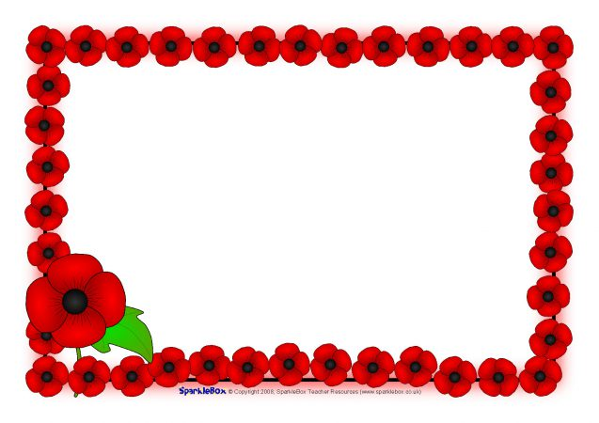](https://www.google.co.uk/url?sa=i&url=https%3A%2F%2Fwww.sparklebox.co.uk%2F1776-1780%2Fsb1778.html&psig=AOvVaw2O9otIMk890As6ih8qK5ls&ust=1605345275134000&source=images&cd=vfe&ved=0CAIQjRxqFwoTCOCaxKqX_-wCFQAAAAAdAAAAABAI)

|  |
| --- |
| **Poppy Poem by Class 2**  Poppies black and red  On our coats and tops  People remember  People show respect  In silence we wait  Every one united  Standing together in peace          poppy-stem-803335068-225x300[1] |

**WE REMEMBER**

**We remember, the last breath of humans**

**We remember, the blood leaking out**

**We remember, the blubbering, the weeping of our families,**

**the graves of our friends,**

**the prayers of mine; hope and faith leaking out**

**of our minds, our souls and our hearts.**

**As the last petal falls, of not one but of one thousand,**

**the hope of humanity disappeared.**

By Angelica Guirey, Year 5