SCHOOL DINNERS & SNACK
We hope that those of you who have been taking us up on the offer of free school lunches and snacks have been really enjoying them. Next week is the final free week as school closes on 23rd October for the half term break.
If you wish your child to continue to have morning snack please ensure that you pay £2.50 per week (50p per day) payable a week in advance (please pay next week for when we return after half term) onto SCOPAY – Trips and Events, Snack 20-21; for those that have still been paying, you are in credit.
If you do not have a SCOPAY account or are having difficulty with it, please either text or email the office and we will try to sort it out for you.
Reception and Key Stage 1 receive Universal Infant Free School Meals and so do not have to pay; however children in Key Stage 2 (unless in receipt of Free School Meals) will need to start paying Dolce for their lunches - £12.00 per week, (£2.40 per day); again if you haven’t got an account let us know.

SOCIAL DISTANCING/FACE MASKS
Recently PCSO Ben Hooper and PCSO Amy Heath have been to our schools for school parking patrols, which overall has gone very well.
One thing that they picked up though is the lack of face masks seen with parents when they pick up or drop off their children. There are some parents who do where them but it is not enough. He reports:
“Myself & Amy have been out on school parking patrols recently, we are happy to report that there wasn’t many issues and everything ran fairly smoothly. We have noticed however that there are quite a few parents without face masks on though.
Wearing a mask isn’t currently a requirement by law, but wearing them doesn’t just protect yourself, it protects other people and their families. We know they can be uncomfortable and restrict your breathing but it is about keeping everyone safe.

We implore you to wear masks whenever possible so we can reduce the infection rate of COVID and get back to a normal way of life quicker. Thank you
PCSOs Ben Hooper & Amy Heath”

WONDER BOOKS
Keep an eye out for a special treat coming home for the half term break!
All children will be given a fun-packed activity book to complete during the week at home. There are over 100 activities, including: puzzles, games, arts and crafts, experiments and more...
We hope all the children enjoy these puzzles and look forward to seeing some photos of their activities and the completed book when they bring them in on 3rd November when we return to school.

CELEBRATION TIME!
It is so refreshing to be able to share with you all some happy news!
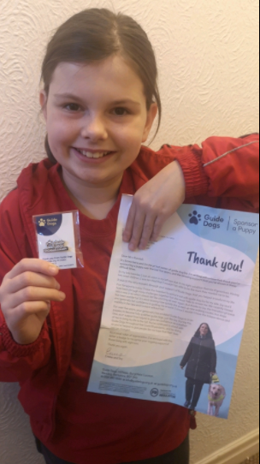
Imogen, in Year 5, has recently received an award and letter, shown in the picture, in recognition of her sponsoring a Guide Dog for the Blind for the last 5 years.

Well done Imogen; we are all so very, very proud of you.
-----------
Does your child have anything to celebrate that they would like to share with everyone? If so, please send us in a picture with a description of what it is for etc. and it will appear on the next Newsletter.

REMINDER: School closes for the half term break on Friday 23rd October and re-opens for the children on Tuesday 3rd November.

