|  |
| --- |
| https://pe-wbcm.s3.amazonaws.com/media/1003/guests-virtual-logo-wall-background.jpg  **We have been absolutely overwhelmed with your generosity in buying the Macmillan Afternoon Tea Bags!**  C:\Users\SCA8752170\AppData\Local\Microsoft\Windows\INetCache\Content.Outlook\H39Y1M1V\IMG_20200923_155156.jpg**Some people have also very, very kindly donated more money as they thought they were such good value.**  Here is a picture of Zack and Reece tucking into their Afternoon Tea.  **We must say a massive THANK YOU to Paula Barnes for her amazing baking, and also to Mary Brookes for her help in putting the bags together.**  We hope that you enjoyed the contents of the bags and thought that they were value for money.  **With your generosity we have raised £571.80 for this marvellous charity.**  Marlfields’ parents and staff, as always, have been amazing with their support! Thank you to one and all. |

**HEAD BOY AND HEAD GIRL**

Every year we chose a Head Boy and a Head Girl and their Deputies from Year 6. Congratulations to the children who have been chosen this year –

[](https://www.google.co.uk/url?sa=i&url=http%3A%2F%2Fclipart-library.com%2Fcongratulations-cliparts-borders.html&psig=AOvVaw3H1ywaAOAfAiENkEAfDeFh&ust=1601375575141000&source=images&cd=vfe&ved=0CAIQjRxqFwoTCLjooozTi-wCFQAAAAAdAAAAABAD)

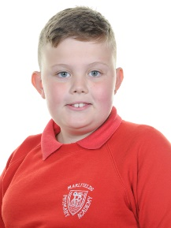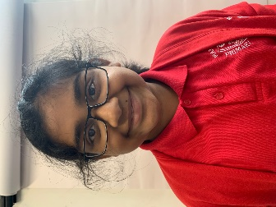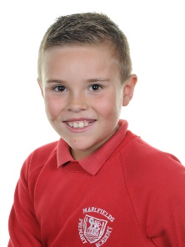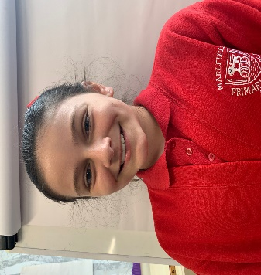

**Head Boy Head Girl Deputy Deputy**

**Charlie Lawton** **Joanna Roy Zack Coates Angelica Guirey**

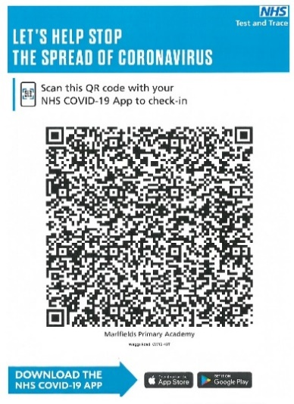**COVID-19 and SOCIAL DISTANCING**

We would like to remind everyone about the current social distancing guidance and urge you to adhere to the rules at all times, and especially at the school gates when bringing your child to school and collecting them at the end of the day.

By working together we can try to reduce the chance of any infections spreading.

If you have downloaded the NHS COVID-19 app onto your phone you can scan the Marlfields QR code to help stop the spread of coronavirus and help the Track and Trace system.

Please see below a letter from the NHS Test and Trace department.

The letter is also on the school web-site under Newsletters and also in the Coronavirus section.

**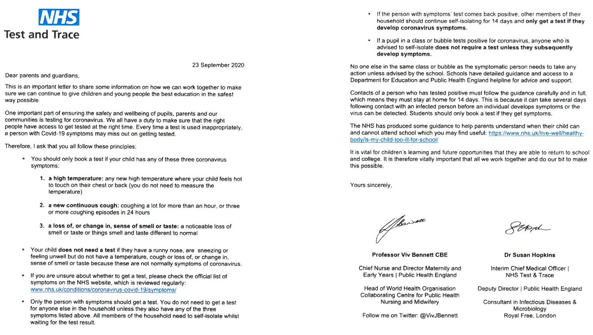**

If your child has had to self-isolate due to having any of the symptoms stated on the letter they should return to school after the recommended14 days. Failure to return to school could result in both parents being fined for their child’s non-attendance.

**IT’S GETTING COLDER**

**Now that autumn is well and truly with us we urge you to make sure your children are really well wrapped up when they come into school.**

**We have been advised to not have any heating on and to have all windows and doors open in all rooms for ventilation and to reduce the chance of any infection spreading. Consequently the children will feel cold in class.**

**We suggest that under their uniform they wear a T-shirt, vest or skins and for an extra layer on top of their sweatshirt to wear their school tracksuit top. They will also need a warm coat with them each day.**

**REGISTRATION PACKS**

We still haven’t received all of the children’s **Registration Packs** back. It is imperative that you complete and return yours either in paper form or via e-mail. We can then check, and where necessary update your child’s records. This form will only need to be completed once during your child’s time here with us at Marlfields.

Thank you to everyone who has returned them either by e-mail or paper version. If you have been unable to either download, edit or print one, we ask that you e-mail the office ([admin@marlfields.cheshire.sch.uk)and](mailto:admin@marlfields.cheshire.sch.uk)and) a paper copy will be sent out to you.

**HAIR CUTS / JEWELLERY / MAKE UP**

It is school policy to not allow children to have extreme haircuts. If a haircut is deemed to be extreme you may be called to take your child home until it has grown out or been rectified.

Equally children should not wear any jewellery apart from a wrist watch and plain stud ear-rings, and to not wear them on P.E. days.

Make up and nail varnish should also not be worn for school. If your child is wearing either of these they may be asked to remove it.

**DINNER ORDERS**

To help us to be as efficient as possible in getting the children fed with their preferred choice of food at lunchtime, can we please ask that you pre-order your child’s food, preferably for the week ahead or even beyond!

If you are unable to or are unsure how to access SchoolGrid from Dolce please let us know and we will do our best to assist you.

**PARENTS EVENING**

At this time of year we are busily trying to arrange Parents Evening appointments for you to come into school to discuss your child’s progress to date. However, with the Covid-19 pandemic still prevalent we will be unable to undertake face to face appointments. Instead we propose to hold virtual Parents Evening. To help us to organise this we would like you to e-mail your time of day preference to take part; morning, afternoon or after school. The e-mail address to use is: [admin@marlfields.cheshire.sch.uk](mailto:admin@marlfields.cheshire.sch.uk)

**HARVEST**

Again, due to the pandemic, this year we will not be holding a Harvest Festival celebration/collection. We ask instead for you to consider making a donation to the local food bank in lieu of this. The larger supermarkets have a collection point that you can put any donations into.