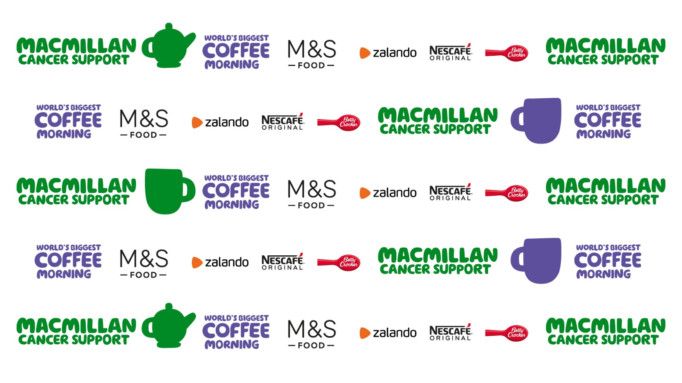

In these strange times that we find ourselves living in, we must adapt our everyday life to meet the new rules that Covid-19 is presenting us with. So…………………………

This year for our **Macmillan Coffee Morning** on **Friday 25th September** we are doing just that! As we will be unable to accept donations of cakes at this time we are offering…..

**“Afternoon Tea”**

**to take away – for just** **£5**

You will get –

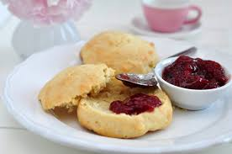

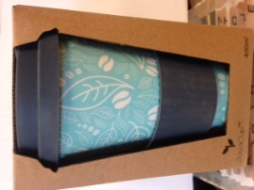 **A lovely re-usable mug, tea bag & coffee sachet, milk,**

**a milk-shake straw, a slice of delicious fruit cake, a slice of luscious lemon drizzle cake, a slice of scrumptious chocolate cake and a tempting scone and jam!**

Treat yourself or a friend to Afternoon Tea, or how about spoiling Granny and Grandpa? A neighbour? Or why not buy one and give it as a treat to a stranger?

**Go on, surprise someone and help us raise as much as we can for a charity who support many, many people in their time of need. Everyone knows someone who has benefitted from support from Macmillan. We need to help them more than ever now as like all charities they too have suffered during the pandemic.**

So that we know how many Afternoon Tea packs to prepare we would like you to pre-order them. We have set up a ‘Trips and Events’ section on Scopay – Macmillan 2020 should you wish to participate. Please e-mail us with how many Afternoon Tea pack you would like.

**Alternatively, if you don’t want to have the Afternoon Tea, you can make a donation against your child’s name on Scopay – Macmillan 2020.**

**Staffing News**

Many of you are aware that Mrs Daley is expecting her second child in the next few weeks. She will be starting her maternity leave from Friday 18th September. We wish her well and will let you all know when Baby Daley arrives, and maybe show you a picture of him or her.

Following the strange time the children have experienced during the pandemic and the length of lost learning, the management of the school have arranged for extra staff to be available to support them this term.

We welcome to the Marlfields Team: Mr Shelton, who is supporting Miss Booth in Year 4 and Mr Mills, supporting Miss Jackson in Year 5. This means our children in these classes will now experience a lower teacher to pupil ratio, which will support them to return to good learning habits. The management of the school will be reviewing this at the end of the autumn term.

We also welcome Miss Trussler to the team; she will be working with classes supporting individual children and also while teachers take their allocated PPA time.

Mr Shelton Mr Mills Miss Trussler

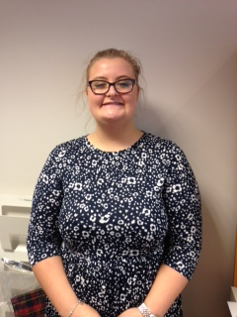

**REGISTRATION PACK**

Thank you very much to those who have returned their new Pupil Registration Pack either electronically or a paper copy. Please may we urge you to complete and return yours if you haven’t already done so. If you are unable to complete it on-line or print one off, please drop us an email to [admin@marlfields.cheshire.sch.uk](mailto:admin@marlfields.cheshire.sch.uk) and we will send a paper copy out to you.

**THANK YOU**

May we take this opportunity to thank you all for supporting the guidance of maintaining social distancing outside the school gates. We would also like to remind you that from Monday, groups of no more than 6, and from a maximum of 2 households should congregate together.

To celebrate our first full week back at school Mrs Barnes made over **200 chocolaty Rice Krispie cakes for the children** to enjoy after their lunch today – they were very, very nice.

## CHERUBS & IMPS Breakfast and Afterschool Club

Opening times: 7:45am – 9:00am and 3:00pm – 6:00pm

Marlfields’ breakfast and after school club is situated within the school grounds of Marlfields. The entrance can be found on the right hand side of the school and can be accessed by a doorbell at the entrance. The provision is for children aged 4-11 years and is utilised by children from Marlfields Academy.

Cherubs and Imps was formed in October 2000 and is a family run business. The owners have numerous childcare qualifications and a wealth of experience in childcare and management. Cherubs & Imps also run a Holiday Club here, opening hours 8:00am – 6:00pm and is utilised by anyone needing care during school holidays.

The Holiday Club (Chimps) aspire to provide as much fun and activities as possible to make the holidays a memorable part of each child's year.

​As part of our provision we provide a healthy breakfast and high tea and we ask that you bring your child a packed lunch. Please help us to use these facilities or we may lose them; if you would like to use either of these clubs, please telephone: **07799 791 336**

**Parents As Partners**

You will receive your Parents as Partners Leaflet on Monday with details of what is going on in class this term.

|  |  |  |
| --- | --- | --- |
| **Academic Year 2020 – 2021** | | |
| **School Opens School Closes** | | |
| **Autumn 1** | **02.09.2020** | **23.10.2020** |
| **Half Term** | | |
| **Autumn 2** | **02.11.2020** | **18.12.2020** |
| **Christmas Holidays** | | |
| **Spring 1** | **04.01.2021** | **11.02.2021** |
| **Half Term** | | |
| **Spring 2** | **22.02.2021** | **31.03.2021** |
| **Easter Holidays** | | |
| **Summer 1** | **19.04.2021** | **28.05.2021** |
| **Bank Holiday** | **Monday 3rd May 2021** | |
| **Half Term** | | |
| **Summer 2** | **08.06.2021** | **21.07.2021** |
| **INSET Days**  **01.09.2021, 02.11.20, 12.02.21, 01.04.21 & 07.06.21** | | |