**SCHOOL HOLIDAYS**

**NEWSLETTER**

**End of July 2020**

**What a very strange term this Summer Term has been.**

**We hope that you have all kept safe and well. We have had a few children in school throughout the pandemic, including during the Easter Holidays, and over the last few weeks, once permitted, have welcomed back more from all of the other years.**

**It has been wonderful to share this difficult time with the children and to see how resilient and stoic they have all been with dealing with this very unusual situation that we have found ourselves in; and we thank them all for their exemplary behaviour and the following of all the new rules and regulations.**

School closed for the children on **Friday**; and will re-open for the children on **Wednesday 2nd September**.

Please see a list below of the school holidays for the next academic year.

|  |  |  |
| --- | --- | --- |
| **Academic Year**  **2020 – 2021** | | |
| **School Opens School Closes** | | |
| **Autumn 1** | **\*01.09.2020**  **02.09.2020** | **23.10.2020** |
| **Half Term** | | |
| **Autumn 2** | **\*02.11.2020** | **18.12.2020** |
| **Christmas Holidays** | | |
| **Spring 1** | **04.01.2021** | **\*12.02.2021** |
| **Half Term** | | |
| **Spring 2** | **22.02.2021** | **\*01.04.2021**  **31.03.2021** |
| **Easter Holidays** | | |
| **Summer 1** | **19.04.2021** | **28.05.2021** |
| **Bank Holiday** | **Monday 3rd May 2021** | |
| **Half Term** | | |
| **Summer 2** | **\*07.06.2021**  **08.06.2021** | **21.07.2021** |
| **INSET Days**  **01.09.2021, 02.11.20,**  **12.02.21, 01.04.21 & 07.06.21** | | |

We will be in contact with everyone should things change regarding Covid-19 rules etc. at school. Obviously things will be different from ‘the norm’ and things may change further in the coming weeks, but we have attached the leaflet as to what we know of at the moment.

Please bear with us as this is a huge learning curve for everyone and we will need to evolve as the situation and the government dictates.

**SCHOOL DINNERS**

Part of the new school regime, up until the October half term, is that school will provide to each child a school lunch, **FREE OF CHARGE,** this to avoid the children bringing in lunch boxes and us having to store them and decontaminating them once they are on the school premises.

These meals will consist of either a hot or cold alternative ‘Grab Bag’. We have attached a copy of the menu to the Newsletter as your lunch preferences have to be chosen on-line in advance.

If you have not used the on-line ordering service before, please contact the office on **01260 633120** or e-mail us at [admin@marlfields.chehire.sch.uk](mailto:admin@marlfields.chehire.sch.uk) and we will endeavour to help you. It may be that you haven’t yet set up your child’s Dolce meals account. You will need this account as food has to be pre-ordered. You can either choose on a day to day basis or for the whole term, the choice is yours. It is really easy to do, so don’t be scared. It’s not often in this life that you get something for nothing!

**READING BOOKS**

Another change to our usual way of learning from September will be to **ONLY** send reading books home on a Friday for you to read together over the weekend; these must then be returned to school the following Monday so we continue your child’s reading in school.

**PRIZE-GIVING**

Prize-giving this year was rather unusual, but still very emotional. Instead of a full afternoon in the hall, singing and presentations followed by strawberries and cream we had 3 socially distancing presentations on the car park! Never the less is was, in its own way, a special time and we were still able to celebrate the children’s achievements and present them with their prizes and treats.

Please see below a list of the prize-winners:

***Presentation of Class Awards for Significant Academic Progress***

**Harvey Porter Scarlett Evans**

**Vayun Bradley Libby Wood**

**Oliver Platt Mackenzie Metcalf-Smith**

**Zack Bloor Angelica Guirey**

**Daniel Oakes Pamela Billington**

***STEM pupils of the year.***

**Tobias Kane Alice Hamilton**

**Reece Coates Giulia Caiazzo**

**Isaac Bell Amelia Grant**

**Matteo Callaghan Amelia Foulds**

**Cesare Caiazzo Mia Wilde**

**George Kane Gaby Shaw**

***Music***

**Oliver Skellern Naomi Ball**

**Riley Reece Amira Begum**

**Alfie Nolan Amy Thorley**

**John Thorley Emily Campbell-Wood**

**Cesare Caiazzo Isabelle Arstall**

**Sam Mead Isabelle Booth**

***Commitment and Attitude For Sports Award***

**Ethan Duval Tilly Matthews**

**Thomas Davies Olivia Dronsfield**

**Toby House Megan O’Hare**

**Charlie Barnes Chloe Mountford**

***Presentation of Sports Personalities of the Year***

**(Excellence) (Commitment)**

**Oliver Renshaw Rohan Bradley**

**Jada Caines Gaby Shaw**

***Kerry Yarwood Kindness Award***

**Scarlett Evans**

***Shannon Boam Inspirational & Courage Award***

**Mia Sandywell**

***Ru Morgan Maths Award***

**Blake Pointon Arthur Gruber Amelia Amini Scarlett Evans**

**Noah Horton Annabelle Toon**

**Lennon Bibby Jasmine Ara Nott**

**Kai Bradley Mia Wilde**

**Rohan Bradley Gaby Shaw**

***School Courtesy Award*** **Alex Wallace**

***Mr Wiggins Environment Award***

***Dylan Wilde Julian Wilde***

Congratulations to all of our prize winners and a massive thank you for your contributions to the ethos of Marlfields.

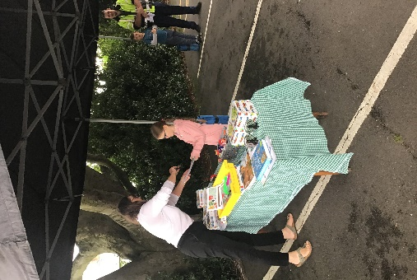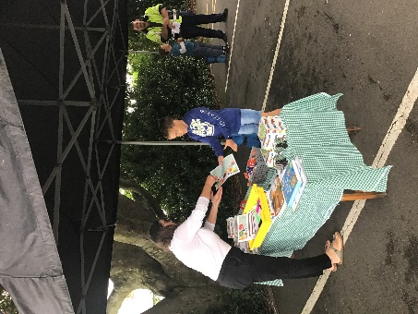

**UNIFORM ORDERS**

Many thanks to everyone for their uniform orders; we must apologise for not being able to fulfil most of them before the end of term.

We are waiting on a delivery from our suppliers. We will let everyone know in due course when we have taken delivery in order for you to collect your order.

[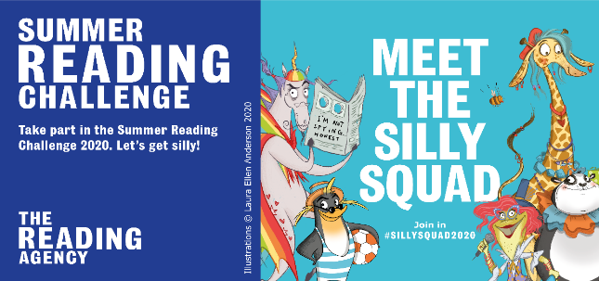](https://www.facebook.com/SummerReadingChallengeUK/)**MESSAGE FROM CONGLETON LIBRARY**

**All participants of The Summer Reading Challenge will get a gift from school on production of your certificate/medal when we return to school in September**

We're looking forward to the coming weeks and hope you'll join us for the Summer Reading Challenge, as we explore the Silly Squads favourite things to read!  
**From 20 June,** we'll be sharing content on our Summer Reading Challenge [Facebook](https://www.facebook.com/SummerReadingChallengeUK/) page, based on different themes each week.

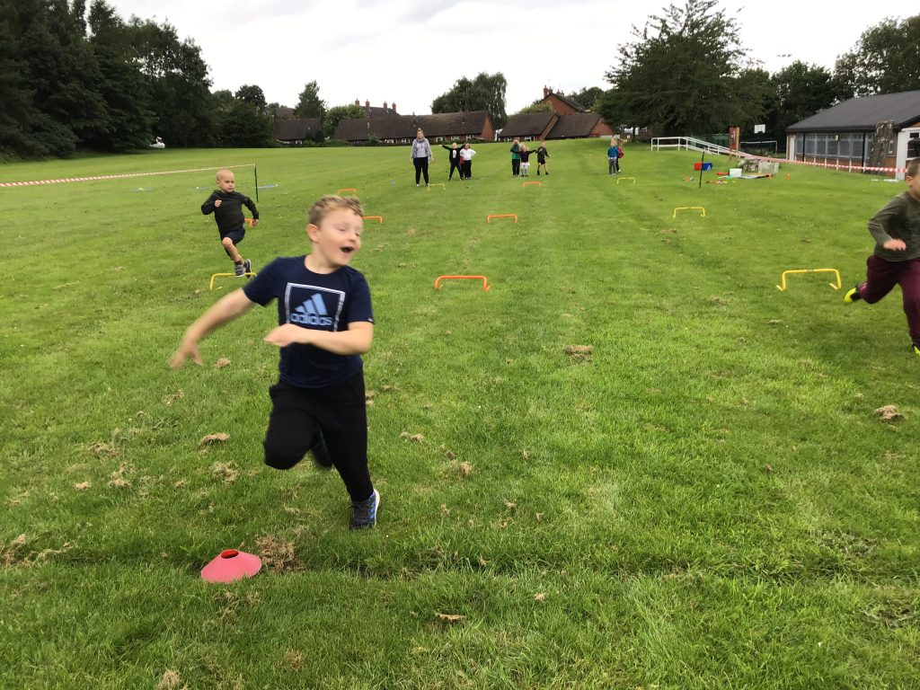We'll start with ***Bamboozle the Panda*** and his love of comics, graphic novels and illustrations, followed by ***Lily the Frog's Jokes and Tricks*** Week.

Next up will be ***Izzie the Octopus and her Poetry*** Week, then ***Snook the Penguin with his Novels and Story Writing*** Week followed by ***Merry the Giraffe's Non-Fiction Week***.  
Finally, at the end of August we'll have ***Brian the Pony with his Villains and Baddies*** Week!

**Year on year, more and more Marlfields’ children take part in the Reading Challenge, why not give it a go?**

**We hope that as many children as possible will take part again this year.**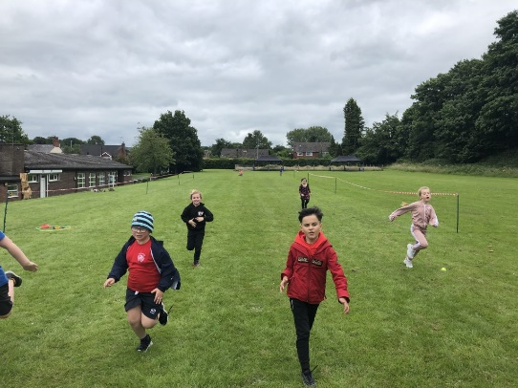

**GET READING!**

**SPORTS DAY**

Sports Day was yet another challenge for us, but nothing, not even Covid-19, gets in the way of the children of Marlfields enjoying themselves.

Nathan came along to support the children with the socially distancing races and it went off spectacularly as you can see from the photographs.

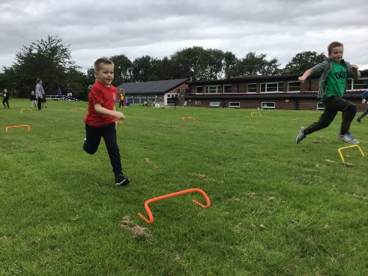A few photos of last weeks’ Sports Day. Please check out the school blog for many more!

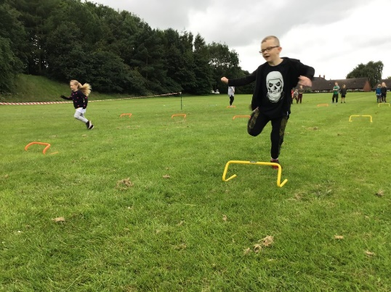

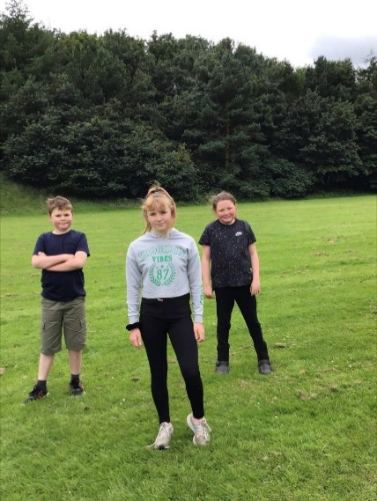

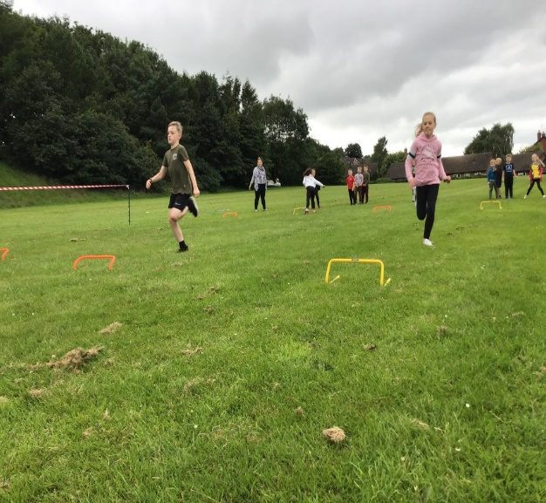

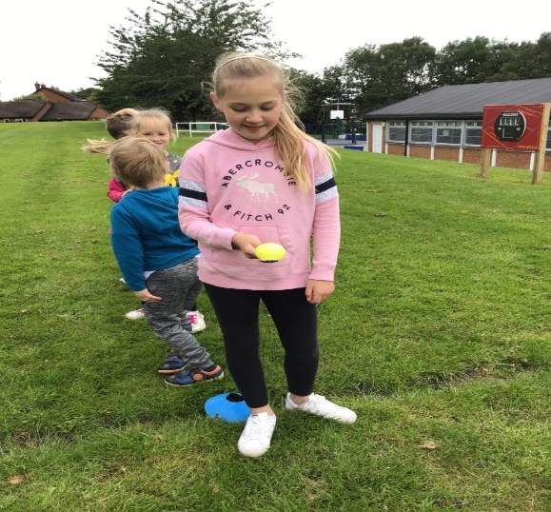

Thank you to everyone who joined us virtually and sent in videos too – **amazing!!!**

**HEADTEACHER’S CHALLENGE**

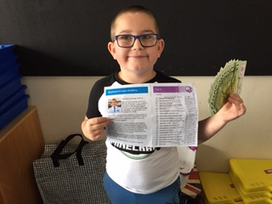

Congratulations to Aiden Ciocan from Year 2 for completing this year’s Headteacher’s Challenge, and in doing so he has earned 20 x £1 notes from the Bank of Marlfields.

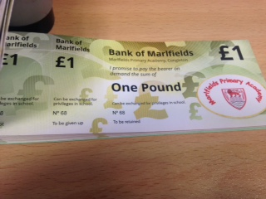

**GREEN FLAG AWARD**

We were recently assessed for Green Flag status; we heard last week that we have been fortunate in achieving it.

In the confirmation letter the organisers said:

*“I would like to congratulate you all for the time and effort that has been invested in environmental education at your school. Your award is well deserved and reflects the hard work you have put into the programme so far.”*

Thank you to all the children for their efforts in helping us to gain this award.

**INDIVIDUAL PENCIL CASES**

Due to increased pressure from the children to be allowed their own pencil cases we are from September, allowing children to bring in their own pencil case.

Within the pencil case your child should have as pictured -

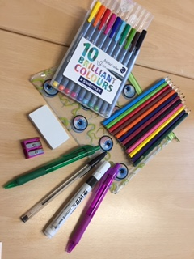

Purple biro

Black biro

Black white-board pen

Pencil sharpener

Rubber

Set of pencil colouring crayons

Set of washable felt tip pens

3 HB pencils

Please may we ask the actual pencil case is CLEAR, not too big as it needs to fit into children’s trays and that the case and equipment are named.

Please note that school take no responsibility for items lost and, as normal, we will have these items in the school for children’s use if they do not want to bring their own.

Any questions please just ask.

And finally ……………………

Attached is the new Dolce Menu for your FREE lunches, and a leaflet advertising activities from the Cheshire East Family Service Summer Programme, and the all important Returning to School Leaflet.

All that is left to say is that we wish you all a happy summer, hope the weather picks up and we return to the beautiful weather that we had at the beginning of lockdown.

Keep yourselves safe, and we will see you all on 2nd September at you allotted gate and time.