Hi Class 2,
Please see above the BBC bite size schedule for the week. I have looked at the work and as we discussed in our zoom meeting last week I do not expect you to complete every exercise. As a guide aim to spend an hour (maximum) on each task. For the English activities complete an example of the tasks to show your understanding but remember we are completing our ‘fun’ writing task.
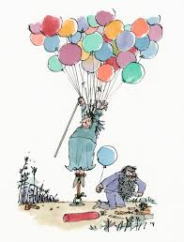
Lots of you have been reading/ watching David Walliams and Roald Dahl. I would like you to write a funny story (the length of this is up to you).
Choose a character who is mischievous... either an animal or a human- maybe an old lady or quiet little brother, who no one expects to cause trouble!
Now choose a few tricks for them to play ... make these really funny.
Finally think about whether they learn their lesson or do they continue to play tricks for a life time .
Draw a story map first to organise your ideas, then get going!
Your main aim is to make us all laugh when we read your stories.
Enjoy doing this- take your time - add illustrations.
We have a zoom meeting on Tuesday so you can share the outline of your ideas .
We can chat about how to make our stories even more funny !
Thank you to those of you who have sent in your home learning work, I look forward to seeing more super writing, maths and research this week.

From
Mrs Radcliffe

