

Home Learning STEM

Family Project

Building a Future

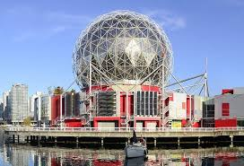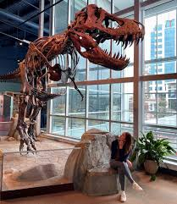

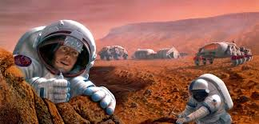

Please find below details of our STEM family learning project.

We understand how difficult it can be to complete online tasks or for you to have brothers and sisters learning about different topics so we have created some ‘whole family projects’. These projects will give you the chance to learn and work together. You do not need to complete all the tasks and you may have some ideas of your own. The idea is that you continue to enjoy your learning. Each topic has 5 areas; Let’s talk, Let’s get active, Let’s work it out, Let’s create and Let’s find out.

Think about where you would like to explore and find out about Scientists and the world!

Lets Talk…

* What can you build with just one cup of Lego?
* How can you make the tallest freestanding tower from just one piece of A4 paper? You can use a pair of scissors, but no glue or tape is allowed.
* Research a scientist and share the information you have learnt with a member of your family. Think about what it is they achieved and how they have helped to develop the future.
* Talk about the importance of Science in everyday life and how Science is not just people dressed in lab coats but researchers who have a huge impact on our way of life
* When light travels from one material to another it bends. Draw a small arrow pointing left or right on a piece of paper. Fill a large, trans-parent glass with water. Hold the arrow behind the glass of water. What happens? Try this out with letters of the alpha-bet. Does it work with them all?

Lets get active….

* Use an empty egg box as a treasure box to collect things from the garden. Can you collect lots of things of the same colour? What about different smells? How many different things can you collect?
* Plan and complete a workout that would burn off enough calories to allow you to eat your favourite chocolate bar; why is it important to eat a varied diet so that you can exercise?
* Complete a workout (this could be a Joe Wicks) when completing the different activities think about which muscles you can feel moving.
* Find a used kitchen roll tube and wrap a piece of card around it. Tape the outside cardboard roll so that it can slide. You can decorate it if you’d like. Use your telescope to look at things really closely. What can you see through it?

Lets create…

* Can you create a suitable home for wildlife that may visit your garden?
* Make Rocket Mice - Cut a circle shape from a piece of paper and then cut it from one edge to the middle. Tape it into a cone and add some mouse features. Balance your cone mouse on top of an empty plastic bottle. Press down on each side of the bottle with some force and shoot your mouse into space. What makes a difference to how far your mouse travels?
* Think up some silly products, such as a chocolate teapot. It would melt as soon as you added hot water. Draw pictures of your ideas.
* Put 2 tablespoons of cornflour into a bowl and mix it with water until it seems like a very thick liquid. Play with it over the bowl. Stir it with a spoon, hit it gently, put some in your hand, roll it into a ball, open up your fingers. Is it a liquid or a solid?

Lets find out….

* Cut the top off a carrot and place it on a plate with some water. Watch what happens. Can you measure any growth?
* Take a clean plastic sandwich bag. Carefully pour some water into it, so it is a third full. Seal it and tape it to a window that gets the sun. Watch what happens inside the bag when the sun is shining on the window. Can you explain this?
* What can you find in your house that sinks in the bath? Are there things that float? What do you notice? Can you sort them?
* Follow the current Space X mission to the International Space Station.

Lets work it out…

* Draw a picture of a big plate and then draw what you had for dinner last night. Find out what type of foods you ate for your meal e.g. dairy product, protein, carbohydrate. Can you find out why your body needs these types of food? You can find out this information by looking at the food packets.
* Ask your parents or carers if you can take a flower from the garden. Carefully dissect it. Can you name the different parts?
* Freeze some treasures in a block of ice in the freezer. Now can you rescue them? What is the best way of getting your treasures back?
* After the Big Bad Wolf blew down the 3 little pigs house they needed to re-pair the roof. They decided to make it waterproof to stop the rain coming in. Can you build them a roof that will stop the rain coming in? Explore different materials to find the one that is most waterproof.