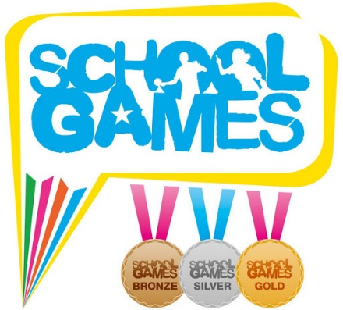
School Games Active Championships

The School Games Active Championships is a national activity campaign to help young people across the UK to #StayInWorkOut using the video-based platform powered by TopYa! New challenges will be available every Monday, Wednesday and Friday to engage with.
Primary and secondary-aged children can join the School Games Active Championships at any time with free active challenges being set via videos within a designated School Games version of the TopYa! Active app. All they need to do is download the app, register as a player and type in the Invite Code 23880.
Children practise the challenges, then submit their best video using a mobile device to receive personal coaching feedback from the TopYa! team of experienced virtual coaches. Points are earned for each video submitted, leading to climbing leaderboards and winning prizes!
The TopYa! Active app is committed to online safety and meets rigorous COPPA and GDPR safeguarding standards. No one can communicate within the app. All children can do to communicate with one another is give each other a virtual ‘high-five’, which functions like a social media ‘like’.
Video content is suitable for young people of all ages and abilities, with regular submissions from National Governing Bodies of Sport.

How do I get involved?
- Download the TopYa! Active app from the App Store or Google Play
- Create your Player (child) account
- When prompted to enter an Invite Code enter 23880 and then choose Primary or Secondary School League based on which type of school you attend
If you are under 13 years old, ask your parent or guardian set up the TopYa! Active account first, and then create player (child) accounts afterwards.

