Marlfields Primary Academy

HOME TASKS
FOR
YEAR 6

Please return to head@marlfields.cheshire.sch.uk so we can continue to support remotely – thank you.

ENGLISH

READING

- Create multiple choice quiz questions for a book you have read – 5 questions please.
- Draw a detailed drawing of the setting of a book you are reading.
- Write a poem to describe a character in a book you are reading.
- Create a word bank of interesting words you have found in the book you are reading – at lease 25 and put them into a grid under the type of word they are. (nouns – common, proper, abstract, concrete, adjective, pronoun etc.)
- Continue to do the comprehensions in your revision book. At least one per day while we are absent from school due to the virus.

WRITING

- Write a factual account of the event _______________.
- Write an information report about an animal that lives in an extreme environment – such as a polar bear, camel etc.
- Write an explanation about how volcanoes erupt – please do not be tempted to just download from the internet but to put it into your own word in a leaflet format.
- Write up a discussion you have with your parents about the advantages and disadvantages of smartphone,
- Write a review of a movie you have seen while absent from school.
- Write a story about a secret passageway, a magic hat and two friends – show your plan as well as your finished story.

LANGUAGE/VOCABULARY/SPAG

- People adapt the way they speak depending on the social situation they are in. Draw a Venn diagram to compare when it is appropriate to use formal language and when it is acceptable to use informal language. Include both spoken and written examples.
- Visit SPAG.com to complete the activities – 15 mins a day.
- Continue to use your grammar revision book – at least one per day.
- Make as many words as you can out of Constantinople – there are apparently 1697 – can you find them all?

MATHS

- Draw a hundreds board. Colour the prime number in red and the composite numbers in blue.

- Create factor trees to fine the prime factors of the following numbers: 34,68,116.

- Write 3 different number sentences using all four operations where the answer is 21.

- Write as many number sentences as you can using the numbers 8,4,11, making sure that the answer is an odd number.

- Research the monthly average temperature at the South, Pole, Antarctica, for each month of the year. Order the months from the warmest to the coldest.

- Find a recipe from a cookbook or on the internet. Triple each of the quantities for all the ingredients. Rewrite the amounts.

- Choose a page from a supermarket – choose 10 items and note their price. Apply a 10%, 25%, 50% and 100% increase on each item.

- Using 10 items from the Argos website that you would want to have and then apply a 15% discount – not the price before and after.

- You parents are giving you £1.25 for everyday you are off school. You have been off 35 days in total, calculate how much money you now have and then x this by 10 times this happen in a year – show your calculations.

- Visit the MyMaths site to complete the work set daily for 15 mins.

- Visit the TTRockstars site to complete the work for 15 mins daily.

- Continue to use your revision books – 2 pages per day.

- Visit the revision websites as seen on the Year 6 page on Marlfields Primary Academy site

SCIENCE

Task 1 - Using YouTube to support, research how to make your own homemade ice cream in a bag. Take photos of the sequence and write a report on how it went.

Task 2
PEOPLE BELIEVE THAT THE EUROPEAN HEDGEHOG WILL DISAPPEAR FROM THE UK?

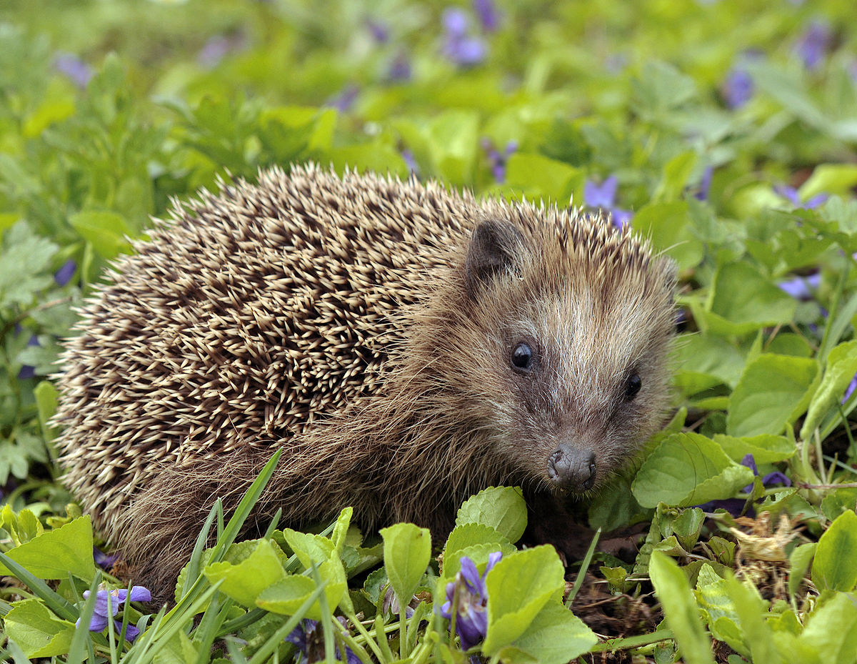

Be a Hedgehog Hero!

Investigate this question and produce a poster that encourages people to become a hedgehog hero – take a photo of your completed poster to upload. Mrs Radcliffe is fond of hedgehogs so will be judging a winner from the class who will receive a prize for the one which is the most eye catching and informative.

ART/DT

Visit on YouTube - search David Litchfield illustration -‘A drawing a day’
He decided to draw a picture and post it online every day for a year. While we are off school - Keep a ‘sketch book’ at home with the one drawing a day you do – hope this improve your own skills over time?

My passwords are:
IDL
MyMaths
TTRockstars

