Our fantastic trip to Cadbury World is now not many sleeps away!

Final arrangements have now been made;
Children need to be at school at 7:45am so that our buses can leave promptly at 8:00am. Please note no cars will be allowed through the school gates as we will be keeping them clear for the coaches. Please use the walking entrances to get to the playground where the children will be met. Weather permitting, we will load the buses without having to come into school to save time. If wet the children will make their way into school. Please do not use the front doors as staff will not be there to take them from you

As you can imagine Cadbury’s World is popular and we have been given strict tour times so need to leave in time to meet them.

Children will wear school uniform and will need a coat as some of the attractions are outside.
They will require a packed lunch, in a bag which can be thrown away after they have eaten. Please note that your child will also require a mid-morning snack. Please do not send glass bottles or cans.

We will not have time to visit the shop, which is expensive and we have sent out an offer for a small reminder of the trip this week for £1. Please make sure that you order this for your child by 5:00pm on Monday so we can assure that we can meet demand. Please do not send your child with any money as there will be no opportunity to spend this. Mobile phones are also not required and any brought will be left in school for the day.

Traffic permitting we will be back to school around 4pm but we will keep you informed by text if we are delayed at all. Mrs Yoxall is our contact at school on the day of the visit. Both Nursery and Reception are in school that day so if your child is not joining us arrangements have been made for them in school for the day, please bring them to school at the normal time and collect at 3:20 pm as normal. We have a number of parent volunteers joining us on the day and we thank them as it would not be possible for us to run such a trip without their support. We also take this opportunity to thank them as they have all contributed £5 to the bus for their seat like the children.
We are sure you will appreciate that such a visit offered to you all at £5 is amazing and this would also not be possible without the continued support of our Friends of Marlfields events and the support they have given towards the coach costs.
THANK YOU FROM ALL OF US.

WEATHER
As the weather can suddenly change from sun, to sleet and to snow can we please remind you to ensure that your child has a warm / waterproof coat with them in school at all times.

If we were to have a heavy snowfall that means that staff are unable to get into school and we have to make the decision to close the school and have a ‘snow day’, we will let you all know via the text message system and we will also make an announcement on the local radio stations –
SILK 106.9 FM and SIGNAL 96.4 FM.

WORLD BOOK DAY
On Friday 6th March we will be celebrating World Book Day. On that day the children may dress up as their favourite book character. We always look forward to seeing everyone dressed up and the imaginative ways that characters are interpreted. Can’t wait to see this years’ array of costumes!

WORLD BOOK DAY BOOKS
If you have already ordered your child’s World Book Day through us, your child should be bringing them home with them on Monday.
We still have a number of the books in school for your child to choose from, should they wish to do still order or pop into the office with their voucher. WH Smiths are running low which is why we try to support.

SCIENCE WEEK
British Science Week begins the week after next. Next week look out for a leaflet letting you know about the various activities that your child will taking part in during that week.
Parents are invited to join us on the Thursday (12th March) from 2:00pm.

Marlfields’ Holiday Dates 2019 -2020
School Closes Re-opens
Summer Term | 03.04.20 | 20.04.20
May Bank Holiday | Friday 8th May 2020
Half Term | 22.05.20 | 01.06.20
 | 17.07.20 | 20,21,22nd July are INSET Days

Dear Parents and Carers,

We would like to invite all mothers, grandmothers, stepmothers, godmothers, aunties, carers, child-minders and friends to a special Mother’s Day Afternoon Tea Celebration in the school hall on Monday 16th March at 3:00pm (EYFS and KS1) and Wednesday 18th March at 3:00pm (KS2).

Here you will be able to enjoy a selection of sandwiches and cakes and a hot drink.
The cost per adult is £4. The children will meet you in the hall and will be able to attend free of charge (with an accompanying adult). Please make the total payment for your adult tickets online.

Please complete the slip below and return to school no later than Friday 6th March 2020.
If you have children in the two separate key stages and would like to enjoy afternoon tea as a family, please indicate on the slip below which date you wish to attend.

We thank you for your continued support.

The Friends of Marlfields Team
-----------------------------------------------------------------------------------------------------------------------------

Mother’s Day Afternoon Tea
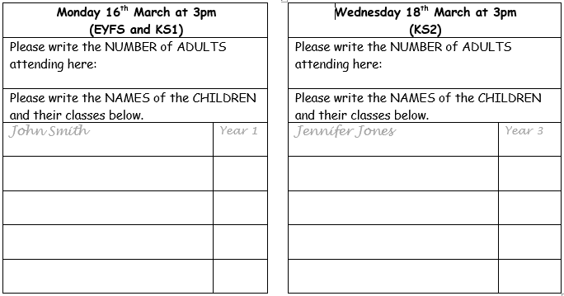

Allergies/dietary requirements: ……………………………………………………………………………………………………………………………
I have paid £……………………………….……… on SCOPAY on (date): ………………………………….……………

Signed: ………………………………………………………………………………….

