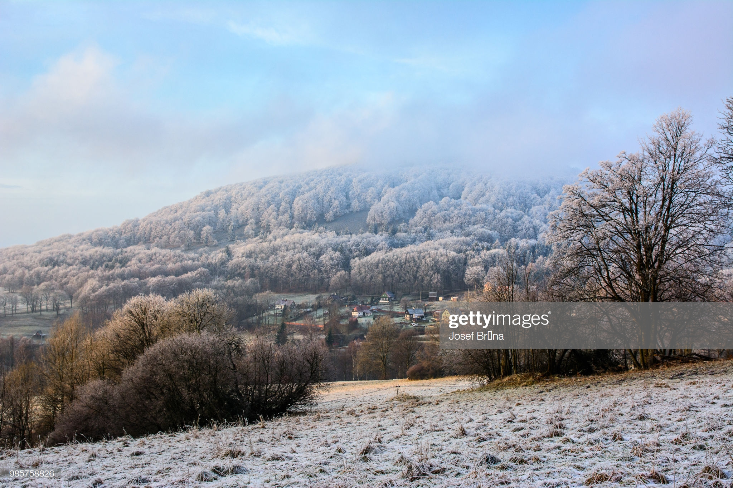**WEATHER**

As we are now getting nearer to that time of year when the weather suddenly changes can we please remind you to ensure that your child has a warm / waterproof coat with them in school at all times.

If we were to have a heavy snowfall that means that staff are unable to get into school and we have to make the decision to close the school, we will let you all know via the text message system and we will also make an announcement on the local radio stations – **SILK 106.9 FM and SIGNAL 96.4 FM**.

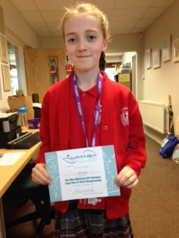 **GYMNASTICS AWARD**

CONGRATULATIONS Gaby on gaining your Gymnastics award and medal that you won last weekend. You look very proud, and we are all very proud of you too. Well done!

Has your child won an award or trophy recently? Let us know or send in a photo and a little write up and we will put it onto our Newsletter so that we can celebrate their achievement.

**CHRISTINGLE SERVICE and CHRISTMAS LUNCH – 12th DECEMBER**

It is traditional for us to visit one of our local Churches to celebrate what the festive season is all about. This year we are holding our Christingle Service at St. Peter’s Church on Thursday 12th December.

The children will come to school as normal and we will then walk down as a whole school to start our service at the church once we’re seated. St. Peter’s have offered to open the church from 9am so that if you wish to walk straight there you can and they will welcome you. Of course you are welcome to walk with us from school also. After the service we will be returning to school to enjoy our lunch which are our providers Dolcie are making as a special Christmas meal for us. If your child is in Reception/Year1 and Year2 you will be aware that your meals are provided free by the Government so you do not need to pay but just order to support correct numbers.

If your child is in Years 3,4,5 or 6 then payment will need to be made unless your child is entitled to free school meals.

Please note that Nursery will not be attending with us but if as a parent you wish to bring your child to the Church and enjoy the service you are welcome. They can then be returned for the continuation of their session. If it is a day that your child is in Nursery they will be enjoying a lunch with the whole school traditionally sits down together. Please check with us if you have any questions.

**CHIRSTMAS SPECTATULAR DAY**

Many of you have indicated that you are coming to join us for the **FANTASTIC & FREE** Christmas Family Day on

**Monday 16th December**!

The fun will begin at 10:00am until 2:00pm.

Many have also asked if parents need to stay for the whole day the invitation is for the whole day with a buffet lunch for you can stay as long as you like.

To support everyone being able to come for whatever length of time we would ask that you please indicate on the slip below your intentions. This will also help us with catering and reduce food wastage.

We have issued tickets which you should have received – thank you for keeping to the given date to support us in finalising details of the event.

Please could you indicate your intentions for us by returning the slip below on Monday. Thank you

|  |  |
| --- | --- |
| **CHRISTMAS SPECTACULAR**  **Family Name:_____________________________**  **No of Tickets I have been given:____________**  **I/we intend to come for the whole day and take the offer of the buffet lunch.**  **Special diet requirements we may need to know please – please note there will be vegetarian options offered.**  **I/intend to come 10-12 Noon only.** | **CHRISTMAS SPECTACULAR**  **I/we intend to come from 10-12 Noon and will not require lunch.**  **I/we intend to come from 1-3pm and will not require lunch.**  **Please note that due to Health and Safety there will be NO HOT drinks offered while the children are with you but at lunchtime we will provide a room where you can enjoy a hot lunch when the children are out at play.**  **You are welcome to bring cold drinks with you but please remember the children have their own water bottles so do not need extra as a snack station is planned into the day’s events.** |

**A POLITE REMINDER**



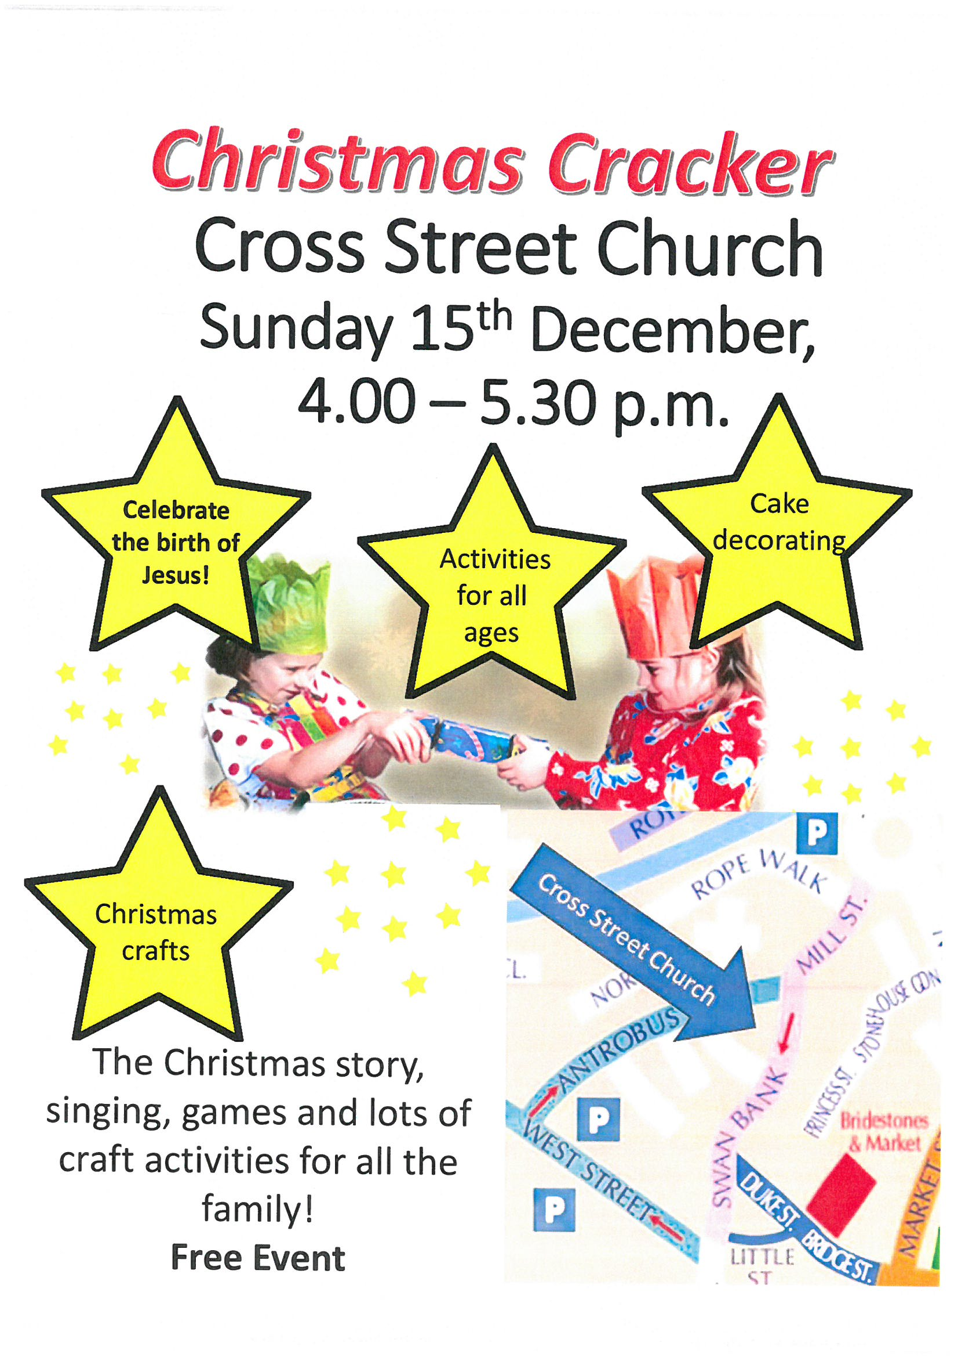

|  |  |  |
| --- | --- | --- |
| **Wednesday 11th December**  **at 6:00pm** | **Years**  **1 & 2** | **The Wriggly Nativity** |
| **Thursday 12th December**  **at 9:30am** | **All**  **---oOo---**  **Children** | **Christingle Service at St. Peter’s Church**  **---oOo---**  **Christmas Dinner Day** |
| **Friday 13th December**  **at 9:30am** | **Nursery**  **& Reception** | **Christmas Play** |
| **Monday 16th December**  **from 10:00am – 2:00pm** | **WHOLE SCHOOL**  **ALL DAY**  **EVENT** | **FREE CHRISTMAS SPECTATULAR**  **DAY IN SCHOOL**  **Parents invited to join us** |
| **Tuesday 17th December**  **9:00am** | **Nursery**  **& Reception** | **EYFS**  **CHRISTMAS SPECIAL** |
| **Wednesday 18th December**  **at 3:20pm** | **School breaks for CHRISTMAS!** | |

**DATES FOR YOUR CHRISTMAS DIARY 2019**