**MONKEY FOREST**

What a fantastic, but wet

time we all had at

Monkey Forest last Friday.

We hope that the children

enjoyed themselves as

much as we did.

We would like to take this opportunity to thank everyone who gave up their time to help us on the trip.

**13th September 2019**

**SUMMER READING CHALLENGE**

If over the holidays you completed the **Summer Reading Challenge ‘Space Chase’** at Congleton Library please bring in your Certificate for us to photocopy for the opportunity of receiving a special treat from the Governors.

**SCHOOL NEWSLETTER**

**BREAKFAST**

Don’t forget to join us on the playground for a **DELICIOUS FREE** breakfast. We are currently offering –

cereals, bagels, toast or porridge.

**Data Collection Sheet**

Many thanks if you have already returned your completed **Data Collection Sheet**, however there are a few missing. If you have not already done so, please send it back as soon as possible in order for us to confirm that we hold the correct details and contact information for your child. If you have mis-laid the form simply call in at the office for a replacement.

**AFTERNOON TEA**

**For MACMILLAN**

Friday, 27th September.

Child’s name _______________________________

I/We would like to order Afternoon Tea for **____** people at the cost of **£1.50** per person.

I have paid £___________ into my child’s on-line account.

Signed: ____________________________________

**ALDI’S KIT FOR SCHOOLS**

**Do you or any of your wider family shop at Aldi?**

From **September 6th until November 3rd**, Aldi’s Kit for Schools promotion is going to give primary schools the chance to win £20,000 to kick-start a health legacy for the school as well as a sports kit!

**Whenever you shop in Aldi and spend over £30 they will give you Team GB athlete stickers for you to bring in to school.**

**PLEASE TURN OVER**

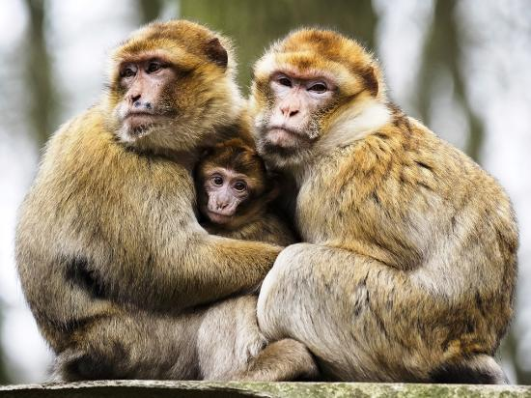To be in with a chance of winning we need to complete a poster which they have sent to us with 300 of these Team GB stickers.

Please ask all of your family to collect them and bring them into school; **even if we aren’t lucky enough win the £20,000 cash prize we will receive a sports kit for free.**

**MACMILLAN COFFEE AFTERNOON**

This year we thought that we would do something different for our Macmillan event. We will be doing an Afternoon Tea.

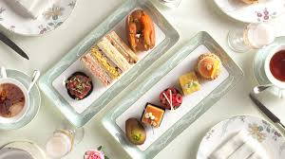This year we will be selling a Mini Afternoon Tea, which will consist of 2 sandwiches and 2 cakes at the cost of £1.50 per person. You will be able to enjoy your afternoon tea with your child should you wish. Payment as usual should paid into your on-line account.

We would also welcome any cake donations from Thursday 26th September

There will also be a raffle and cakes on sale for you to take home.

Afternoon Tea will begin at 2:00pm on Friday 27th September.

We hope that you will feel able to help us to raise as much money for this worthwhile cause. To help us with catering please complete the form below.

During the Afternoon Tea afternoon you are welcome to also join us for the opening of our new water fountain in memory of Mr Davenport who was one of our Governors.

