**STOKE CITY VISIT**

Last week two representatives from Stoke City FC came into school to deliver an assembly to the whole school.

In a letter from them after the event they commented on how fantastic all of our children were during the assembly.

Each child that was in the assembly were given the opportunity to buy some match tickets at a reduced price, and the children of Year 2 were also given membership of the City7’s Club, a replica Stoke shirt and a pair of match tickets. Many of you have taken up the opportunity to go and see them play and we hope you have a great time!

**FAIR TRADE FORTNIGHT**

For two weeks each year, thousands of individuals, companies and groups across the UK come together to celebrate the people who grow our food, people who live in some of the poorest countries in the world and who are often exploited and badly paid. This year we are focusing on the people – in particular the women – who grow the cocoa in the chocolate we love so much.

£1.86 is the amount a cocoa farmer in West Africa needs to earn each day in order to achieve a living income.

Currently, a typical cocoa farmer in Cote d’Ivoire lives on around 74p a day. Almost all cocoa farmers in West Africa live in poverty. For the women the situation is even worse. They may plant and harvest on the farm, look after children, carry water, collect wood, cook and clean for the family, and transport the cocoa beans to market but often with fewer rights than men.

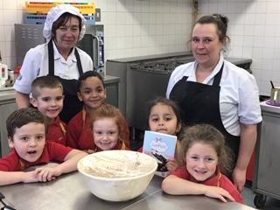This is why Fairtrade are campaigning for a living income to become a reality for cocoa farmers in West Africa, and we have helped them too in our own way this week.

Mrs Barnes has been working with groups of children to make scrumptious chocolate brownies, chocolate cookies, chocolate cakes pops, and all things chocolaty! Some of the children can be seen in this picture in the school kitchen with the cook Ms Morrey and her assistant Mrs Churchman. Proceeds from the sale of all of the goodies will be sent to the charity to help them with their good work. Thank you to those children who entered our poetry competition linked to our Fair Trade celebrations and the winners will be announced very soon. Y1 children are seen opposite enjoying the cooking Funds raised from selling our chocolate cakes will be sent to the Fair Trade Society to support their work. Thank you for your help as we love to help others less fortunate when we are having fun.

**WORLD BOOK DAY**

What a fantastic array of costumes you all come to school in yesterday to celebrate World Book Day!

[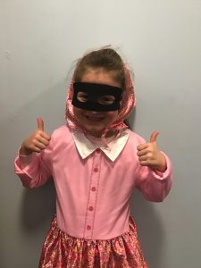](http://blog.marlfieldsprimary.co.uk/wp-content/uploads/2019/03/004-2-2.jpg)

[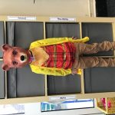](http://blog.marlfieldsprimary.co.uk/this-week-in-reception-w-b-4-3-18/img_2375/#main)We had everything from Gangsta Granny to Fantastic Mr Fox to children (and staff) not even bothering to get dressed for school and turning up in their pyjamas!

Thank you to everyone who brought in £1 to take part.

Funds raised will go towards buying books for each class.

Well done everyone for entering into the spirit.

Please turn over.

**“British Science Week – Journeys”**

**A Poster Competition**

Next week we will be running a poster competition linked to Science Week. As the theme of the week is Journeys your task is to make an A4 or A3 poster linked to Journeys. Some ideas include:

* Journeys you have made to different places
* Famous journeys
* Every day journeys
* Journeys linked to other areas of Science such as; the water cycle, life cycles of plants or animals or of materials such as plastic.

Be sure to include fantastic information, diagrams with labels and make it eye catching. There will be prizes for the best 3 posters. Good luck!

**“Thumbs up Thursday”**

Please join your child in their classroom on **Thursday 14th March** to help celebrate Science week by sharing their fantastic work. There will be an experiment set up in each class for you to investigate with your child. We hope to see you there!

**TATTENHALL CENTRE**

Last week Years 3 and 4 set off to enjoy an over-night stay at the Tattenhall Centre. They arrived safe and sound and easily settled into their new home for the night. They took part in a drama workshop with Clem from the Busy Days Company; the theme was volcanoes and earthquakes. The children all worked hard to be creative, imaginative, and to work as a team. They had lots of fun and have laughed a lot too.

[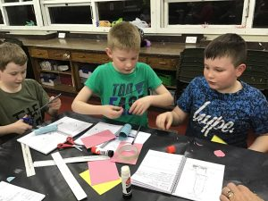](http://blog.marlfieldsprimary.co.uk/wp-content/uploads/2019/02/827FF6DD-D59B-4116-8729-BE00A09C0866.jpeg)[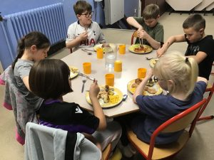](http://blog.marlfieldsprimary.co.uk/wp-content/uploads/2019/02/EA54CDDD-B6CF-40DB-9D19-A7B9298B9E88.jpeg)They had a lovely tea then held a competition to see who could build a rocket that would travel the furthest. Charlie P’s rocket won!

After all the excitement everyone got into their pyjamas ready to enjoy a movie night, before settling into bed for a well-deserved sleep ready to start the fun all over again in the morning. When they got back to school they were all excited following all of their adventures and tired at the same time. Many thanks to Mrs Isherwood for letting them go, and super thanks to all of the staff who went along for the adventure, giving up their own free time. It is greatly appreciated.

!**LOST SPECTACLES**

Has your child lost a pair of spectacles? There has been a pair that were found on the playground last week sitting in the office. They are in a case. Please call in to the office if you think that they may be yours.

**HOLIDAY DATES**

School Closes School Re-opens

|  |  |  |  |
| --- | --- | --- | --- |
| **Summer Term** | **05.04.19** | **23.04.19** | |
| **Summer Half**  **Term** | **24.05.19** | **03.06.19** | |
| **Summer holidays** | **19.07.19**  **22.07.19, 23.07.19. 24.07.19 INSET DAYS** | | |
| **Autumn Term** |  | | **02.09.19** |
| **Half Term** | **25.10.19** | | **04.11.19** |
| **Christmas** | **18.12.19** | | **06.01.20** |
| **Half Term** | **14.02.20** | | **24.02.20** |
| **Summer Term** | **03.04.20** | | **20.04.20** |
| **Half Term** | **22.05.20** | | **01.06.20** |
|  | **22.07.20** | | **5 INSET Days to be alloctated** |