

**Marlfields Newsletter**

29TH March 2019

**ON-LINE PAYMENTS**

Following the Easter holidays we will be a ‘cashless’ school.

All payments made for lunches, snacks, uniforms, trips etc. will therefore have to be paid on-line.

Letters giving you the information on how to register on-line have been sent out a few times now. If you have still not received one, please call into the office and you will be issued with another to enable you to register. If you have any problems in registering please don’t hesitate to call in to the office and we will do our best to help you out.

From April 23rd cash payments **WILL NO LONGER BE ACCEPTED.**

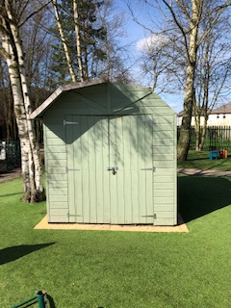**SHED FOR SALE**

We are offering for sale a shed, which is on the grass by the playground. It is only about 2 years old. The body of the shed is solid and sound, however part of the roof blew away during recent storms, but it could easily be repaired.

We are asking £50 for it, buyer to dismantle and remove.

If you are interested please call into the office or telephone 01260 633120.

**EPILEPSY AWARENESS DAY**

On Tuesday Gaby from Year 5 organised a Cake Sale to raise funds for the Epilepsy Society.

The theme of the day was ‘something purple’; children came to school wearing something purple along with their school uniform and Gaby even sold cakes with purple icing on!

We are pleased to tell you that during the day Gaby managed to raise **£96.63**. Well done Gaby, we are all extremely proud of you and the effort that you put in to raise this amount. We are already looking forward to next year!

**YEAR 3 BIRDS**

Mrs Guildford, our visiting Art Teacher has been working with the children of Year 3 to create these amazing bird models. The models are going to be sent to Spain where they will go on show in an exhibition for Spanish children to enjoy work produced by children in England. Following the exhibition they will be returned home.



Emotional Health and Wellbeing is currently high on the DfE agenda and we decided as a team to work toward gaining the AcSEED Award. We are pleased to report that we are the first school in Congleton to gain this award and therefore lead the way yet again. The criteria was strict and detailed and after gathering evidence we submitted the evidence and heard in January that we had met necessary criteria and was awarded the award. The following email was received:-

**From:** AcSEED Awards [mailto:admin@acseed.org]   
**Sent:** 30 January 2019 18:38  
**To:** Marlfields Primary Head  
**Subject:** The AcSEED Award: Marlfields Primary Academy

**The AcSEED review of your school self-assessment is now complete. The review concluded that Marlfields Primary Academy meets the AcSEED criteria for emotional wellbeing and mental health support, and has therefore been accredited with The AcSEED Award. Congratulations!**

**EASTER ASSEMBLY**

Make a note in your diaries for our Easter Assembly, which will take place in school on **Wednesday 3rd April at 2:30pm.** You are all most welcome to attend.

**CLUBS**

As we are approaching the end of term we need to send out the list of our free after school clubs. Please complete one form for each child and return it as soon as possible in order to secure a place. Places at clubs are offered on a first come, first served basis.

**MISS CARTER’S SKY-DIVE**

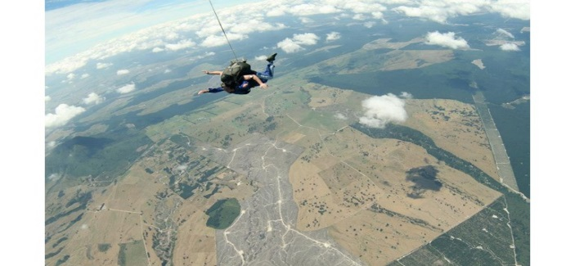There is still time for you to sponsor Miss Carter for her sky-dive which she doing to raise much needed funds for **The Christie Hospital** who support and treat so many people in lots of different ways.

She will be doing the sky-dive on **Saturday April 13th** in memory of a dear friend who died in 2017.

The minimum target that she has set to raise is £400, but with your help I am sure we will be able to get way beyond this amount.

If you would like to make a donation please either send it in to school in a clearly marked envelope, or you can go onto her JustGiving page to donate.

**FRIENDS OF MARLFIELDS**

You should have received quite a few letters in the last few months from us, the Friends of Marlfields. We would like to take this opportunity to thank you tremendously for your support in our events so far during this academic year. So far we have raised over £500! Money raised through the Friends of Marlfields charity is spent on your child. The Friends of Marlfields fund aims to buy the little (and big!) extras for the children in school, such as Christmas presents, Easter gifts, contributions towards school trips, leavers gifts and playground improvements.

To plan, organise and run these events for the benefit of all of the Marlfields children requires a lot of people power! All parents and carers of children at Marlfields are automatically members of the Friends of Marlfields. How much you help, however, is up to you. We currently have a group of dedicated parents who meet for about an hour every few weeks to generate ideas and plan future events. Some of those parents have taken on specific roles which are listed below:

**Chair - Sam Oldfield, Vice Chair – Helen Horton, Treasurer- TBC**

Other active committee members include:

**Abi Pointon, Rachel Brewer, Mary Brooks, Helen Corsan, Paula Barnes, Emma Powell, Jodie Lea-Pettican**

Understandably, regularly attending meetings is a commitment that a lot of parents would find impossible. However, we would still be enormously grateful for help in other ways. For example, we need parents to help to run events when they can, whether that would be serving tea and coffee, collecting tickets on the door, or calling Bingo numbers, every little bit of help helps! If this is something you would be willing or able to do, please leave your name and number with the school office and one of us can get in touch. By signing up to help during one event, does not mean you will be automatically signed up to help at all future FoM events, just the one or ones that you’d like to.

With an action-packed summer term ahead, we would also like to find out what skills and interests the parents, carers, friends and relatives have. For example, can you bake cakes, or do you know someone who can? Do you own a bouncy castle company? Do you run a beauty business that could supply a raffle prize which will in turn generate business for you? Do you run an ice cream van service? By letting us know you are not committing to anything, just pointing us in the right direction so not only may you be able to help us, but we may be able to help you too.

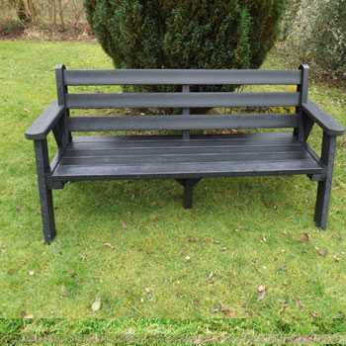**FROM BOTTLE TO BENCH**

Alfie in Year 2 is still working very hard collecting bottles and would like to say that he still needs lots more 2l clear plastic bottles to enable us to send them off to be recycled and modelled into one of these benches.

We need to have approximately 50kg, which as we am sure you will agree is a lot!

He would be most grateful if you would continue to collect them over the Easter holiday and bring them in when we return.

**HOLIDAY DATES**

School Closes School Re-opens

|  |  |  |
| --- | --- | --- |
| **Summer Term** | **05.04.19** | **23.04.19** |
| **Summer Half Term** | **24.05.19** | **03.06.19** |
| **Summer holidays** | **19.07.19**  **22.07.19, 23.07.19. 24.07.19 INSET DAYS** | |
| **NEXT YEAR’S DATES** | | |
| **Autumn Term** |  | **02.09.19 INSET DAY**  **03.09.2019 children in** |
| **Half Term** | **25.10.19** | **04.11.19 INSET DAY**  **05.11.19** |
| **Christmas** | **18.12.19** | **06.01.20** |
| **Half Term** | **14.02.20** | **24.02.20** |
| **Summer Term** | **03.04.20** | **20.04.20** |
| **Half Term** | **22.05.20** | **01.06.20** |
|  | **22.07.20 INSET DAY** | **2INSET Days to be alloctated** |