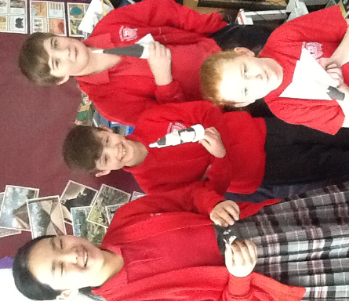

**SCIENCE WEEK AROUND THE CLASSES**

For Science Week **Year 6** completed a range of activities for Mission X –Train Like an Astronaut. During the week we make balloon powered rockets, designed astro-gardens and conducted a range of astronaut training tests. We also learnt about life on Mars and what humans would need to be able to survive there.

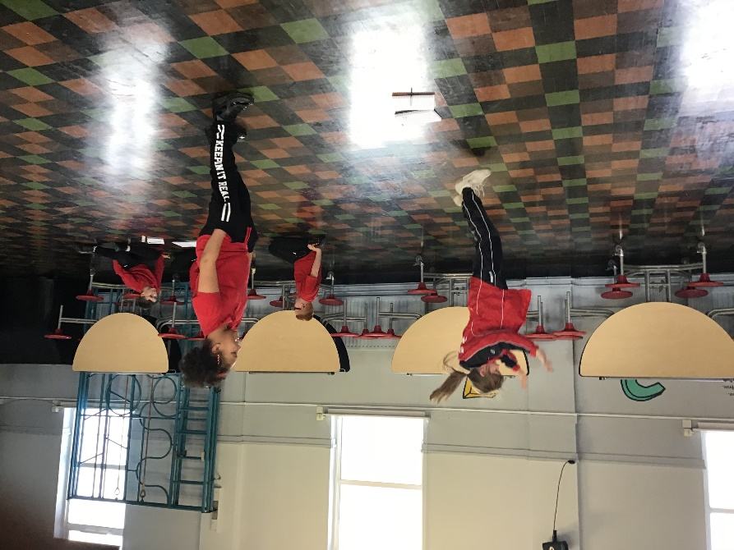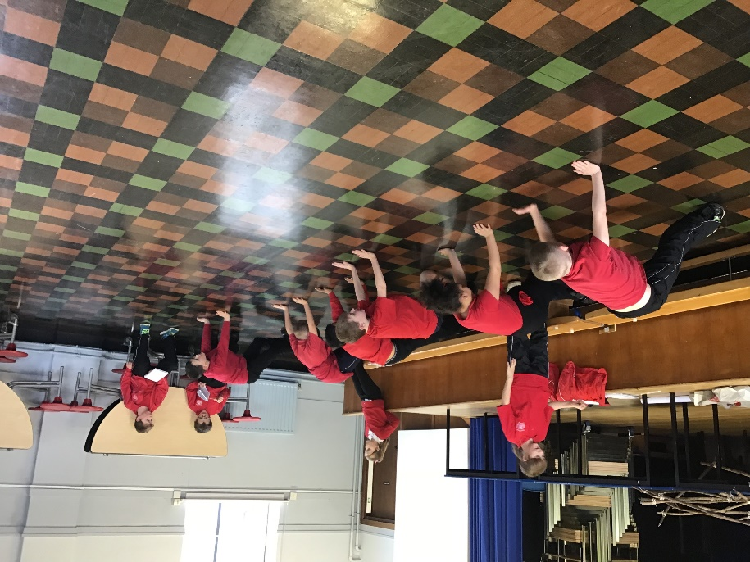During Science week, **Year 5** took part in Mission X where we used reasoning and problem solving in order to solve a range of problems including designing a garden fit to grow fruits and vegetables for ingredients to make a meal for an astronaut going into space. We even managed to link our learning with most subjects in the curriculum including: Maths, Art and PE.

**Class 4** were very busy during science week.

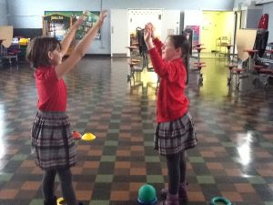         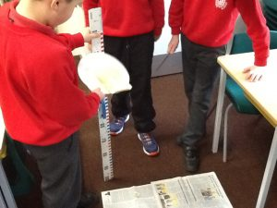 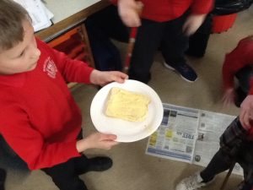

We designed and raced rockets, thought about how to keep our bodies fit and healthy and also investigated whether toast always falls butter side down or not. 

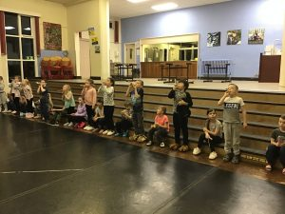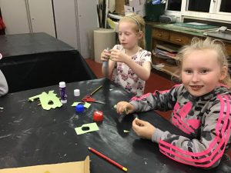 For their Crest Award **Year 3** made rockets. Our challenge was to make them go the furthest. To propel them we used a straw and our lungs! One by one we launched our final product. Jasmine won - she either has the best aerodynamics or the biggest puff!!!

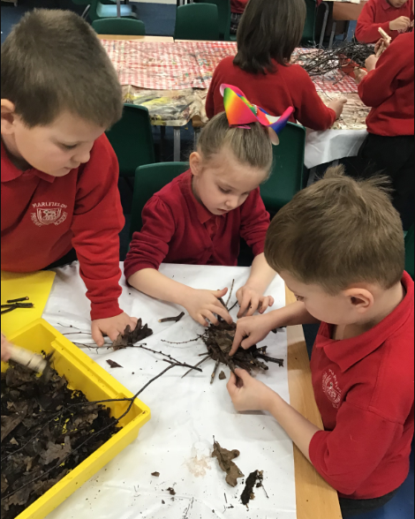During science week **Year 2** pupils loved taking part in the House Team Forest School Event.

They then spent time investigating and experimenting with different materials.

Their favourite day was comparing the properties of man-made and natural materials in the making of birds nests.

They also made a Textile Tree to compare a range of fabrics.

They had enormous fun!

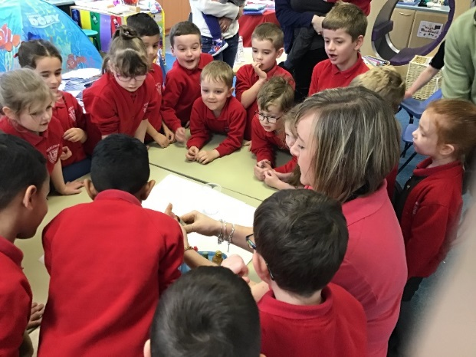

During Science Week, **Year 1** completed lots of exciting experiments. On Wednesday, we were set 4 different challenges, including making slime, mixing colours and completing scientific reactions with bicarbonate of soda and vinegar. During ‘Thumbs up Thursday’ we shared our experiments with our grown-ups. The theme for this years’ Science Week was ‘journeys’ so on Friday, we completed different transport themed experiments, making ramps of different heights and predicting how this would impact how far a ball would travel down them. We also made our own rockets, to see how the design would impact how far it could travel.

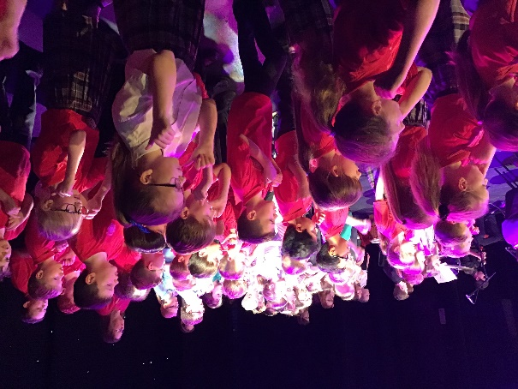**A MUSICAL VISIT TO CREWE LYCEUM**

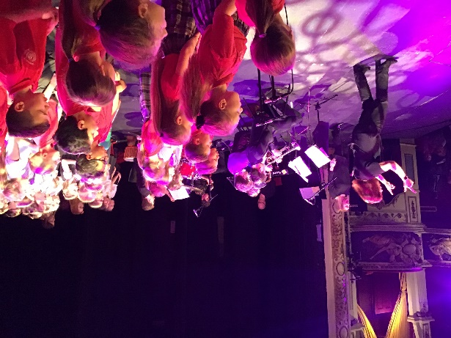On Tuesday, Years 4 and 5 had a very exciting trip to **Crewe Lyceum** to take part in **Singfest**, which is an annual singing festival where different schools from around Cheshire East get together to perform for their parents. This year they performed **‘Music Through The Decades’.**

During the afternoon, our children were invited to stay and play their own brass instruments with the **Congleton Youth Orchestra**. At the end of the day they were all sad to leave as they had such an amazing day.

**AUTHOR VISITS MARLFIELDS**

Please see the separate sheet giving you details of this exciting visit to school next week by Edward Trayer, writing under the pen name Billy Bob Buttons, who is the author of the 2014 UK People´s Book Prize Winner and UK bestseller, I Think I Murdered Miss. He is also the author of sixteen other children's books including the Rubery Book Prize finalist Felicity Brady and the Wizard´s Bookshop, the much-loved The Gullfoss Legends, the award-winning TOR Assassin Hunter and TOR Wolf Rising and, for younger children, the hysterical Muffin Monster. He is visiting us on Thursday.

**MOTHER’S DAY GIFTS**

Please note that the final day to apply for one of the Mother’s Day Gifts is **Monday 25th March**. Any requests after this date cannot be accepted. Thank you for your support.

**CAKE SALE FOR EPILEPSY AWARENESS**

Gaby from Year 5 will be selling cakes for 50p on Tuesday 26th March to raise funds for Epilepsy Awareness. If you wish to support the cause further, please also wear something purple with your school uniform.

**EASTER BINGO**

**Friends of Marlfields Easter Bingo Night** on **Friday 29th March** at 5:30pm with **eyes down at 6pm**.

Come and join in what is sure to be an eggs-ellent evening!

**Bingo books, dabbers, refreshments and raffle tickets will be available to purchase on the night with prices starting at just 50p.**

Please note that Bingo players will be listening carefully to the caller, hoping to win as many eggs as possible. Whilst young children are welcome at the event, please remember that they must remain under your close supervision to ensure that all families are able to enjoy a fun evening. We thank you in advance for your understanding.

**EASTER ASSEMBLY**

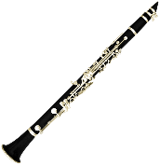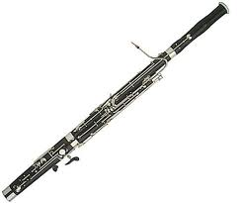Make a note in your diaries for our Easter Assembly, which will take place in school on **Wednesday 3rd April at 2:30pm.** You are all most welcome to attend.

**WHICH SUPERHERO INSTRUMENT ARE YOU?**

**15TH June 2019 – 10:00am start**

**TRINITY METHODIST CHURCH, WAGG STREET, CONGLETON, CW12 4BA**

**CONGLETON YOUTH ORCHESTRA OPEN DAY**

**EVER WANTED TO LEARN A MUSICAL INSTRUMENT?**

**THE CONGLETON YOUTH ORCHESTRA OPEN DAY IS YOUR CHANCE TO TRY A SELECTION OF INSTRUMENTS AND BEGIN YOUR OWN MUSICAL JOURNEY. OPEN TO AGES 7 AND OVER.**

**THE MORNING WILL TAKE THE FORM OF A MUSIC WORKSHOP.**

**WE OFFER FREE LOAN OF ORCHESTRAL INSTRUMENTS (subject to availability) AND EXPERT TUITION FOR 3 TERMS (30 minute duration in small groups) EACH SATURDAY MORNING.**

**MEMBERSHIP OF THE CYO IS £25 PER TERM. LESSONS BEGIN September 2019. Further details can be obtained from the secretary on 01260 278843 or via our web-site: www.CONGLETON-YOUTH-ORCHESTRA.ORG.UK**