Momo Challenge
Recently on the internet there have been stories about an image of a woman with wide eyes and a long wide grin on her face. Many people find this picture scary and creepy. You might have heard stories about this image or seen it yourself.
People have taken this image from the work of a Japanese Artist called Keisuke Aisawa who made a sculpture of a half woman half bird in 2016 for an art Gallery in Tokyo, Japan. This is known as a Hybrid creature, it is common in Japanese, Greek and many other cultures as folklore. Sometimes people make sculptures or artwork of this to make money or for school work. Sometimes people steal and change these images for other purposes.
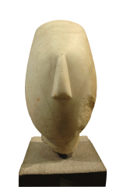
Keisuke Aisawa did not make the Momo Challenge. Others have taken the image of the sculpture and used it to scare people without Keisuke’s consent. They might appear on websites like YouTube or Facebook in the middle of videos or posts, or even in messages to your phone.
Sometimes the image in these videos or messages might ask you to do things. Some of these things might be very dangerous to you or others. Some of these things might be intended to get access to data on your computer or your phone, or ask for money.
If you see these things on the computer, or receive a message on your phone, you should stop and let an adult know, such as your parent or teacher.

