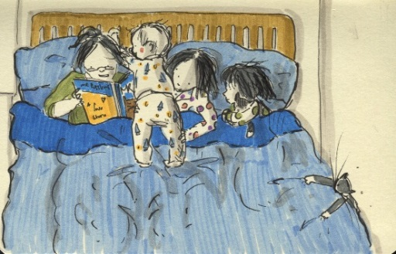

**WORLD BOOK DAY 2019**

Our theme is ***“BED-TIME STORIES”***

We would like the children to dress up as either one of their favourite bed-time story characters, or to simply come into school in their pyjamas. To take part, simply come into school on that day dressed up and bring in £1. All money collected will go towards some new class reading books.

Throughout the day there will be various reading activities

for the children to take part in.

There will also be a competition for the children to design

their own book cover for their favourite book.

There will be a prize for the winning design. Good luck!

**oOo**

As you know, each child gets given a Book Voucher to redeem for a book or as part payment for a book. As in previous years, if you would like us to redeem the voucher on your behalf, we are more than happy to collect it. If you would like us to do this please choose from the list below.

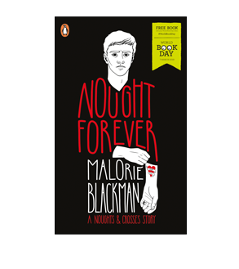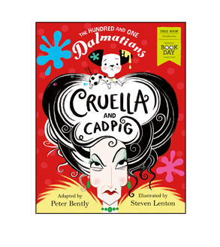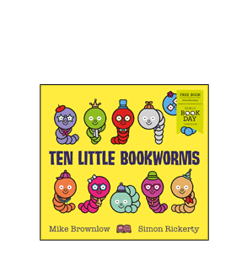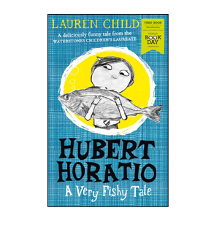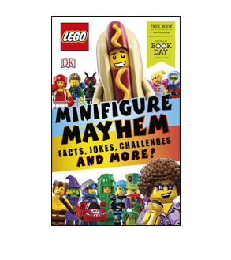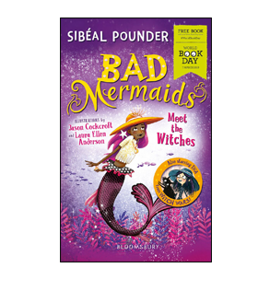

O o o o o o

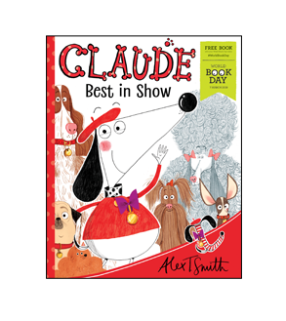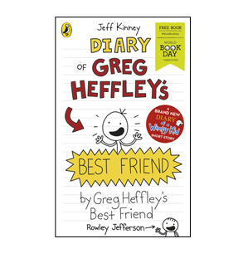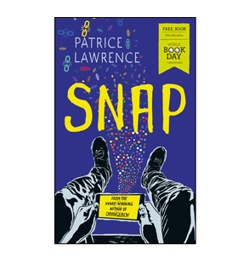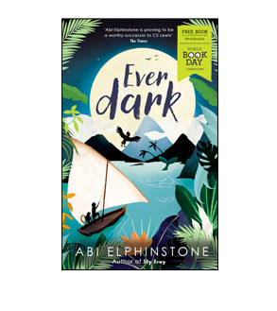

O o o o o o

**Child’s Name: Class:**

**please turn over**

**SCHOOL FUNDING PETITION**

**We have been asked by Cheshire East Council to make you aware of the following important message.**

You have possibly seen previous information about the unfair funding schools in Cheshire East receive.  Cheshire East remains one of the lowest funded authorities nationally and the current national fairer funding proposals do not address the significant variations in funding schools receive across the country.  Schools in Cheshire East do an amazing job achieving excellent outcomes for Children and Young People but behind the scenes schools are struggling to balance the budget.

Cheshire East Council together with the full school community is committed to campaigning for fairer funding.  The Leader of the Council, Cllr Rachel Bailey, and the Portfolio Holder for Children and Families, Cllr Jos Saunders, are committed to support any campaign but it is the voice of our schools and families that has the greatest impact.

Nationally, a School Funding Petition has been developed which all Cabinet Members, and Senior Officers in the Council have signed including the Chief Executive, Executive Director for People and the Director of Education.

We would like to ensure the results of the Campaign highlight the strength of feeling about school funding for Cheshire East Schools ensuring we are the area with the highest level of responses by a significant majority, if possible.

I would therefore encourage you, your family and friends to sign the petition.  This does take less than one minute to complete.  The only information you need is your postcode

Please add your name by following this link:

<https://petition.parliament.uk/petitions/232220>

I would like to thank you for your support on this matter.

**WEATHER**

Even though the weather earlier in the week was glorious, please ensure that your child still has a coat with them in case the weather should change.

**FROM BOTTLE TO BENCH**

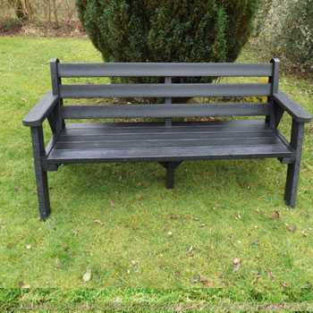Alfie in Year 2 is still working very hard collecting bottles and would like to say that he still needs lots more 2l clear plastic bottles to enable us to send them off to be recycled and modelled into one of these benches.

We need to have approximately 50kg, which as we am sure you will agree is a lot!

Alfie says we are currently up to 6kg so we are getting there.

If you have any bottles, please remove the labels, rinse out the bottles and send them into school please. We do not need the lids.