**COLD WEATHER**

***Friends of Marlfields (PTA)***

***IMPORTANT REMINDER***

*Don’t forget the Friends of Marlfields Coffee and Cake Morning on Wednesday 6th February.*

*Parents, carers, grandparents and friends are all welcome.*

*We are looking forward to seeing you there!*

***Miss Carter’s Sky-Dive***

Many thanks if you have

already made a

donation to Miss

Carter’s fund-raiser in

aid of The Christie Hospital.

However, she would greatly appreciate more. Either send your donation into school in a named envelope or on Miss Carter’s JustGiving page.

Please remember each day to send your child into school with a warm winter coat, hat, scarf, gloves and sensible shoes. Boots may be worn to school, **but** when the children are **indoors they need to change their footwear to either shoes or their P.E. pumps.**

Children **MUST** have their P.E. kit in school every day so that if they get wet they will have something to change into.

**Please ensure that you inform the Office of any changes to your telephone numbers so that if we need to text you in the event of an early closure we can ensure that you have got the message**.

**Should the decision to close early or to not open because of heavy snow, where possible we will text everyone, and will also place an announcement on the**

**following local radio stations:- Signal Radio, BBC Radio Stoke or Silk FM**

***96.4FM 94.6FM 106.9FM***





**FROM BOTTLE TO BENCH**

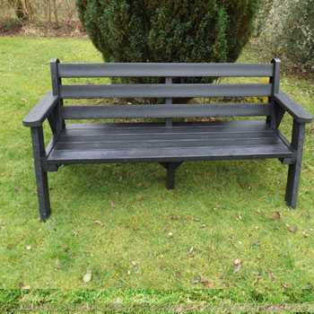We still needs lots of 2l clear plastic bottles to enable us to send them off to be recycled and modelled into one of these benches. We need to have approximately 50kg, which as we am sure you will agree is a lot!

If you have any bottles, please remove the labels, rinse out the bottles and send them into school please. We do not need the lids.

**HOLIDAY DATES 2018 - 2019**

**Last Day In School School Opens**

|  |  |  |
| --- | --- | --- |
| **Autumn Term** |  | **03.09.18** |
| **Half Term**  **Holiday** | **26.10.18** | **05.11.18**  **INSET DAY**  **06.11.18** |
| **Christmas Holiday** | **20.12.18** | **07.01.19** |
| **Spring Half**  **Term** | **15.02.19** | **25.02.19** |
| **Summer Term** | **05.04.19** | **23.04.19** |
| **Summer Half**  **Term** | **24.05.19** | **03.06.19** |
| **Summer holidays** | **19.07.19**  **22.07.19, 23.07.19, 24.07.19**  **INSET DAYS** |  |

**HOLIDAY DATES 2019 - 2020**

**Last Day In School School Opens**

**Holidays during term time**

**The law states that parents / guardians do not have the right to take their child out of school during term time.**

In **exceptional circumstances only** the Principal can authorise a period of leave.

**A form, which can be collected from the School Office, must be completed and authorised by the school BEFORE the absence;**

**If the holiday is unauthorised by the Principal and you still take your child out of school for a holiday you may be served with a FIXED PENALTY NOTICE.**

|  |  |  |
| --- | --- | --- |
| **Autumn Term** |  | **02.09.19** |
| **Half Term**  **Holiday** | **25.10.19** | **04.11.19** |
| **Christmas Holiday** | **18.12.19** | **06.01.20** |
| **Spring Half**  **Term** | **14.02.20** | **24.02.20** |
| **Summer Term** | **03.04.20** | **20.04.20** |
| **Summer Half**  **Term** | **22.05.20** | **01.06.20** |
| **Summer holidays** | **22.07.20** | **5 INSET DAYS TO BE ARRANGED** |