Welcome back to school, and a happy 2019 to you all!

FRIENDS OF MARLFIELDS (PTA) MEETING
The first meeting of the year for the Friends of Marlfields will be Monday 14th January at 9:00am.
We hope as many of you as possible can come along to help us think up new fun ways to raise extra funds for the children. Any questions before then, please let us know on 01260 633120.

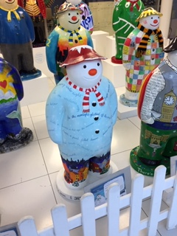
SNOWMAN
Did any of you get the chance to go to MediaCityUk during the holidays to see the Snowmen on display?
The large ones which were distributed around and about were absolutely fantastic, but in our opinion the ones which were painted by schools were the stars of the show!
We were most excited when we saw that our entry was on the front row and right in the centre so it seemed the most prominent one!
He will be returned to school shortly. You can still view them all on their web-site https://walkingwiththesnowman.co.uk/
PE KITS
We already have a number of children who have not had their PE kit in school this week. The children do get upset at having to miss out on their PE sessions.
PE is not optional and all classes have PE at some point each week. Therefore please ensure that your child has their kit with them each Monday and leave it in school until Friday when it can be taken home for washing ready to return back on Monday. Many thanks in anticipation of your co-operation.

COLD WEATHER
Please remember each day to send your child into school with a warm winter coat, hat, scarf, gloves and sensible shoes. Boots may be worn to school, but when the children are indoors they need to change their footwear to either shoes or their P.E. pumps.
Children MUST have their P.E. kit in school every day so that if they get wet they will have something to change into.
Please ensure that you inform the Office of any changes to your telephone numbers so that if we need to text you in the event of an early closure we can ensure that you have got the message.

Should the decision to close early or to not open because of heavy snow, where possible we will text everyone, and will also place an announcement on the following local radio stations:-
Signal Radio, BBC Radio Stoke or Silk FM
96.4FM 94.6FM 106.9FM

YOUR BIRTHDAY – YOUR CLOTHES!
Please remember that if it is your child’s birthday on a school day, we would like them to come in to school wearing their own clothes as a treat and to make them feel special.
We look forward to being able to wish your child “a Happy Birthday” when we see them in ‘normal’ clothes rather than uniform.
Some parents have asked that if it is a child’s birthday during a holidays would it be acceptable for the child to wear non-uniform on the last day of the half term.
This is fine with us so we look forward to seeing the children on the last day of term before their birthday in their own clothes.

