

**PRIOR NOTICE - ON-LINE PAYMENTS**

Following the Easter holidays we will become a ‘cashless’ school.

All payments made for lunches, snacks, uniforms, trips etc. will therefore have to be paid on-line.

Letters giving you the information on how to register on-line were sent out a few weeks ago. If you did not receive one, please call into the office and you will be issued with another to enable you to register. If you have any problems in registering please don’t hesitate to call in to the office and we will do our best to help you out.

From April 23rd cash payments **WILL NO LONGER BE ACCEPTED.**

As a reminder, all lunches, snacks etc. must be paid for in advance. Due to an increased number of bad debts credit will not be given from February 25th – no payment, no goods!

**FAIR-TRADE FORTNIGHT - World Poetry Competition**

During the holiday we would like the children to prepare an entry for our celebration of **Fair Trade Fortnight** which is the first two weeks after the half term break.

This year the **Fair Trade Society** are supporting a fair deal for cocoa farmers.  To celebrate this, we are asking all the children to write a poem about a cocoa bean.

Any form of poetry can be used (acrostic, limerick, narrative, rhyming, nonsense etc). The cocoa bean should be the focus of the poem **and the winner will be able to take their class to Cadbury’s World for a day out.**

During **Fair Trade Fortnight** Mrs Barnes, our cooking Teaching Assistant, will be holding fair trade chocolate workshops and sending any profit to the **Fair Trade Society** to support the fundraising that they do.

The judging of the poem will be on the following criteria:

1. It’s with the theme, **2)** poem concept and premise **3)** structure and pacing **4)** style and tone.

No poem will be too short or too long and can be handwritten or typed.

Return your entries to school by Wednesday 26th February and we will announce the winners on World Book Day (March 7th)

**EGG DECORATING**

*In preparation for our Easter events we have already sent home a small egg with your child for them to* ***decorate it over the holiday in any way that they wish, ensuring that their name and class in clearly shown on it****. Please return it to the class teacher by* ***THURSDAY 28th FEBRUARY****.*

**HALF TERM HOLIDAY**

School closes today, (Friday 15th February) for the half term holiday.

**School re-opens on Monday 25th February**.

Hope you have a lovely break and we will see you in a weeks’ time.

**CODE OF CONDUCT**

Please find with this Newsletter a copy of our children’s Code of Conduct. Due to recent events, we also point you to our Parents’ Code of Conduct; this can be seen on our web-site: http://marlfieldsprimary.co.uk

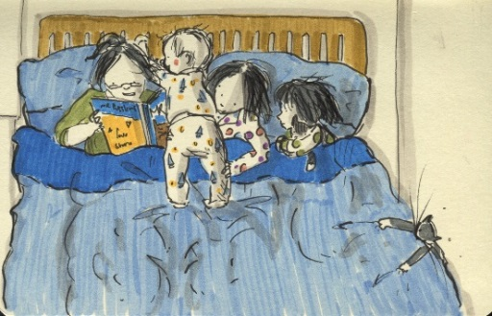

**WORLD BOOK DAY 2019**

This year **World Book Day** takes place on **Thursday 7th March.**

Our theme is ***“BED-TIME STORIES”***

We would like the children to dress up as either one of their favourite bed-time story characters, or to simply come into school in their pyjamas. To take part, simply come into school on that day dressed up and bring in £1. All money collected will go towards some new class reading books.

Throughout the day there will be various reading activities

for the children to take part in.

There will also be a competition for the children to design

their own book cover for their favourite book.

There will be a prize for the winning design. Good luck!

**oOo**

As you know, each child gets given a Book Voucher to redeem for a book or as part payment for a book. As in previous years, if you would like us to redeem the voucher on your behalf, we are more than happy to collect it. If you would like us to do this please choose from the list below.

**HALF TERM FUN AT CONGLETON LEISURE CENTRE**

**Fun Swim: 18th/20th/21st February, 2:30-3:30pm**

**Family: £12, Adult: £5, Junior: £4.20**

**Bouncy Tots: 19th February, 10:00-11:00am**

**Age 1 – 5: £2**

**Roller Disco: 18th February, 12:45-1:45pm**

**Adult: £3.25, Child: £2.80**

**“Mouse Trap”: 20th February, 10:00-11:00am**

**Age 6 -12: £2**

**Netball Camp: 22nd February: 10:00am-3:00pm**

**£15**

**THE FRIENDS OF MARLFIELDS**

The next Friends of Marlfields meeting will be on **Wednesday 27th February at 9:15a.m**. Everyone is welcome to come along and share any fundraising ideas that you may have!

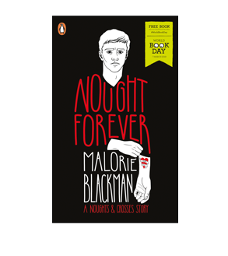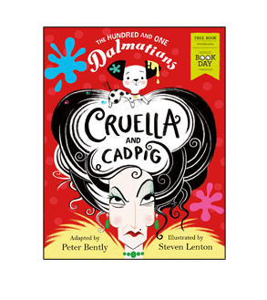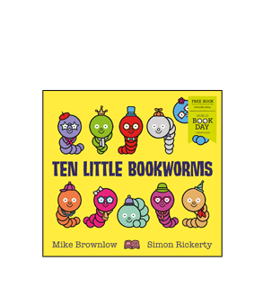

O o o o o o

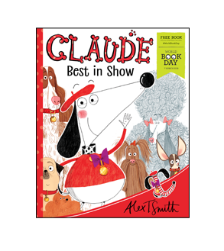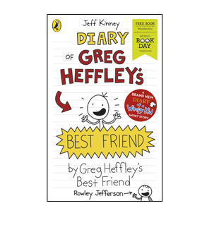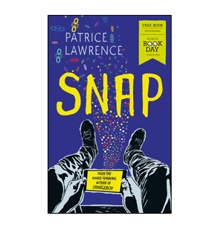

O o o o o o

**Child’s Name: Class:**