**COLD WEATHER**

***Miss Carter’s Sky-Dive***

Many thanks if you have

already made a

donation to Miss

Carter’s fund-raiser in

aid of The Christie Hospital.

However, she would greatly appreciate more. Either send your donation into school in a named envelope or on Miss Carter’s JustGiving page.

***Friends of Marlfields (PTA)***

***THANK YOU!***

*The Friends of Marlfields Coffee and Cake Morning on Wednesday 6th February raised over £300 and we would like to thank you for your support. Our next event will be advertised soon but if you would like to be involved please call the office and we will put you in touch with one of the members.*

*In preparation for their Easter events we are sending home a small egg with your child. They need to* ***decorate it and ensure that their name and class in clearly shown on it****. It needs to be returned for* ***TUHRSDAY 28th FEBRUARY*** *to the class teacher. THANK YOU!*

Please remember each day to send your child into school with a warm winter coat, hat, scarf, gloves and sensible shoes. Boots may be worn to school, **but** when the children are **indoors they need to change their footwear to either shoes or their P.E. pumps.**

Children **MUST** have their P.E. kit in school every day so that if they get wet they will have something to change into.

**Please ensure that you inform the Office of any changes to your telephone numbers so that if we need to text you in the event of an early closure we can ensure that you have got the message**.

**Should the decision to close early or to not open because of heavy snow, where possible we will text everyone, and will also place an announcement on the**

**following local radio stations:- Signal Radio, BBC Radio Stoke or Silk FM**

***96.4FM 94.6FM 106.9FM***

**FROM BOTTLE TO BENCH**

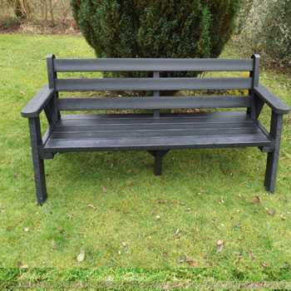Alfie in Year 2 is working hard collecting the bottles and would like to say that he still needs lots of 2l clear plastic bottles to enable us to send them off to be recycled and modelled into one of these benches. We need to have approximately 50kg, which as we am sure you will agree is a lot! Alfie says we are currently up to 6kg so we are getting there.

If you have any bottles, please remove the labels, rinse out the bottles and send them into school please. We do not need the lids.

**ECO FLAG AWARD RENEWAL**

Last week our children welcomed the Eco Green Flag Award Assessor who spent the morning with us. We were the first school in Congleton to gain the Eco Green Flag in 2006 and have successfully renewed every two years since. The Assessor was again impressed with our work and said this about us.

*“This is an excellent school, and they are ground braking with ideas that not only benefit the school but the local community. I was impressed on how they have managed to reduce the number of parents using cars to bring children to school over the year. It was very nice to see that the whole school is included in eco projects including the Reception class and there are many outdoor classrooms. There are a few Eco-Boards placed in strategic position throughout the school corridors, so the children cannot miss them. Well done to everyone and keep up the great work.”*

**HOLIDAY DATES 2018 - 2019**

**Last Day In School School Opens**

**Holidays during term time**

**The law states that parents / guardians do not have the right to take their child out of school during term time.**

In **exceptional circumstances only** the Principal can authorise a period of leave.

**A form, which can be collected from the School Office, must be completed and authorised by the school BEFORE the absence;**

**If the holiday is unauthorised by the Principal and you still take your child out of school for a holiday you may be served with a FIXED PENALTY NOTICE.**

|  |  |  |
| --- | --- | --- |
| **Autumn Term** |  | **03.09.18** |
| **Half Term**  **Holiday** | **26.10.18** | **05.11.18**  **INSET DAY**  **06.11.18** |
| **Christmas Holiday** | **20.12.18** | **07.01.19** |
| **Spring Half**  **Term** | **15.02.19** | **25.02.19** |
| **Summer Term** | **05.04.19** | **23.04.19** |
| **Summer Half**  **Term** | **24.05.19** | **03.06.19** |
| **Summer holidays** | **19.07.19**  **22.07.19, 23.07.19, 24.07.19**  **INSET DAYS** |  |