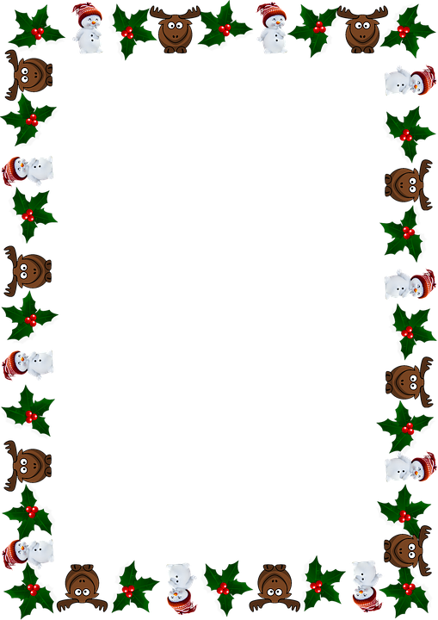

**Marlfields Newsletter**

**20th December 2018**

|  |
| --- |
| **IT’S CHRISTMAS!!!**  ***(Well, almost)***  We would like to thank you all for your support this term, and hope that you will support us for the rest of the school year.  We hope that everyone who has joined the school over the past term have settled in well and have made many new friends. |

**NEW TENANTS IN OUR OLD NURSERY BUILDING**

      We are sure you are aware of the workmen who have been busy in our old Nursery building.

      As you know this was occupied by Cherubs and Imps until recently; they have now

      moved to another part of the school.

      This is an area of our building that the school has always leased to a third party, since1998.

      It is completely self-contained and we do not need the space for our children in school,

      therefore we will continue to lease the building as this is one of the ways we are able to

      offer the little extras the children enjoy each year without asking you for money such as our

      recent trip to Cinderella on Ice.

      In January we will be welcoming our new tenants – Cornerstones Alternative Provision who

      are commissioned by Cheshire East Education Department to work with a small number of

      children generally over a six to twelve-week period.  It will not affect our day to day work as

      their hours **on site will be 9.30am till 2.30pm.**  They are completely separate to us and we will

      be their landlord.

      They will be on the site term time only.  Cornerstone Alternative Provision will be the latest

      Addition to The Fermain Academy who were recently graded as an Outstanding School in their

      recent  Ofsted and while we are not connected to them as with any community working we

      are sure we can learn something from them being on site.  Any questions please do not hesitate

      to speak to Mrs Isherwood.



We would like to let you know about a project that a number of schools in Halton, Warrington, Cheshire West & Chester and **Cheshire East** are participating in. The project, called Operation Encompass, is being run in partnership with **Cheshire Police**.

The project aims to support children who are affected by domestic abuse.

Following a domestic abuse incident, the Police will make contact with the school and communicate relevant information to nominated school staff, to ensure that the school are made aware early enough to support children and young people in a way that means they feel safe and included.

Each school has a member of staff (key adult) who is trained to liaise with the police, when required, whilst ensuring support is available to the child.

We are committed to working in partnership, to safeguard and protect children across Cheshire and provide the best possible care and support for our pupils.

In the meantime, if you would like to speak to someone further about the project or require further information, please do not hesitate to contact Mrs Isherwood

You can also find out more about Operation Encompass via the following web-site: <http://www.operationencompass.org/>

# j0350585

# j0213487MARLFIELDS PRIMARY & NURSERY SCHOOL

IS YOUR CHILD INTERESTED IN LEARNING A

MC900136595[1] **MUSICAL INSTRUMENT, OR WOULD THEY LIKE**

j0350579**SINGING LESSONS?**

# Mr Pickford currently has vacancies for learning the following

# instruments in Key Stage 2: -

**Keyboard Piano Guitar Cornet**

**+ Singing**

Lessons take place during school time for 10 minutes, 20 minutes or 30 minutes. The cost will be £4.00 per 10 minute lesson, £8 per 20 minute lesson or £12 per 30 minute lesson.

**We must emphasise at this point that this fee is payable at the beginning of each half term,**

e.g. 10 minutes lessons for a 7 week term would be –

7 x £4.00 = £28.00

**We must also emphasise that the fee is non-returnable in the event of your child not taking a lesson, or deciding to cease tuition. Should your child wish to cease lessons a terms notice must be given.**

It will also be necessary for your child to have his/her own music book, and to have access to their chosen instrument at home on which to practise.

**If your child is interested in taking up this opportunity to learn an instrument, please fill in the slip below and return it as soon as possible.**

------------------------------------------------------------------------------------------------------------------

### **Instrument/Singing Lessons**

My child ___________________________ in Class_____ would like to begin __________________tuition.

**I agree to pay the fee set at the beginning of each half term, and understand that this is non-returnable**.

**I understand that if my child decides to cease lessons a terms notice must be given.**

Signed __________________________ parent / guardian Date __________

**SCHOOL LIFE REMINDERS FOR JANUARY**

**COLD WEATHER**

Please remember each day to send your child into school with a warm winter coat, hat, scarf, gloves and sensible shoes. Boots may be worn to school, **but** when the children are **indoors they need to change their footwear to either shoes or their P.E. pumps.** Children **MUST** have their P.E. kit in school every day so that if they get wet they will have something to change into.

Please ensure that you inform the Office of any changes to your telephone numbers so that if we need to text you in the event of an early closure we can ensure that you have got the message.

**Should the decision to close early or to not open because of heavy snow, where possible we will text everyone, and will also place an announcement on the following local radio stations:-**

**Signal Radio, BBC Radio Stoke or Silk FM**

***96.4FM 94.6FM 106.9FM***

**UNIFORM**

Parents are reminded that Marlfields has a uniform and that children are expected to wear this at all times.

Uniform forms are available from the stand outside of the office should you wish to place an order.

|  |  |  |
| --- | --- | --- |
| **Uniform (compulsory)**  Red sweatshirt with logo  Red polo shirt with logo  Grey tartan kilt for girls  Grey trousers for boys  Grey tights/white socks for girls  Sensible black school shoes (**no trainers**). |  | **P.E. Kit: (compulsory)**  A red T-shirt with logo  Dark, preferably Black shorts  Black pumps for indoors P.E.  Trainers for outdoors P.E.  School logo track suit for outdoorP.E.which may be worn on Thursday and Fridays. |

**Medicines in School**

School can **only** administer medication which has been **prescribed** by a health professional and is brought to school in its original pharmacy bottle with label; a form for us to administer the medication **MUST** be filled in at the office. Medications should be left at and collected from the school office by an adult.

**School day**:

School starts at **8:55am**; children in Reception and Years 1 – 6 should assemble prior to this time on the big playground. Children in the Nursery should enter by the door nearest the Waggs Road pedestrian walkway which opens at 9:00am.

At the end of the school day - **3:20pm** parents should wait in the same place as in the morning and the class teacher will bring the children out to you. It would be greatly appreciated if parents did not crowd round the doors and stand well back as the teachers need to clearly see who the children are going to.

***If someone other than yourself should come to school to collect your child at the end of the day please inform the class teacher or the office who will be collecting.***  If we have not been notified we will not allow your child to leave school with that person until we have contacted you for verification which can cause consternation for whoever is collecting your child, yourself and indeed us, so please help us to help you by letting us know in advance. Similarly if you wish to allow your child to walk home on his/her own we need to have a letter from you indicating your wishes.

**School Meals & snack:**

All the children in Key Stage 1 are eligible to Universal Free School Meals;

If your child is in Y3, 4, 5 or 6 and you think that your child is entitled to Free School Meals you will need to check with and/or apply to Cheshire East Council on **0300 123 5012** or on-line.

For all other children the price of school meals is **£12.00 per week (£2.40 per day)** which should be sent in a **named** envelope **each Monday** morning even if your child only has, for example a school lunch on a Thursday, or any other day than Monday. Cheques should be made payable to **Marlfields Primary Academy. Alternatively you can pay directly into the school account or via our on-line payment system.** Please ask at the office for details.

**School snack** cost 50p per day/£2.50 per week, again this should be sent in on a Monday morning in a named envelope.

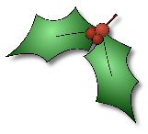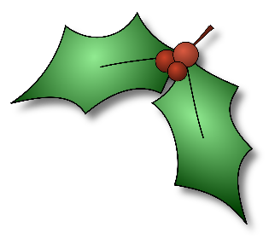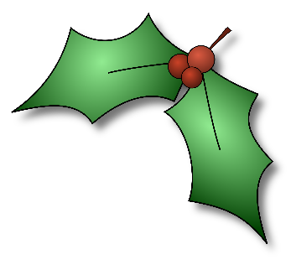

**School closes today (Thursday 20th December) for the Christmas Holiday and**

**will re-open for the children on Monday 7th January 2019.**

**Merry Christmas**

**and**

**Happy New Year**

**to you all.**

