Marlfields Newsletter
14th December 2018
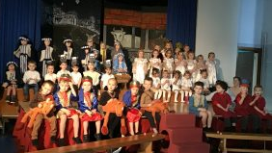
What a busy and exciting week we have had this week! It all started off last Friday with the Key Stage 1 performance of “Jesus’ Christmas Party”. It is always lovely to see so many eager faces wanting to do their best in front of family members. On Tuesday this week the children of the Foundation Stage performed “The Tip Toe Nativity”. Lots of people had tears in their eyes as we realised that we have some natural actors in our school!

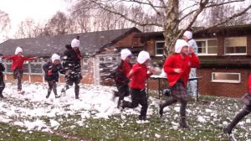
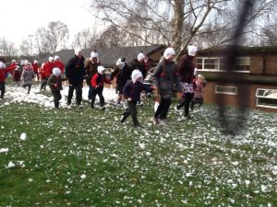
On Wednesday we had the Snowman Sprint, and is if by magic just as we were about to run we had snow (probably the only place in the UK to have had snow!) Thanks go to Miss Booth who brought two fabulous snow machines to help us along the way. We haven’t got an actual total yet but we estimate that we have raised about £1,500 for the Hospice thanks to all your hard work in gaining sponsors. As you can see everyone had great fun

After the run we came inside for hot chocolate and to have a go on a few stalls that we had set up, such as a Tombola, Guess the name of the Snowman and face painting to name just a few. Thank you for your support.

On Thursday the majority of the school got onto one of five coaches for the journey to Altrincham to Planet Ice. We watched the touring production of “Cinderella on Ice”. It was an amazing afternoon, but rather CHILLY!
Thank you Mrs Isherwood for taking everyone for a lovely Christmas outing.

Today (Friday) was the final Christmas performance, this time by Key Stage 2 who performed “The Magical Christmas Jigsaw”. Again this was another fantastic performance from the children. We are sure that you would join us in praising all the staff and children involved in the three productions for all the hard work that each and every one has put in to provide us all with a bit of Christmas cheer.

To try to boost the monies raised we would like to invite the children to come into school on the last day –Thursday 20th December with £1 so that they can come to school wearing their own Christmas Jumper. We hope that you feel able to support us in this additional fund-raiser for East Cheshire Hospice.
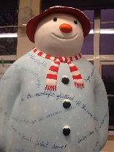
SNOWMAN TRAIL
Don’t forget to go and have a look at our Snowman around MediaCity in Manchester. Marlfields’ Snowman will be on display with other schools exhibits and 12 large Snowmen which have been painted by artists to celebrate 40 years since Raymond Briggs’ book “The Snowman” was published. Ours is called ‘Well Read Snowman’ and illustrates how great adventures can be written.

Venue Change: The following week on Wednesday 19th December is our Christingle Service for KS1 and KS2 at St Peter’s Church, Chapel Street from 9:30am, followed by Christmas Lunch for the children back at school.
The next day Thursday 20th December is our last day in school before the Christmas break.
School will finish at the usual time of 3:20pm.

