Marlfields Newsletter
30th November 2018

Please don’t forget to collect as many sponsors as possible in the sponsorship envelope which we sent out last week for this year’s SNOWMAN SPRINT in aid of the East Cheshire Hospice. Please also ensure that the front is filled in properly and if appropriate could you Gift Aid it as for every £1 donated the government give an extra 25p which soon adds up!
The Snowman Sprint is a fantastic way to celebrate the festive season while raising vital funds for our local East Cheshire Hospice.
Please, please, please try to get as many sponsors as you can to help this very worthwhile and well deserving charity. At our last Christmas Elf Run which we did for the Hospice we managed to raise over £2000. Can we beat it this year? Go on, give it a go and let’s try!

For everyone who collects sponsorship money to take part and raises more than £3 the Hospice will give you a snowman hat to wear during the race and to keep as a memento of the day. Children who do not return the forms will be invited to watch the sprint. Our Snowman Sprint will take place on Wednesday 12th December at 2.30pm.

During the morning of that day each class will take part in various ‘Snowman’ themed activities. After lunch the children will watch the film ‘The Snowman’ and then at 2:30pm there will be the sprint! Parents, grandparents and friends are more than welcome to come along to watch or to even take part in what we hope will be an especially fun afternoon!

After the race there will be numerous games, stalls, raffle, face painting and refreshments on sale to hopefully raise even more money. All proceeds will go to the East Cheshire Hospice. We would greatly appreciate any donations of tombola or raffle prizes that we can use for the Snowman Sprint Fundraising afternoon.
Christmas Events
Over the next three weeks, lots of esciting things will be happening at school, we hope that where possible that you can attend to support your child and the school.

- The first event to happen will be on FRIDAY 7th December – which is the Key Stage 1 (Years 1 & 2) Christmas production of “Jesus’ Christmas Party” at 9:30am in the school hall.

- The following week on Tuesday 11th December it is the turn of our Foundation Stage (Nursery & Reception) children to dazzle us all with their Christmas production of “The Tiptoe Nativity” at 9:30am in the school hall.

- The following day, Wednesday 12th December is our SNOWMAN SPRINT SPECTACULAR EVENT events for the children throughout the morning, and the grand race event from 2:30pm followed by games and stalls within school.

- Thursday 13th December sees the whole school having an early lunch before heading off to Altrincham’s Planet Ice to watch Cinderella on Ice at no cost to yourselves. Please complete and return the permission slip below – NO SLIP, NO TRIP! Please note that we will not return to school until approximately 4:30pm following this Christmas treat.

Friday 14th December is the turn of the children in Key Stage 2 (Years 3 – 6) to entertain us with “The Magical Christmas Jigsaw” in the school hall at 9:30am.

The following week on Wednesday 19th December is our Christingle Service for KS1 and KS2 at St James The Great Church, Astbury Street from 9:30am, followed by Christmas Lunch for the children (details overleaf).

The next day Thursday 20th December is our last day in school before the Christmas break. School will finish at the usual time of 3:20pm.

We hope that you are able to come along to support some or all of these events, you will be made most welcome even if your child is not in that year group.
----------------------------------------------------------------------------------------------------------------CINDERELLA ON ICE

Child’s Name: _______________________________________________ Class:_______

I give permission for my child to travel by coach to Planet Ice in Altrincham to watch Cinderella on Ice Thursday 13th December.

I or my representative ___________________________________ will collect my child after the visit, and understand that this will be approximately at 4:30pm dependant on traffic.

Signed: ______________________________ parent/carer Date: _____________

Emergency Contact number: _______________________________________
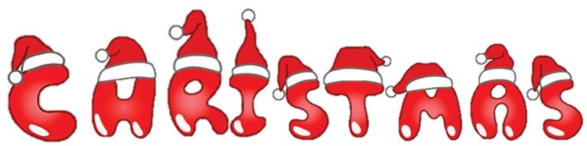

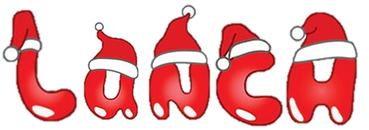

Choice of:
Roast Turkey with Stuffing & Gravy
Cheese Flan (v)

Served with:
Roast Potatoes, Carrots & Sprouts

Followed by a choice of:
Ice Cream Snowman
Festive Slice with Custard
Fresh Fruit

Selection of Drinks

Lunch is £2.40 per child, unless in receipt of Free School Meals,
including universal infant free school meals.

Child’s Name: _________________________________________________ Class: ________
Would like a School Christmas Lunch on Wednesday 19th December.

I enclose £2.40 / My child gets FSM / My child gets UIFSM
please delete where applicable

Please complete and return this slip ASAP in
order for your child to receive a
Christmas Lunch

On: Wednesday 19th December

Choose from:
Roast Turkey with Stuffing & Gravy
Cheese Flan (v)

Served with:
Roast Potatoes
Carrots & Sprouts

Followed by a choice of:
Ice Cream Snowman
Festive Slice with Custard
Fresh Fruit

Selection of Drinks

------------------------------------------------------------------------------
Lunch is £2.40 per child, unless in receipt of free school
meals, including universal infant free school meals.

Many thanks, catering supervisor

