**SUMMER READING CHALLENGE 2018**

The Summer Reading Challenge at the Library, “Mischief Makers” has now finished. The children will receive a Mischief Makers certificate and a medal from the Library and to receive our treat from school they need to bring these in by **25th September**. Thank you to those of you who have already brought your certificates in.

**MARLFIELDS RECOGNISED FOR EXCELLENCE IN SCIENCE TEACHING**

Marlfields has today been awarded the prestigious BRONZE Space Education Quality Mark, in recognition of its excellent work compared nationally. UK schools and colleges receive the Space Education Quality Mark when they can show that they have significantly used the context of space in subjects, have worked with other organisations, shared resources and used space to enrich the curriculum.

The Space Education Quality Mark was created by ESERO-UK, which supports the space sector and teachers to open doors for young people from all backgrounds, by delivering inspiring world-class teaching in science, technology, engineering and mathematics (STEM) subjects. Alex Brown,European Space Education Resource Office Manager at STEM Learning, said:

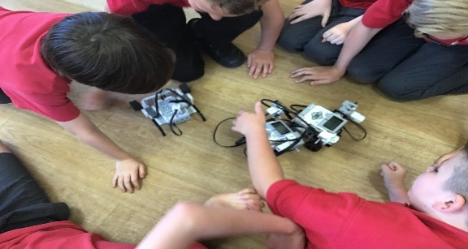“We are delighted to congratulate Marlfields Primary Academy on receiving the BRONZE Space Education Quality Mark. Each school and college who receives the Space Education Mark has demonstrated a real and ongoing commitment to excellent STEM education in their school. Marlfields Primary Academy is a great example of this.”

**BEES IN MANCHESTER**

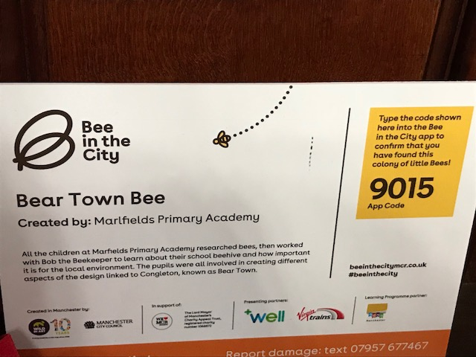

As you are aware Year 4 decorated one of the bees to be on the Bee trail in Manchester over the summer holidays. Some of our children had a day out in Manchester and found our bee within Manchester Cathedral, it was one of over 100 bees and we had some lovely comments on Congleton Chat’s Back from members of our town’s community about how fantastic it was that as a school we were representing Congleton in supporting this high profile event.

Thank you Thane, Sam and Charlie for our great photos!

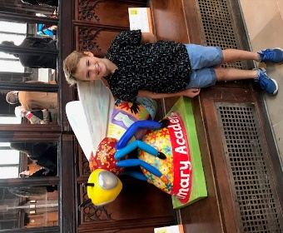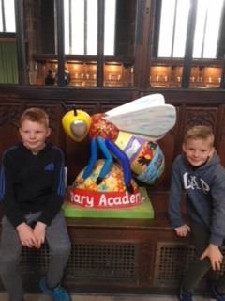

**WORDS ARE SOMETIMES NOT ENOUGH**

It is with great sadness that during the summer break one of our Governors passed away at the East Cheshire Hospice. Mr Davenport was a Governor at the school for over 14 years and took an active role in looking after our environment and finances. He has accompanied many of the class trips and been the link Governor for Year 5 for a number of years often popping in to see them.

Brian was married to Mrs Davenport (Norma), who worked at Marlfields for 38 years as a midday assistant and supporting children.

Although Norma retired she still comes into school as a volunteer each week working with our Reception children. Best wishes from the school have been sent to the family but in memory of the time Brain gave to many of us all here now and those over his 14 year role as a Governor at Marlfields we invite you, should you wish, to bring a donation into school for the East Cheshire Hospice in Macclesfield. This will then be sent onto the hospice in memory of Brian. Thank you.

**BOOK CHARACTER DRESS UP DAY – 13th SEPTEMBER**

On Thursday 13th September we are celebrating reading and books. It is Roald Dahl Day and many of our children are doing an author investigation within their work this term. To celebrate we are inviting everyone to come dressed as their favourite character from any book they have enjoyed. There is no cost to this day.

**CHERUBS & IMPS**

Cherubs & Imps provide before and after school care for our pupils and you will have noticed that they have moved into a new area. Their rates are competitive and they have been a partner of the school for over 15 years providing high quality care. Please contact them if you have a need for daily support or even holiday support as they work during the holiday to meet the needs of working parents. Their number 01260 272221.

You may be wondering what the area that they were in will now be used for and in the first instance we will be doing re-decoration and will keep you informed of the use it will be put to when we have it confirmed.