SPORTS DAY
We would like thank everyone who came to our Sports Day on Tuesday 3rd July.
We all had a great time and enjoyed the events and activities. Well done to all the children, there was a real feeling of good sportsmanship throughout the morning!
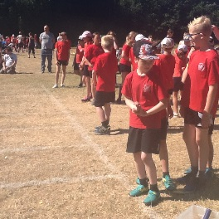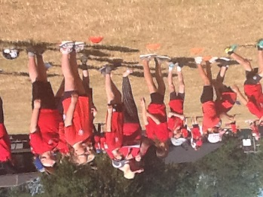

TOWN SPORTS
What a wonderful evening for the Town Sports events. The children really enjoyed themselves and some of our children went home with medals!
Well done to everyone who took part and all those families that came to support.
A big thank you to the Yates family for helping out with a pop-up-gazebo and Ms Young for kindly providing soft drinks for everyone.

SUMMER READING CHALLENGE 2018
The Summer Reading Challenge encourages children and families into the Library to inspire them to read for pleasure along with fun social events.
This year the theme is “Mischief Makers”; this is to commemorate the 70th anniversary of The Beano.
The children will receive a Mischief Makers collector poster to get them started, and all they then have to do is over the Summer holidays is to
read at least SIX books whilst collecting stickers for their chars along the way.
At the end of the challenge they will receive a certificate and a medal from the Library and a special surprise from school too!

PLANTING AT ASTBURY MERE
On Wednesday 27th June Year 3 children helped plant the new planter outside the café at Astbury Mere. Working with Patti Pinto and Jeannie Silk the children spent the afternoon making the planter look wonderful. Let’s hope the hot weather hasn’t been too much for the recently planted bed.
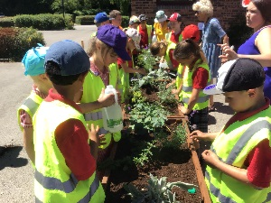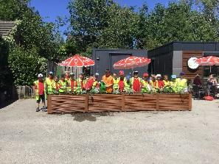

RECEPTION CLASS ENTERPRISE WEEK
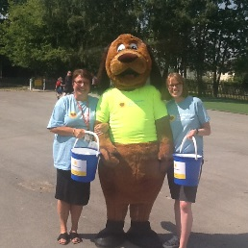

This week for our Reception Class Enterprise Week the children raised money for the East Cheshire Hospice, a very worthwhile cause that we should support as much as possible.
On Thursday 5th July the children all wore something yellow and during Sports Day Mrs Barnes walked round with a collection bucket for donations, for which we thank her.
So far we have raised over £300 and the money is still coming in!
All further contributions would be gratefully received and should be brought to the main office.
Well done Reception Class this was a wonderful idea and so many people will benefit from your generosity.

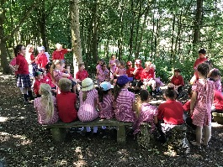 FOREST SCHOOL WEEK
This week we have celebrated our wonderful woods by joining in a range of activities based around work in our woodland. The children worked in their house teams to create natural art work, complete a curiosity box and joined in challenges to extend their knowledge of the animals which represent each house.
SCHOOL COUNCIL PIRATE DAY FRIDAY 13th JULY
Come dressed as a Pirate for the day (Cost £1 towards School Council Funds)! Ice pops will be on sale 20p or 50p for lollies.
‘PIRATES OF THE CURRYBEAN’ – TICKETS AVAILABLE
Year 6 have kindly opened up tickets to the rest of the school (limited tickets available to first come first served). Please apply on the slip below.
We would like ______tickets for the Y6 performance of ‘Pirates of the Currybean’ on Thurdsay12 July at 6pm.
Name of child ____________________ Class _____

