We hope you all had a really great half term holiday and have enjoyed the first week back at school.

**WARM WEATHER**

Wow! Are you enjoying the hot sunny days?

Please ensure that your child has with them in school a hat to provide your child with some shade and a water bottle that they can easily re-fill whilst in school to keep them hydrated.

You should also apply one of the long-acting sun creams that you can now buy. Children are not permitted to apply their own creams during the day so please do not send them in with a bottle.

We do limit the length of time that the children are exposed to the sun, but equally we need to give them some out-side time which means that they will need to wear sun screen.

**HALL FLOOR**

During the half term holiday, we had the Hall floor stripped and re-polished and you would not believe the difference it has made!

Next time you are in for Thumbs up Thursday pop your head into the Hall and have a look, you’ll be amazed at the transformation.

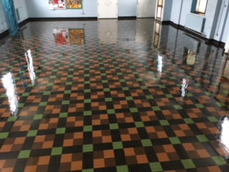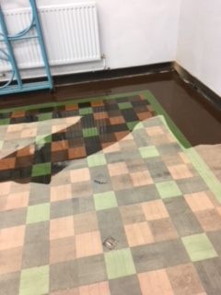 Before After

**Can you believe the change?**

[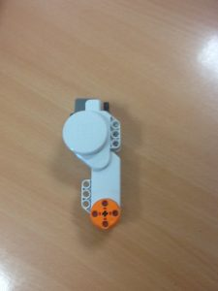](http://blog.marlfieldsprimary.co.uk/wp-content/uploads/2018/06/IMG_3367.jpg)

**BLUE PETER BADGES**

Don’t forget, if your child has been fortunate enough to win a Blue Peter Badge, please allow them to bring their badge into school on **Monday 18th June 2018** in order for the Congleton Chronicle to take a photograph of all our winners together.

**SPORTS DAY**

We would like to remind you of the date and times of our Sports Day. This year **SPORTS DAY** will take place on **Wednesday 5th July** starting **at 9:30am**. Key Stages 1 & 2 will unite to take part in mixed team events with siblings being in the same team. The children need to wear their Marlfields P.E. kit. The children will be provided with sun visors in their team colours.

Drinks will be available for you to buy during the morning.

Following the sports why not bring a picnic lunch for you and your child to enjoy together?

Should the weather be inclement and we need to cancel, we will text you as early as possible, and Sports Day will be scheduled to take place on the reserve date will be on Thursday **5th July**, at the same times as above.

Should you wish to go along to cheer the Marlfields team, the annual TOWN SPORTS competition takes place on Wednesday 4th July at Congleton Town FC at 6:00pm.

# A day with Robo

By Class 6

Last week, class 6 took part in assembling a robot with Karol Langer (a robot designer).

[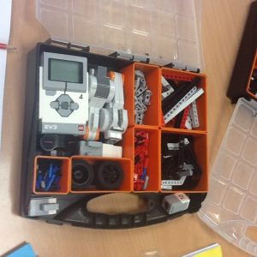](http://blog.marlfieldsprimary.co.uk/wp-content/uploads/2018/06/IMG_3354.jpg)We all enjoyed it and we were all grateful that we received the opportunity to take part.  
To start with, we were divided into groups of three.

[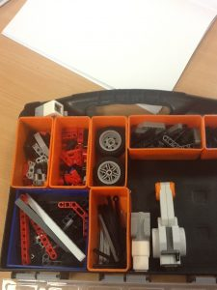](http://blog.marlfieldsprimary.co.uk/wp-content/uploads/2018/06/IMG_3365.jpg)My group was me Lily and Ella. Everyone worked together and created a working moving robot. It was great fun.  
First, we used the motors (like the legs) to construct a stable base. My group used connectors, pins and beams (part of the set) with the motors and it looked amazing.  
After this, we added the controller (like the brain) and the sensor (it made the robot turn away from obstacles) the machine would work. The final step is to build the robot and to decorate it. My group and several others added wings to the robots. Finally, we tested them out and had a race. Some of us had to adjust a couple of things, like the direction of the sensor, but they ended up working very well indeed.

**YEAR 5 GO TO ASTBURY MERE**

Last Friday Year 5 went to Astbury Mere to have a go at paddle boarding and canoeing. When they came back at lunchtime they were all buzzing with excitement at the fun time that they had in the water.

Libby wrote the following report –

What I learnt…….

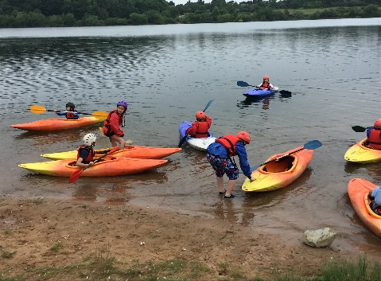I learnt how to hold an oar and what all the parts are. I started with canoeing. Our instructor, Aaron, told us all the parts of the canoe, how to control it, and how to move it. I shared a canoe with Chloe.

What I enjoyed…….

I enjoyed all of it. I liked how Aaron was very funny. I enjoyed learning all the different parts. Aaron tipped the canoe upside down and we ran and slid across the bottom of it, this was called the Penguin Slide. It was so funny!

What I will work on next time …….

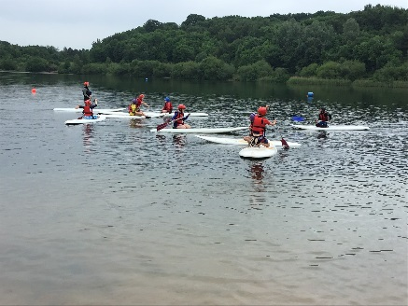I will work on keeping the canoe straight and not turning doughnuts, and getting used to the cold water quicker!

Thank you Mrs Isherwood for allowing us to enjoy this amazing experience.

**HOLIDAY DATES 2017 - 2018**

**Last Day In School**

|  |  |  |
| --- | --- | --- |
| **Summer Holidays** | **20.07.18**  **23.07.18**  **24.07.18**  **25.07.18**  **INSET DAYS** |  |

**HOLIDAY DATES 2018 - 2019**

**Last Day In School School Opens**

|  |  |  |
| --- | --- | --- |
| **Autumn Term** |  | **03.09.18**  **INSET DAY**  **04.09.18** |
| **Half Term**  **Holiday** | **26.10.18** | **05.11.18**  **INSET DAY**  **06.11.18** |
| **Christmas Holiday** | **20.12.18** | **07.01.19** |
| **Spring Half Term** | **18.02.19** | **25.02.19** |
| **Summer Term** | **08.04.19** | **23.04.19** |
| **Summer Half Term** | **24.05.19** | **03.06.19** |
| **Summer holidays** | **19.07.19**  **22.07.19**  **23.07.19**  **24.07.19**  **INSET DAYS** |  |





**CAMEO**

**(Come And Meet Each Other)**

**DAYS**

Starting Reception Class / Year 1 is a very exciting time (Sept 2018).

Why not come along to

**Go Bananas** on our

**CAMEO DAYS** and meet your fellow class mates to break the ice and to ease any first day nerves.

Please book your place via Facebook or call 01260 289145.

**14th August 2018 –10.00 – Midday**



Normal entrance fee's apply.

FREE HOT DRINK WITH EACH PAYING CHILD!!



**Marlfields Primary Academy**

Principal: **Mrs S. Isherwood** Waggs Road,

Vice Principal: **Miss M. Carr** Congleton,

**Email:** [**head@marlfields.cheshire.sch.uk**](mailto:head@marlfields.cheshire.sch.uk) **or** Cheshire. CW12 4BT

[**admin@marlfields.cheshire.sch.uk**](mailto:admin@marlfields.cheshire.sch.uk)

Tel: 01260 387057

11th June 2018

**Parent Trustees**

Dear Parents and Guardians,

Vacancies have arisen for two Parent Trustees on our governing board. This letter therefore gives notice that the parent body is required to elect two members to serve as Trustees on the governing board for a term of 4 years.

The position of Parent Trustee is a responsible, challenging and interesting role, and is one, which requires commitment and dedication to our school. No experience is necessary as there are many courses available, both in person and online for ‘new’ Trustees to help them understand the role and the responsibilities that the post entails. The Clerk to Trustees provides information on training courses and will provide new trustees with an induction pack.

The governing board expects trustees to:

• Adhere to the Code of Conduct for Trustees of Marlfields Primary Academy

• Attend 3 termly meetings of the Full Governing Board (the next meeting is Wednesday 11th July at 5pm)

• Sit on at least one committee and attend the meetings which are usually held once a term

• Commit to attend training courses as necessary and take part in formal monitoring within the school at agreed times of the year.

If you would like to find out more about how you can contribute to governance at our school, please contact myself or the Clerk to Trustees; Mrs Camp (scamp@marlfields.cheshire.sch.uk), and we will pass on your details to the Chair of Trustees who will then arrange a time for a conversation.

A nomination paper is on the reverse of this letter. Please be sure that the nominated person is prepared to stand for office and that the signature of a seconder is obtained prior to submitting the nomination. In the event of there being more nominations than vacancies, an election will then be held, prior to which each nominee will be asked to submit a personal statement. These will be available for all parents to consider before the election takes place.

Completed nomination papers should be handed in to the School Office on or before midday on Monday 25th June 2018.

Yours sincerely,

Mrs S Isherwood

Principal

**PARENT TRUSTEE ELECTIONS – NOMINATION PAPER**

**MARLFIELDS PRIMARY ACADEMY**

**1. THE CANDIDATE**

Surname Forename Preferred title

_________________________________ ______________________________ ________

Address Names (s) and Age (s)

of Child(ren) in school

___________________________________ ________________________________ ________

___________________________________ ________________________________ ________

___________________________________ ________________________________ ________

Telephone number ________________________________

**2. PROPOSER AND SECONDER**

**Proposer’s signature** __________________________________________________

Name _________________________________________ Names (s) and Age (s)

of Child(ren) in school

Address

________________________________________ ________________________________ ________

________________________________________ ________________________________ ________

________________________________________ ________________________________ ________

**Seconder’s signature** __________________________________________________

Name _________________________________________ Names (s) and Age (s)

of Child(ren) in school

Address

________________________________________ ________________________________ ________

________________________________________ ________________________________ ________

________________________________________ ________________________________ ________

**3. AGREEMENT TO NOMINATION**

I agree to stand as a candidate in the above parent trustee election.

Signature ______________________________________________ Date ____________________

(No individual may normally serve on more than two governing/trustee bodies)

**4. ELECTION STATEMENT**

You may wish to attach, in not more than 100 words, a statement in support of your nomination. This will be sent to parents with the ballot paper.