staffing structure for the
academic year September 2018 to July 2019.
FOUNDATION STAGE
NURSERY:  Reception: | Mrs N Daly  Miss S Barber | 4 mornings per week
KEY STAGE 1
Year 1: | Miss S Carter
year2: | Mrs S Radcliffe
Teaching Assistant support in these areas:
Mrs Maddison, Mrs Milroy, Mrs Bennett and Mrs Boon
There is also 1:1 Support Staff with other children.
KEY STAGE 2
year 3: | Mrs L Pearce - | TA: Mrs J Wood
year 4: | Miss S Booth - | TA: Mrs M Boon
year 5: | Miss A Sowry
Year 6: | Miss M Carr - | TA: Mr P Rowe -2 days
There is also 1:1 Support Staff with other children.

As part of our transition work and to support children moving to their new class in September we have arranged ‘Move Up’ sessions this term.
These ‘Move Up’ sessions will be on Thursday 28th and Friday 29th June and will allow children to meet their teacher in their new classroom ready for September. The teachers will ask the children to complete some getting to know each other activities, including writing, maths activities and social games. This will allow the teachers to put names to faces and better prepare for their new class over the holidays as well as alleviate any of your child’s worries.
As part of this process we would like to invite you to meet your child’s new teacher on Thursday 28th June starting at 3.30pm and repeating the meeting at 4pm for parents with siblings in the school.
Should you have any questions regarding the above arrangements please do not hesitate to ask.
Meet the Teacher on Thursday 28th June 2018
Child’s Name________________________ Current Class ____

Child’s Name________________________ Current Class ____

Child’s Name________________________ Current Class ____
□ I will be attending the ‘Meet the Teacher’ meeting at 3.30pm in class ____.
□ I will be attending the ‘Meet the Teacher’ meeting at 4pm in class _____.
□ I will be unable to attend either of these meetings.
Signed: ___________________________ parent/carer
Date: ____________
SPORTS DAY
We would like to remind you of the date and times of our Sports Day. This year SPORTS DAY will take place on TUESDAY 5th July starting at 9:30am.
Key Stages 1 & 2 will unite to take part in mixed team events with siblings being in the same team.
The children need to wear their Marlfields P.E. kit.
Drinks will be available for you to buy during the morning.
Should the weather be inclement and we need to cancel, we will text you as early in the day as possible, and Sports Day will be scheduled to take place on the reserve date will be on Thursday 5th July, at the same times as above.
Should you wish to go along to cheer the Marlfields team, the annual TOWN SPORTS competition takes place on Wednesday 4th July at Congleton Town Football Club’s ground at 6:00pm.
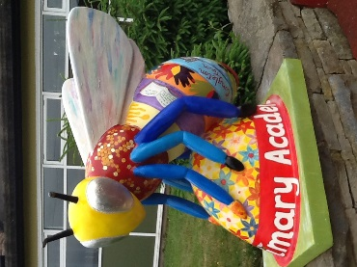

In recognition of the atrocities that took place at the Manchester Arena last year and to celebrate the Manchester bee symbol which was adopted following the disaster, 95 Worker Bees have been produced and decorated by various artists and schools etc. to form a trail around Manchester this summer.
(The worker bee motif has been part of the city’s heraldry for more than 150 years as an emblem of the industrious Mancunian spirit.)

We have decorated one of the bees and ours is on display at Manchester Cathedral. The trail begins on Saturday 23rd July and runs through to 23rd September. Why not go along to follow the trail and try to find all of the bees!
BLUE PETER BADGE HOLDERS
Our amazing Blue Peter Badge Holders together in celebration of their achievements!

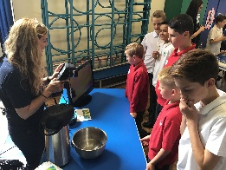
THE GREAT SCIENCE SHARE

Earlier this week a number of children went to Rode Heath Primary School to join in the Great Science Share Week, which is a national scheme to encourage children to take part in science experiments and to share them with others.

