**RIGHT ROYAL WEDDING RECEPTION**

 Thank you to everyone who have sent in their contributions for us all to share at our Royal Wedding Reception Picnic. The weather forecast is for a nice day on Friday, let’s hope that they get it right!

The order of the day is, during the morning the whole school will (weather permitting) walk down to Congleton Park for a morning of games and fun. We will then walk back to school for a Royal Picnic Lunch.

**Don’t forget to come to school dressed for a wedding!**

**ANNUAL FOOTBALL TOURNAMENT**

Thanks must also go to everyone who came along to the annual inter-school football tournament to either cheer on our team or to help with refreshments etc.

Although our team of marvellous players didn’t win, they all played with great sportsmanship and talent – we are proud of you all. Thank you for representing Marlfields at football!

During the morning we sold refreshments – bacon and sausage butties, tea and coffee, sweets and soft drinks and we are pleased to let you know that we made over £300 profit.

**BLUE PETER BADGES**

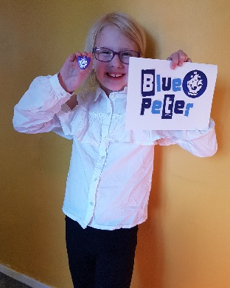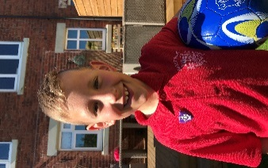Has your child been lucky enough to gain a Blue Peter Badge?

If they have completed the Headteacher challenge, please allow them to bring their badge into school on **Monday 18th June 2018** in order for the Congleton Chronicle to take a photograph of all our winners together.

**SUMMER READING CHALLENGE 2018**

The Summer Reading Challenge encourages children and families into the Library to inspire them to read for pleasure along with fun social events and a creative on-line element and it’s easy to take part: you can either sign up as a

family at the Library from mid-July or alternatively if the children bring in their Library Card Mrs Stapleton will walk groups of children to the Library to enrol them.

This year the theme is “Mischief Makers”; this is to commemorate the 70th anniversary of The Beano.

The children will receive a Mischief Makers collector poster to get them started, and all they then have to do is over the Summer holidays is to read at least **SIX** books whilst collecting stickers for their chars along the way.

At the end of the challenge they will receive a certificate and a medal from the Library and a special surprise from school too!

**FREE HALF TERM ACTIVITIES**

From Saturday 26th May – Sunday 3rd June 2018 there are lots of free events taking place across Cheshire. Please use the link below to see what is happening, when and where.

[**www.amazedbyscience.co.uk**](http://www.amazedbyscience.co.uk)

**HOLIDAY DATES 2017 - 2018**

**Last Day In School School Opens**

|  |  |  |
| --- | --- | --- |
| **Summer Half Term** | **25.05.18** | **04.06.18** |
| **Summer Holidays** | **20.07.18**  **23.07.18**  **24.07.18**  **25.07.18**  **INSET DAYS** |  |

**HOLIDAY DATES 2018 - 2019**

**Last Day In School School Opens**

|  |  |  |
| --- | --- | --- |
| **Autumn Term** |  | **03.09.18** |
| **Half Term**  **Holiday** | **26.10.18** | **05.11.18** |
| **Christmas Holiday** | **20.12.18** | **07.01.19** |
| **Spring Half**  **Term** | **18.02.19** | **25.02.19** |
| **Summer Term** | **08.04.19** | **23.04.19** |
| **Summer Half**  **Term** | **24.05.19** | **03.06.19** |
| **Summer holidays** | **24.07.19** | **5 INSET DAYS TO BE ADDED** |