All this week we have been celebrating British Science week in school.

Each day each Class have been doing something totally different. Here is a snippet of their activities.
Thursday was ‘Slime Day’ for all. Many thanks to everyone who supported us by sending in 50p. We raised £65 which has gone towards paying for workshops which the children have taken part in during the week. Many of the following reports have been written by the children themselves.

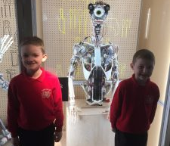
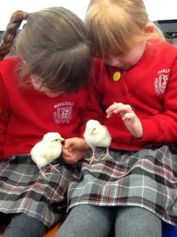
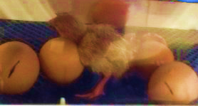
Reception Class: Their main focus during Science Week was watching the eggs in an incubator and hatching out into adorable chicks and watching them grow, and being able to carefully hold them.
The chicks have now left us to go back to the farm to continue growing there.
Reception have also been on Spring Walks to look at all the changes in the environment now that Spring is here.

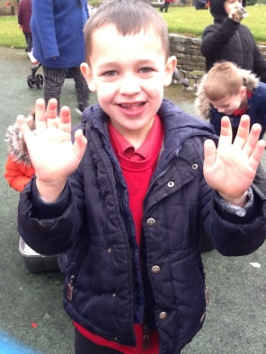
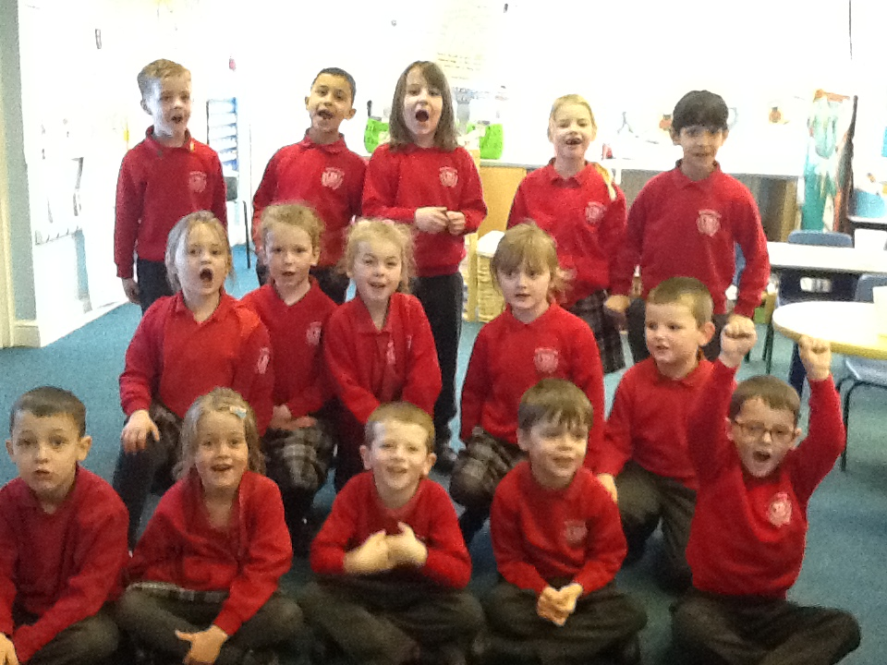
Year 1: Year 1 enjoyed all of their Science Week activities.
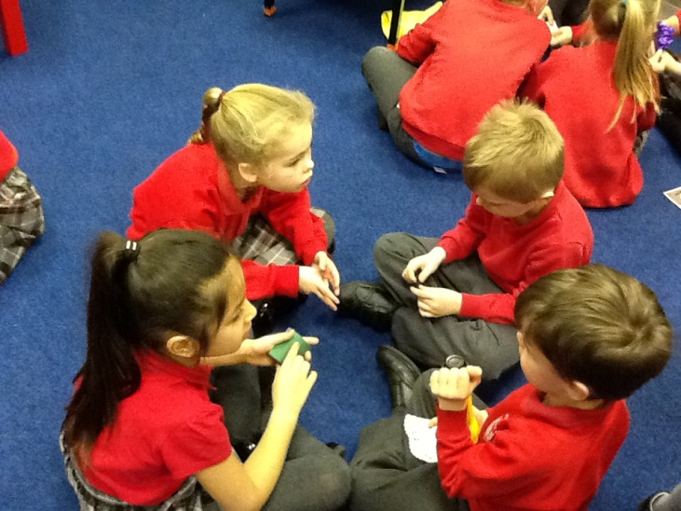
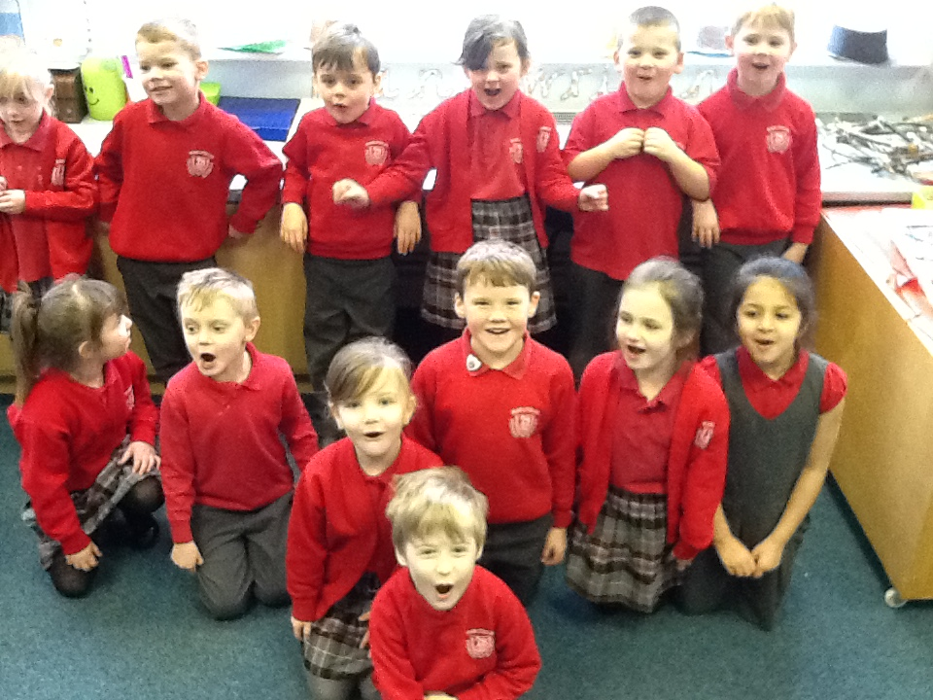
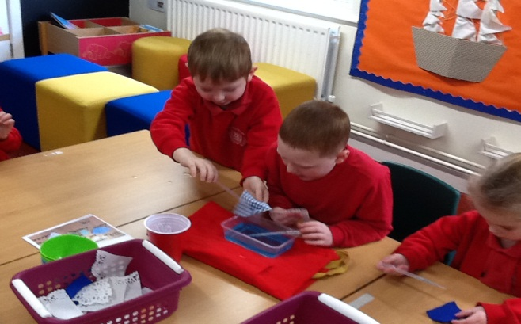
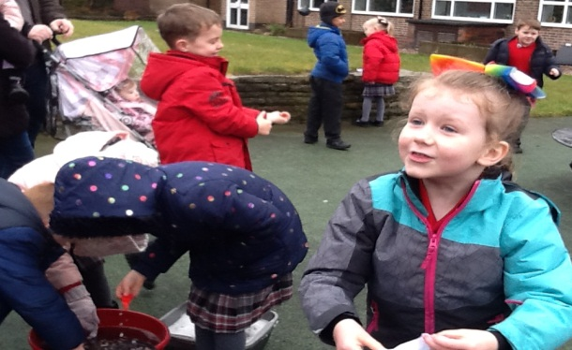
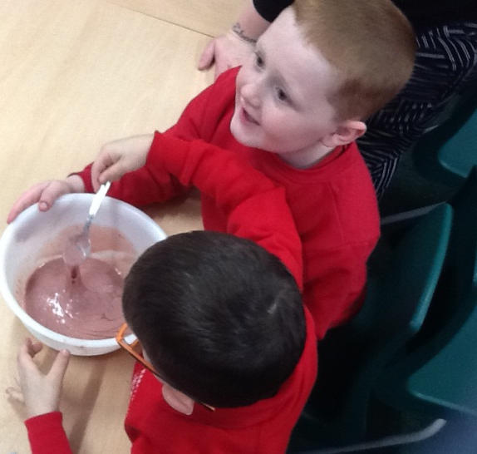
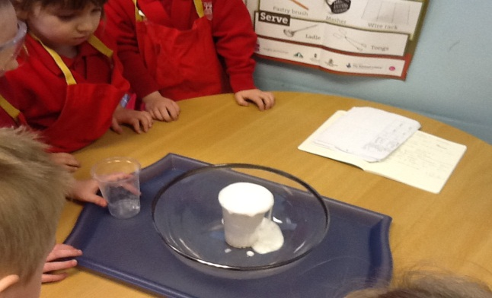
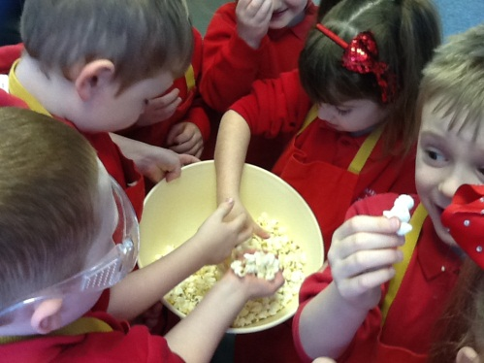

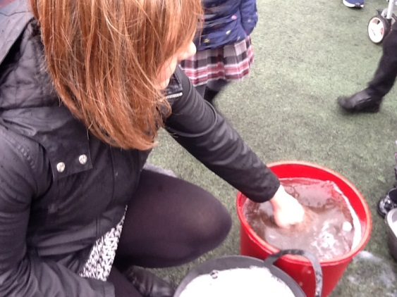

As part of working to gain the Crest ‘Star’ awawrd they have taken part in many, many challenges. Such as the Slime, Light, Tea Bag, Eye, Muddy Mess, Umbrella, Nature, Food, Bubble and of course the Crest Award Challenges.
For more pictures of everything that they have enjoyed please take a look at the school blog.

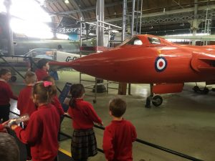
Year 2: On Tuesday Mrs Abraham and Mrs Radcliffe set off on a coach with their helpers and children from Year 2 to visit the Manchester Museum of Science and Industry. They took part in lots of Science investigations, learned about robots and robotics.
They discovered aircraft, both old and new and were super impressed when they saw a Red Arrow airplane as they have been learning about them in their topic work.

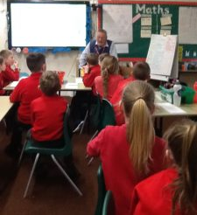
Year 3: To end our science week, Mr Challiner came to talk to us all about mining. It was fascinating to learn about how diamonds were mined and how mines work.
We were also given the opportunity to ask questions about a miners work and about how rocks were formed.
Mr Challiner then set us a challenge to draw one of machines that was used in the mines of the Queens crown which houses the famous Cullinan Diamond. .

Years 3 & 4: On Wednesday Years 3 & 4 went to The Quinta Arboretum and had a great time.
Here is their report on the day –
Do you like adventure and being outdoors? Well you would love a day at Quinta Forest. As part of our science week we were invited to spend the day with Nic at the forest school. First we completed a scavenger hunt, some of the items
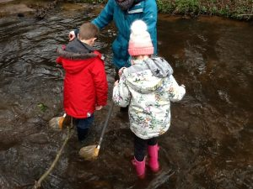
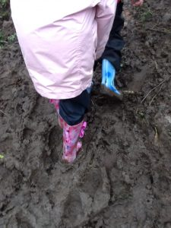
on the list were harder to find than we thought! After that we went stream dipping. The path down to the stream was so muddy that some of us lost our wellies! We found lots of different creatures in our nets and learnt that young bugs were called nymphs.
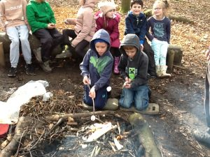
After lunch we lit the campfire and toasted marshmallows which were delicious. Next we played sardines!
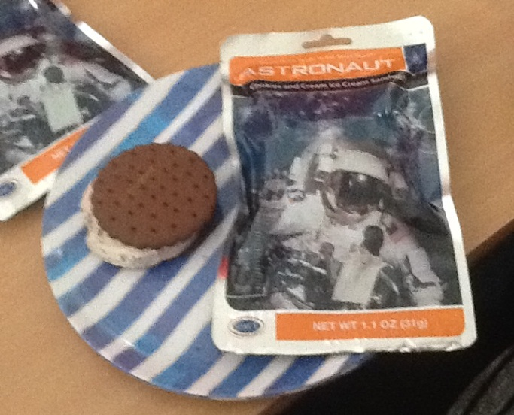
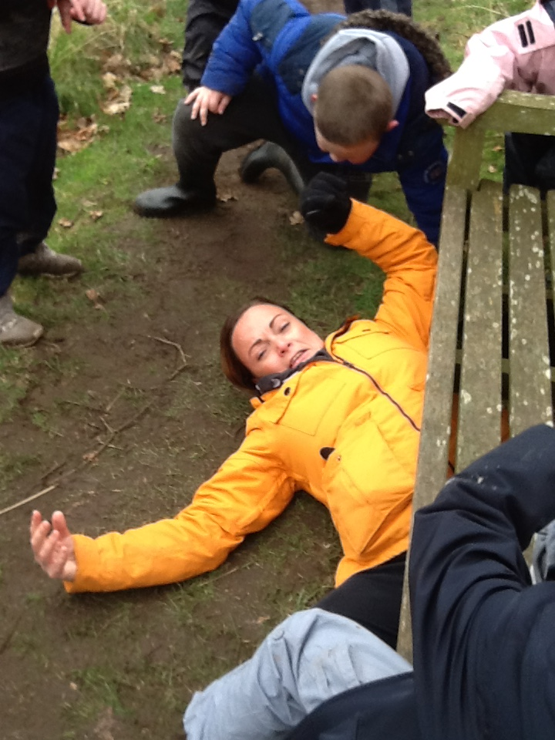
Miss Booth hid under a bench and Miss Carter was found curled up under a pile of twigs. We had an amazing time and can't wait to go back. We only wish that we could have stayed overnight!

Year 4: Year 4 co-ordinated the Slime Workshops for all of the school and had a fantastic time showing the other classes how it is done!

Should you wish to have a go here is how to make perfect slime every time:
You will need:
1 teaspoon, 1 bowl, 1 cup, PVA glue, Borax powder, food colouring or poster paint, shaving foam (optional).
Pour ½ cup PVA glue and ½ cup of water into a bowl and stir.
Add food colouring or poster paint to colour.
Add shaving foam if you want a fluffier slime.
Mix 1 teaspoon of Borax powder into 1 cup of water and stir.
Slowly add 6-10 teaspoons of the Borax solution into the mix of glue and water. If the slime is too gloopy add more Borax solution.
Pour a teaspoon of the Borax solution onto your fingers and knead the slime.
Have fun!

Year 5: Class 5 were introduced to Kitchen Science by Mrs Barnes who comes into school each week to support cooking with children. They made corn dance; shown how the honeycomb in our favourite CRUNCHIE bar is made and how popcorn pops. The children used all their senses and many heard for the first time the popcorn popping and did not realise that it came from a corn plant. They also compared astronaut ice cream with home made varieties. The astronaut ice cream was surprisingly tasty.

Year 6: Class 6 and some children from Class 5 had an exciting Drone Workshop. We spent the day coding and programming a drone to complete three

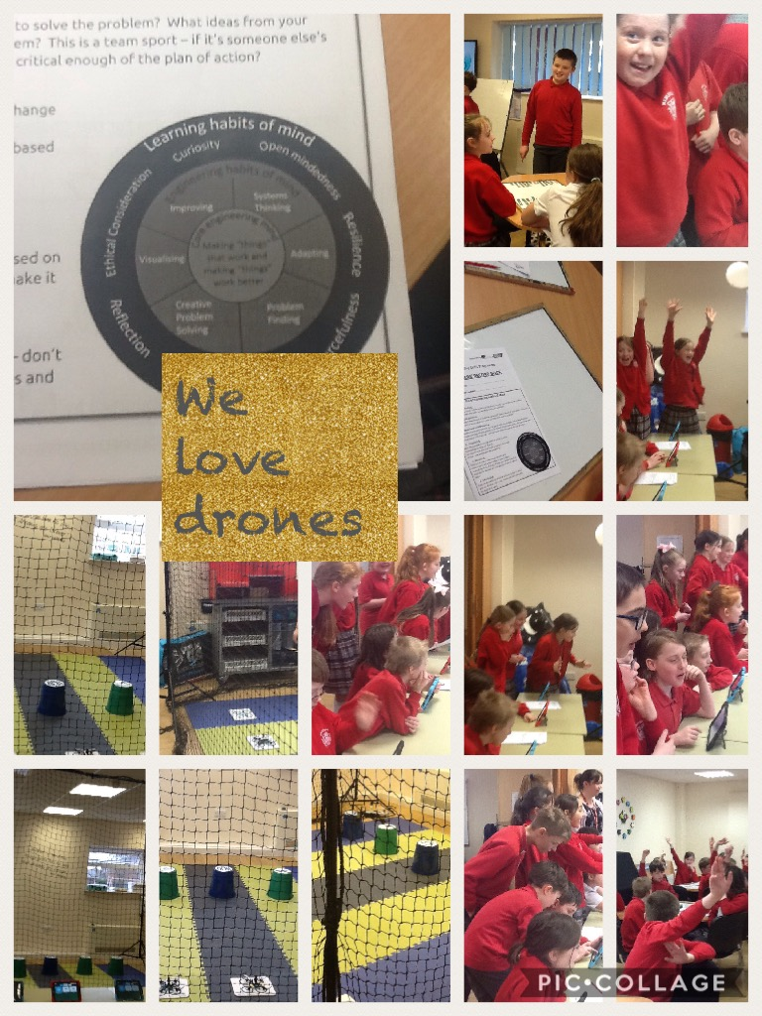
challenges. We used all four areas of STEM (Science, Technology, Engineering & Maths) throughout the day to help us complete all of the challenges. We also learnt engineering learning habits of mind – where we adapted, problem solved, visualised and improved skills in working together.

AUTISM ASSEMBLY
On Thursday 22nd March we will be having a visitor who will give a special assembly on ‘Autism’to both Key Stage 1 and Key Stage 2 chldren.
At Marlfields we encourage the children to recognise that everyone is unique and that while we all look the same on the outside, we all share the same feeling and endure medical conditions that cannot be seen from the outside.
This assembly will give an insight to us all on how difficult it can be to live with autism day after day. Often we share book recommendations with each other and there is a book called ‘The Curious Incident of the Dog in the Night-time’ which is a great book for adults to read.

LAST CALL FOR
Singfest – Broadway to Motown
Years 4, 5 and 6 will be joining with other schools to sing in a massed celebration concert at Crewe Lyceum on Thursday 29th March at 10:00am.
Tickets are available for parents and relatives buy to watch the concert.

Tickets are available online at the following website:
www.lovemusictrust.com/schools/singfest-broadway-to-motown/singfesttickets
When booking, Marlfields are singing in concert number 5.

EASTER CELEBRATIONS
We are already preparing for our Easter celebration and will be performing ‘The Three Trees’ to reflect on the Easter story from the tree elements point of view. It is not to be missed! We are inviting you to join us at school on Tuesday 27th March at 9:30am and then we will host a coffee
morning after for you as visitors and the children to enjoy. We will be charging a £1 for a drink and cake and there will be ‘Easter’ activities for children to enter for 50p should they wish. The money raised will go to school funds to help support the little extras that all children benefit from, such as the science workshops held last week.

SPORT RELIEF
Don’t forget to stay on Friday after school to watch the children play football against the teachers. We hope to start as close to 3:30pm as possible and aim to finish for approximately 4:30pm.
There will be hot and cold drinks on sale during the matches as well as Hot Dogs.
All monies raised will be sent to Sport Relief.

ILLNESS
May we take this opportunity to remind you that if your child has sickness and/or diarrhoea it is imperative that you keep them off school for 48 hours AFTER the last episode of sickness or diarrhoea.

If your child needs prescribed medicine during school hours (eg antibiotics)please come to the office to fill out a permission form for us to medicate your child. Medicines should be dropped off and collected by an adult.
-------------------------------------------------------------------------------------------------------------------------
Please complete and return the accompanying Home/School Agreement

EASTER LUNCH MENU
Monday 26th March

Pork or Quorn Hot Dog
or
Fish Fingers
served with Chips & Baked Beans

-oOo- -oOo-

Chocolate Nests or
Jelly or
Yoghurt or
Fresh Fruit Platter

Cost £2.40 or FREE if your
child is in Key Stage 1
or in receipt of Free School Meals

……………………………………………………………………………

Child’s Name: _____________________________ Class: ______

My child would like to have a school Easter Lunch on Monday 26th March.

I enclose £2.50
My child is in KS1
My child receives Free School Meals

Signed: ______________________________ parent/carer

