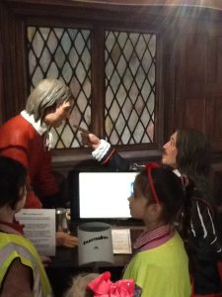
Many, many thanks to Lily in Year 6 for taking on the task of organising last weeks lovely Coffee Morning in aid of the charity Stand Up To Cancer. Thanks also to everyone who supported her in the quest to raise money for charity by coming along for a brew and a cake. Thank you also to those who helped out on the day. Lily and her mum were overwhelmed when they added all the money up and discovered that they had raised £150!
Congratulations Lily for a job well done!

PAYMENTS TO SCHOOL
Paying your child’s dinner and/or snack money directly into the school bank account is our preferred way. This saves you looking for the correct money each Sunday night. You can either pay it in weekly, monthly, half termly or termly whichever suits.
Our banking details are:
Lloyds Bank, Market Street, Crewe.
Sort code: 301259, Account no. 17801268.
As a reminder, dinners for Key Stage 1 children (Reception – Year 2) remains free, for children in Key Stage 2 (Year 3 – Year 6) the cost is £2.40 a day/£12.00 per week and snack money for all children is 40p a day/ £2 per week.

HANLEY MUSEUM
Last week Year 4 went on a trip to the Potteries Museum in Hanley. They saw the Staffordshire Hoard and made Saxon pottery and even our own Saxon helmet! It was a brilliant trip and all paid for out of the class enterprise money!
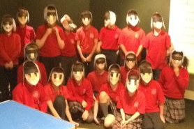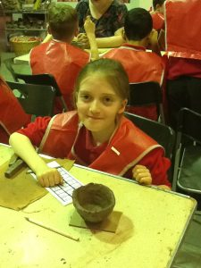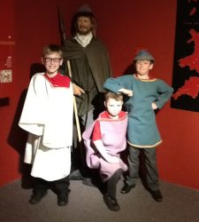
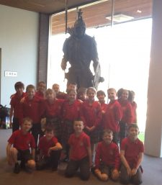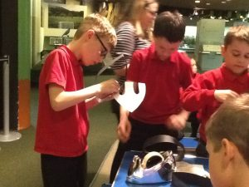

A MAGICAL HISTORY TOUR of Congleton
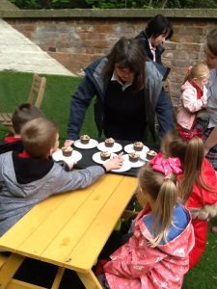
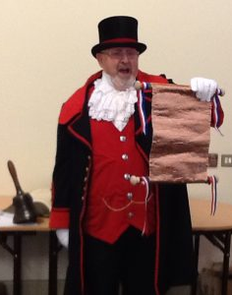
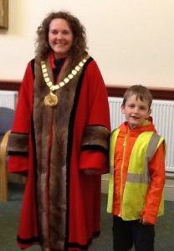
WOW! What an amazing day Year 2 had on when they went investigating in Congleton this week learning all about its history! The children said ‘It was the best day ever going to the Museum, Town Hall, park and café. They made the most delicious cupcakes and smoothies!!! Thank you Mrs Isherwood for letting us go.’

AUTHOR VISIT
Monday, 30th April we are hosting a visit by the author Anya Acres who is coming in to talk to Reception, Year 1 and Year 2.
Anya was a teacher for twenty years whose passion is to inspire children to read and write for pleasure. She has written a book called ‘Ollie Discovers the Planets’ which she will show to, and share with the children. She will also be selling copies of the book should your child wish to buy a copy at the cost of £7.99, simply fill in the slip below and return it to school with the correct money by Monday. If you would like to check out her website for more details she can be located at www.olliediscovers.co.uk

………………………………………………………
Author Visit

Child’s Name:______________________________ Cl:____

My child would like to order ____copy(copies) of the book ‘Ollie Discovers the Planets’ by Anya Acres.

I enclose payment of £________ for the book(s)

Signed: _________________________ parent/carer

OFFICE RECEPTION DOOR

We would like to take this opportunity to remind parents that children should not be brought to the main entrance to get into school instead of going onto the playground.
Children using the front door before 9:15am will be refused entry and you will have to walk him/her round to the appropriate door, which is the one nearest to Cherubs and Imps. Which is manned until 9:15am. After this time the front door is the one to use and your child will receive a late mark on the register.

ANNUAL FOOTBALL TOURNAMENT
All of the Primary Schools in Congleton come along to take part in the Vale Juniour Inter-School Football Tournament takes place on the Marlfields’ football pitches on Saturday 12th May.
This is usually a fun filled and exciting morning for all the teams as they play multiple matches for the honour of winning the trophy.

Please come along to support our team as they play, or volunteer your services to help the staff who will all be here either coaching the team or cooking and serving food and drinks as illustrated below, to raise funds to help pay for those little extras for the children.

If you feel that you will be able to offer your services in any way, please call into the office and leave your deals with Jayne (Mrs Yoxall).
HOLIDAY DATES 2017 - 2018
Last Day In School School Opens
Summer Half Term | 25.05.18 | 04.06.18
Summer Holidays | 20.07.18  23.07.18  24.07.18  25.07.18  INSET DAYS

ROYAL WEDDING

The marriage of Prince Harry to Meghan Markle takes place on Saturday 19th May. We thought that it would be nice to host our own celebration on Friday the18th May.
We propose that we have a right royal reception picnic! Therefore we are aksing that each child contributes some goodies to share. Please could your child bring as their contribution as below as soon as possible:
Nursery & Reception – a 6 pack bag of crisps.
Years 1 & 2 – an 8 pack of biscuits e.g. Kit Kats, Viscounts, Breakaways or similar.
Years 3 & 4 – a 2ltr bottle of pop
Year 5 – cakes or mini rolls
Year 6 – a packet of jelly.
To get into the spirit of the day we would like the children to come to school on that Friday dressed as wedding guest. If you would like to join us to help please let Jayne in the office know – you are more than welcome.
PARKING
This morning we had a complaint from one of our neighbours. They were unable to exit their driveway having to wait for 15 minutes for the car owner (one of our parents)to return! When parking on Waggs Road please be considerate of our neighbours and their property, they do have every right to phone the police but work with us so please consider them when parking.

HOLIDAY DATES 2018 - 2019
Last Day In School School Opens
Autumn Term |  | 03.09.18
Half Term  Holiday | 26.10.18 | 05.11.18
Christmas Holiday | 20.12.18 | 07.01.19
Spring Half  Term | 18.02.19 | 25.02.19
Summer Term | 08.04.19 | 23.04.19
Summer Half  Term | 24.05.19 | 03.06.19
Summer holidays | 24.07.19 | 5 INSET DAYS TO BE ADDED

